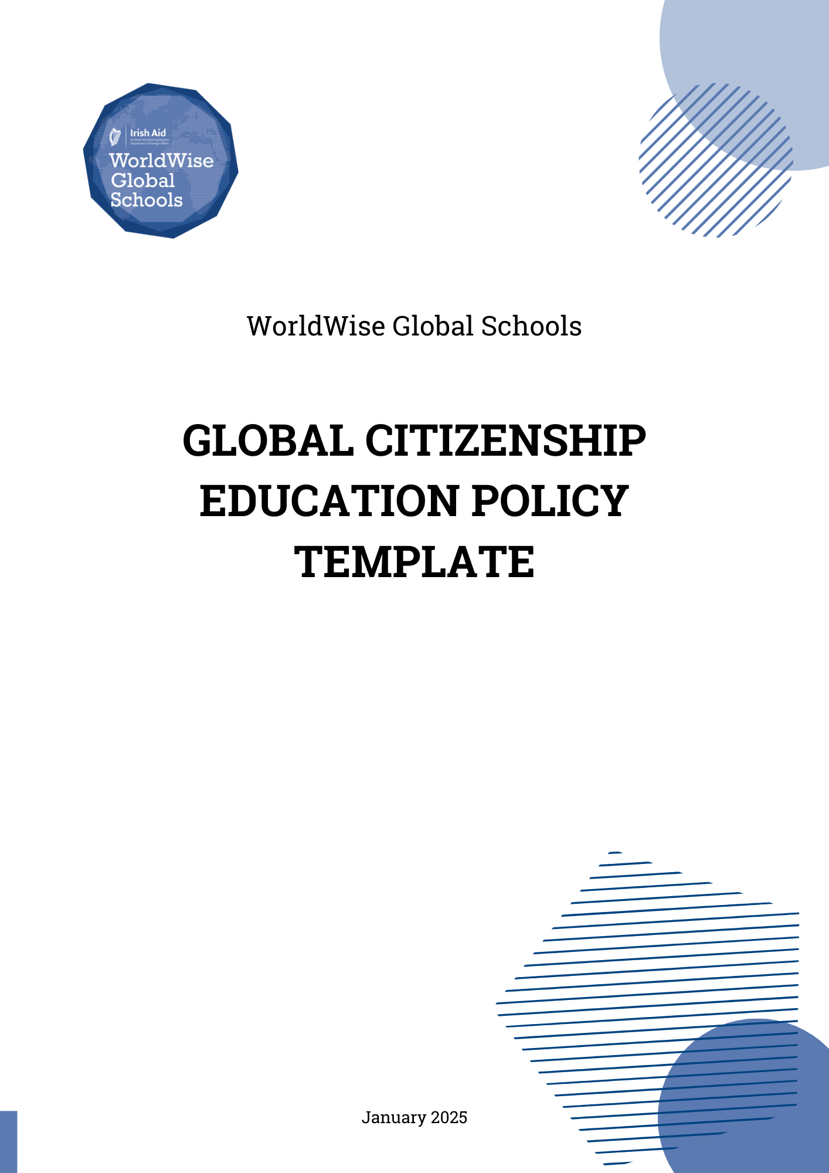

Global Citizenship Education Policy Statement: Instructions

This Global Citizenship Education Policy Statement template is provided purely as a guide to assist in drafting your own Global Citizenship Education Policy Statement.
It is largely directed at mainstream post-primary schools. However please add to, edit, amend, or delete statements to reflect your own educational setting. Should you wish to adapt it for your alternative setting please do so where relevant, or get in touch with WorldWise Global Schools to assist you.
All blue text is instructional and can be deleted. Highlighted text is to be replaced with the name of your school. All hyperlinks to our are underlined and bolded.
The content of your Global Citizenship Education Policy Statement should be drafted in collaboration with the whole-school community and incorporate youth voices.

The following Global Citizenship Education Policy Statement template is informed by:
- Irish Aid’s WorldWise Global Schools, the national Global Citizenship Education programme for post-primary settings.
- Irish Aid’s Global Citizenship Education Strategy 2021-2025.
- ESD to 2030: Ireland’s National Strategy for Education for Sustainable Development (ESD).
- Céim: Standards for Initial Teacher Education, from the Teaching Council of Ireland, which includes GCE as a core element for all initial teacher education programmes.
- The United Nations Sustainable Development Goals (SDGs), in particular Goal 4.7 which identifies GCE as an educational approach that supports the development of inclusive and equitable quality education to further the pursuit of a more just and sustainable world.

WorldWise Global Schools is Ireland’s national Global Citizenship Education (GCE) programme for post-primary settings. WorldWise Global Schools aims to increase the reach, accessibility, quality and effectiveness of GCE in the post-primary sector.
WorldWise Global Schools (WWGS) provides a comprehensive range of supports for learners and educators, including grant funding, training, events, resources, and personalised support from our team.
[insert school name and logo]

Global Citizenship Education Policy Statement

Purpose
The purpose of this Global Citizenship Education (GCE) Policy Statement is to outline how our school promotes and supports a whole-school approach to GCE.
Rooted in social justice, Global Citizenship Education equips learners and educators to think critically and to reflect; to challenge unjust global systems and structures and our roles within them, and to take meaningful action for change.

Scope
Global Citizenship Education is key to building a more inclusive, just, and sustainable future. It aims to build a sense of common humanity and to empower us all to assume roles as active and contributing global citizens.
Reflecting these aims, GCE applies to all learners, educators, leaders and employees of our school. Parents and guardians should note, and where possible, promote the GCE Policy Statement. The Board of Management will ensure that decisions made in relation to our schools’ actions and activities align with the GCE Statement.

Aims for Global Citizenship Education
Our aims for Global Citizenship Education in X school are firmly grounded in and informed by the WorldWise Global Schools Guiding Principles for GCE. The 5 Guiding Principles for GCE apply to curricular, extra-curricular, whole-school actions and activities, as well as leadership and policy domains.

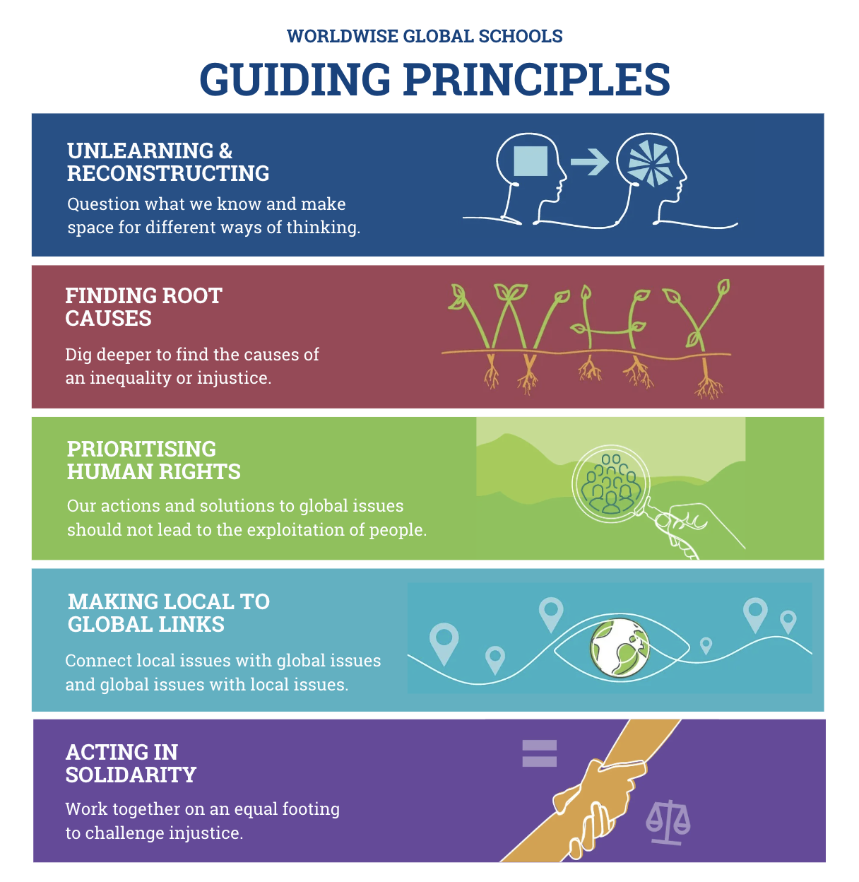

Aims for Global Citizenship Education at X School:
Where possible, the relationship between the school’s mission and values, and Global Citizenship Education should be articulated here. For instance, if your mission statement emphasises concepts such as equality, justice, and/or citizenship, these can be linked to the aims of Global Citizenship Education. For more information on the aims of GCE, see the Appendix at the end of this document.
For the following sections, please delete any statements that are not applicable, and expand upon those that are.

- To foster a practice of critical exploration, deep reflection and shared learning in understanding the complexities of injustice and inequality.
- To use active and participatory teaching and learning methods to enrich the learning experience and cultivate Global Citizenship Education skills such as critical thinking.
- To support learners to raise awareness of global justice issues and take action for meaningful change.
- To support learners to articulate their voices and participate as active global citizens in local and global communities.
- To work collaboratively and thematically on global justice issues across the whole school setting and, where possible, extend that collaboration into our local and global communities.

GCE in Teaching and Learning Activities
We recognise that Global Citizenship Education is aligned with the Principles of Junior Cycle and Senior Cycle; that GCE supports the development of Junior Cycle Key Skills, and Senior Cycle Key Competencies, and that GCE contributes to the achievement of Statements of Learning in Junior Cycle and the Vision for a Redeveloped Senior Cycle. (For more information on GCE and the Post-Primary curriculum, including in Youthreach settings, see Educating for a Wise World: A WorldWise Global Schools Guide to Teaching Global Citizenship in Post-Primary Settings).

We acknowledge that ‘doing GCE does not mean doing something extra’ (WWGS, 2024), and we recognise that GCE already exists in national curricula as laid out by the National Council for Curriculum and Assessment (NCCA). We endeavour to seek out the existing links and overlaps and to embed those into our curricular planning and teaching and learning.

We emphasise a collaborative and thematic approach to exploring global justice issues, we recognise the value in cross-curricular approaches and peer learning.

We employ active and participatory teaching and learning methods so that learners are empowered to play an active role in shaping their own learning, their participation, and their agency as global citizens. We endeavour to remain up to date and current with GCE teaching and learning methods by regularly consulting WorldWise Global Schools’ dedicated webpage.

In line with children’s rights under Article 12 of the United Nations Convention on the Rights of the Child (UNCRC), we aim to facilitate youth voices and participation in planning for GCE and throughout our GCE teaching and learning.

GCE across the Whole School
Following best Global Citizenship Education practice, we aim to incorporate GCE across our whole school and wider community, through both curricular and extracurricular GCE activities and actions.
We understand that a whole-school approach will facilitate a more comprehensive, critical and deeper exploration of global justice issues; it will also strengthen our efforts to raise awareness of global justice issues and to support learners to take action.
As part of a whole-school approach to GCE we will prioritise scaffolding GCE events, activities and/or trips through teaching and learning. By scaffolding, global justice themes can be explored on a school wide level through curricular, cross-curricular and extracurricular activities. Scaffolding will occur in classrooms, assemblies, through peer learning, workshops, celebrations, (social)media, school displays, school newsletters, post-primary programmes such as debating. Edit/amend to make relevant to scaffolding in your school.
To support our scaffolding, we will draw heavily on the WorldWise Global Schools Guide to Scaffolding Events, Activities and Trips which follows the WorldWise Global Schools five Guiding Principles for GCE and ensures that participants move actively towards an in-depth and critical understanding of global justice themes.
We will also consult the WorldWise Global Schools Guide to Ethical Communications to ensure that our online and offline GCE communications reflect the global justice values of equality, solidarity and shared learning.

As part of a whole-school approach to GCE we will incorporate the WWGS Global Passport, an EU accredited framework to integrate GCE into all aspects of school life. We will use the Global Passport Framework to support and strengthen effective whole-school planning for GCE and as a GCE reflection tool.

GCE and Current and Controversial Issues
As part of our approach to GCE in X school we support our educators and learners in exploring current and controversial issues that may arise in classrooms or in the wider school community. Recognising the complex and ever changing global world we live in, we understand that current and controversial issues are also complex and changing, that they are often emotive, and that they may be subject to misinformation, disinformation and malinformation. Current and controversial issues can include (Edit/amend to make relevant to your context), the climate crisis, eco-anxiety, far-right sentiment, racism, war and conflict, social isolation, online influencers, amongst many more.
We recognise that creating an environment characterised by trust is key in exploring controversial issues. We are committed to building supportive and respectful relationships, in safe and inclusive spaces, where we can unlearn and reconstruct our understanding of current and/or controversial issues. We respect diverse and multiple perspectives, and rely on trusted and verified sources of information when exploring these issues.

GCE and Critical Media Literacy
In the context of the current globalised and digitalised age, we are experiencing an increased flow of information and the expansion of spaces and forms of communicating. We recognise the potentials and dangers for young people in this context, in particular the accelerated spread of misinformation, disinformation, hate speech, and online violence. We acknowledge that critical media literacy skills are necessary to effectively access, critically engage with, and share information and knowledge online, including on social media platforms (UNESCO, 2024). We regard education in general, and global citizenship education in particular, as crucial in assisting and equipping learners with critical media literacy skills and competencies. We identify opportunities to embed critical media literacy into curricular areas, teaching approaches and into our whole-school communications. We consult up to date and relevant resources and GCE materials to inform our approach to critical media literacy.

GCE Supports and Resources
As a WorldWise Global Schools affiliated school, we draw on the supports and resources available to us through the WorldWise Global Schools programme. This includes our dedicated regional WorldWise Global Schools Education Officer and regular WorldWise Global Schools trainings, workshops and events which can support our professional development and strengthen our GCE work.
All necessary and appropriate supports will be given to GCE lead teachers, individual educators and subject departments to attend Continuous Professional Development training and/or workshops to support their GCE work.
We are informed by WorldWise Global Schools’ resources which include subject specific and curriculum linked resources designed to assist the teaching and learning of GCE in a range of post-primary subject areas. We also draw upon a range of national and international educational materials and resources to support our work in Global Citizenship Education. We endeavour to remain up to date and current in terms of the resources and materials we consult by staying informed through WorldWise Global Schools, developmenteducation.ie, and Irish Development Education Association (IDEA) delete or expand here to include relevant NGOs, programmes, or providers.
We keep the resources and materials for Global Citizenship Education in a designated space in topic/theme/subject boxes for each unit of work; we also store our GCE materials in the relevant online space. Edit to make relevant to the process in your school.
Where necessary and/or relevant, we engage with GCE facilitators and/or NGO providers to support and strengthen our GCE work. In these cases we will consult the WorldWise Global Schools recommended and approved WorldWise Global Schools Panel of Facilitators providing GCE workshops to post-primary settings.
Our school uses the WWGS Global Passport framework to record and measure our Global Citizenship Education journey. Each year we aim to record and self-assess our GCE engagement and provide examples of GCE activities, planning, teaching and learning across the whole school context. WorldWise Global Schools will then review our self-assessment and determine the Global Passport level.

Monitor and Review
In line with a whole-school approach to Global Citizenship Education, the planning, coordination and review of GCE is the responsibility of the entire team of leaders, educators and learners at X school. However, our strategic lead GCE teacher (option to include teacher’s name) will take lead responsibility for monitoring and reviewing our GCE work, with all necessary and appropriate support given to said teacher/our strategic lead GCE teacher.
As part of our school’s agreed cycle of monitoring and evaluation, we use the WorldWise Global Schools Reflection Tool to monitor and evaluate the delivery of GCE in our school.
We recognise the value of reflection as key in consolidating learning, encouraging critical thinking and informing GCE planning. To guide our reflection, we consult the WorldWise Global Schools reflective questions for educators and learners, available in Educating for a Wise World: A WorldWise Global Schools Guide to Teaching Global Citizenship in Post-Primary Settings.

This Statement was implemented on [insert date].
To ensure our school strives to improve its work within Global Citizenship Education the Statement will be reviewed X e.g. annually/ every 2 years.

Signed:

Date:

Appendix: Aims of Global Citizenship Education

Irish Aid’s definition of Global Citizenship Education:
Global Citizenship Education (GCE) is a lifelong educational process, which aims to increase public awareness and understanding of the rapidly changing, inter-dependent and unequal world in which we live.
By challenging stereotypes and encouraging independent thinking, GCE helps people to critically explore how global justice issues interlink with their everyday lives and how they can act to build a better world.

Source: Irish Aid (2021). Irish Aid Global Citizenship Education Strategy 2021-2025, Irish Aid, Dublin.

UNESCO’s definition of Global Citizenship Education:
The primary aim of Global Citizenship Education (GCED) is nurturing respect for all, building a sense of belonging to a common humanity and helping learners become responsible and active global citizens. GCED aims to empower learners to assume active roles to face and resolve global challenges and to become proactive contributors to a more peaceful, tolerant, inclusive and secure world.
Education for global citizenship helps young people develop the core competencies which allow them to actively engage with the world, and help to make it a more just and sustainable place. It is a form of civic learning that involves students' active participation in projects that address global issues of a social, political, economic, or environmental nature”.

Source: United Nations: Global Citizenship Education, Academic Impact Report 2024

For more on definitions and descriptions of GCE see:
- Andreotti, V (2006) 'Soft versus critical global citizenship education', Policy and Practice: A Development Education Review, Vol. 3, Autumn, pp. 40-51.
https://www.developmenteducationreview.com/issue/issue-3/soft-versus-critical-global-citizenship-education
- Andreotti, V (2006) 'Soft versus critical global citizenship education'. Poster
https://drive.google.com/file/d/145kxU9mVVwEgvH2Jnus9zRaOzehVBj-d/view?usp=sharing
- O’Flaherty, J., McCormack, O., Lenihan, R., & Young, A. M. (2024). Critical reflection and global citizenship education: exploring the views and experiences of teacher educators. Reflective Practice, 1–19. https://doi.org/10.1080/14623943.2024.2421598
- O’Toole, V., & O’Flaherty, J. (2022). The role of emotion in higher education: exploring global citizenship education. Irish Educational Studies, 43(4), 645–663. https://doi.org/10.1080/03323315.2022.2135565
- Pashby, K., da Costa, M., Stein, S., & Andreotti, V. (2020). A meta-review of typologies of global citizenship education. Comparative Education, 56(2), 144–164. https://doi.org/10.1080/03050068.2020.1723352
- UNESCO (2015) Global Citizenship Education: Topics and Objectives.
- UNESCO (2017)The ABC’s of Global Citizenship Education.
- UNESCO (2024)- What you need to know about GCE.

GCE Book Publications in Irish Context
- Curious Teachers, Critical Classrooms (2023) edited by B. Golden-available for free download through the Dice Project.
- Global Education in Ireland: Critical Histories and Future Directions' (2024) edited by E. Dillon, N. Gaynor, G. McCann and S. McCloskey -available for free download through Bloomsbury Collections.
- A Teacher’s Handbook on Global Citizenship Education in the Post-primary Classroom by S. Hoy, G. O’Brien and S.O’Brien (2024) available from Oak Tree Press.

