THE CRIMINALISATION OF SOLIDARITY
SECTION 5

The following is a selection of lesson ideas and materials for the #FreeHumanitarians Week of Action 15th – 19th November 2021, but which remain relevant in the context of ongoing charges against a number of volunteers and humanitarian workers.
The section also includes drama activities and writing prompts to address the wider issues relating to the ‘chilling effect’ on solidarity and humanitarian efforts.

Curriculum Links: Geography/English/Drama/Politics and Society/CSPE

In the midst of the biggest refugee crisis in history, several European governments have pushed for harsh penalties for volunteers and Non-Government Organisations (NGOs) who attempt to assist people attempting perilous, and even life-threatening journeys. In Europe in 2019, over 104 people were arrested for helping refugees - more than in any other year on record – and more are awaiting trial.
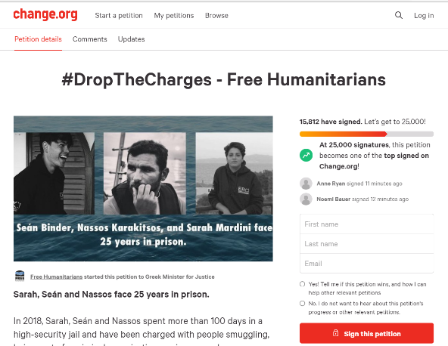
In just one example of this clampdown young Kerry man Seán Binder, and Syrian volunteer Sara Mardini were arrested and imprisoned in 2020, along with two others, whilst volunteering with a Greek Humanitarian NGO. They now face up to 25 years in prison. Below you’ll find a selection of videos and activities relating to the case, as well as the wider issues of the criminalisation of refugees and solidarity with people seeking safety.

Seán and Sarah’s trial, along with 22 others, began in Greece on Thursday 18th November 2021. The case was quickly adjourned, leaving the humanitarian volunteers and workers in limbo yet again. Teachers and students have an opportunity to learn and take action in support of solidarity and human rights.
Below are some ideas for classroom discussion, exploration, and student action.
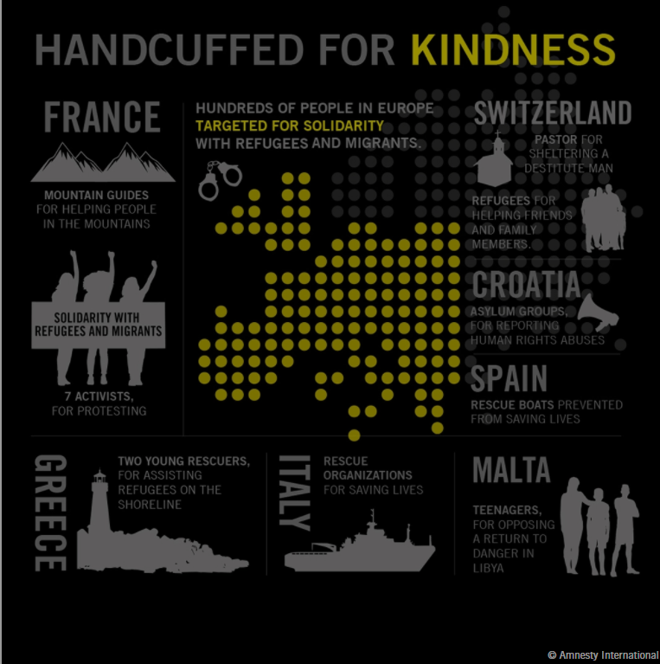
This infographic from Amnesty International highlights a few examples of people targeted with criminal charges for showing solidarity with people seeking safety.
Solidarity on trial in Europe (amnesty.org)

Video 1: Introducing Sarah and Yusra Mardini
This short video describes the journey taken by Sara Mardini and her younger sister Yusra to reach safety and re-join their father in Europe. As part of that arduous journey made the crossing from Turkey to Greece in and overcrowded dingy. When the boat’s engine failed, the sisters entered the sea and swam for three and half hours to stop the dinghy from capsizing, ensuring the safety of everyone else onboard. The sisters were finally reunited with their father in Germany. Yusra, a competitive swimmer, went on to compete at the Rio and Tokyo Olympics. Sara returned to Greece to volunteer her time and skills to support refugees making the same perilous journey. Their story has inspired many people, and production has begun on a Netflix film based on their story, which is due to air in 2022.
How Yusra Mardini Survived a 25-Day Trek From Syria And Became an Olympian (nbcnews.com)

Video 2: Introducing Seán and Sarah, and the story of their arrest. (Amnesty Canada, 2019)
Sarah and Seán met in Lesvos and worked together as volunteers with a humanitarian refugee support organisation. This short video from Amnesty introduces them, their solidarity work, and the moment they were arrested for carrying out search and rescue work on the island of Lesvos, Greece.
W4R 2019: Greece - Sarah Mardini and Séan Binder - Bing video

Video 3: Sarah Mardini describes her journey, the case, and what people can do.
In this longer interview Sarah describes what drove her family to leave Syria and describes the journey in more detail.
How I was arrested for handing out blankets to refugees | Sarah Mardini | TEDxLondonWomen - YouTube
Video 4: Understanding this case and the wider issue of the criminalisation of solidarity.
In this video, an interview on France 24, Sean Binder goes into more detail about the charges brought against them and describes some of the root causes of the suffering they witnessed, and the wider problem of people facing criminal charges for simply trying to help people in danger and distress.
Jailed in Greece for helping migrants: The story of humanitarian worker Sean Binder - YouTube
In this interview, Seán outlines how EU policies create an impossible situation for people seeking safety (see segment 4.40 - 5.20 minutes). Ensure that the class understands the points made and discuss the options (or lack of) left to people seeking safety from war, persecution, or grinding poverty.
- People cannot enter the EU without visas and documentation.
- Asylum seekers cannot access permission to travel from their home country
- They can only claim asylum (International Protection) once they arrive in the EU country.
- The EU policy of border control, known as ‘Fortress Europe’
- Rescue missions, with safety patrol boats in the Mediterranean have been minimised or called off.

Discuss the meaning of a ‘Catch-22’ situation and ask how these policies make refugees increasingly vulnerable to people-smugglers

Video: ‘Why Don’t Refugees fly?’
Watch this short video by the late Professor Hans Rosling, as he addresses one of the factors forcing people to make unnecessarily dangerous journeys and drives them into the hands of smugglers.
www.youtube.com/watch?v=YO0IRsfrPQ4

Additional material (for listening at home):
“If there is a perfect role model for young Irish people – although there is no such thing – Seán Binder comes extremely close.” Charlie Bird (2020)
In this interview with journalist Charlie Bird, Seán describes his motivation and experiences as a refugee solidarity refugee in Greece.
Charlie Bird Interviews Search and Rescuer, Seán Binder - Senior Times

Watch this short video and search online to learn more about Sara Yardini and her sister Yusra’s journey from Syria, and their subsequent work to protect refugee rights.
www.unhcr.org/ph/16798-october-e-newsletter-yusramardini.html

Additional Reading:
Greece: Life-Saving on Trial | Human Rights Watch (hrw.org)
In this article Human Rights Watch describes how the introduction of regulatory obstacles prevents humanitarian NGOs from offering potentially lifesaving support and criminalises their solidary activities. HRW also outlines objections to these restrictions by the United Nations and Council of Europe’ Commissioner for Human Rights. While the article focusses on Greek regulations, it should be noted that punitive laws are being enforced in several EU counties and in the USA.
“In 2020, Greece introduced new rules on registration for nongovernmental groups that prompted intervention by three United Nations special rapporteurs, the Council of Europe’s Expert Council on NGO Law, and its commissioner for human rights. Several groups unable to meet the requirements were forced to suspend their humanitarian activities, a European Parliament report found. Greek police officials have announced abusive criminal investigations against other humanitarian workers, whom law enforcement and political officials appear to have targeted with “smear campaigns,” the UN special rapporteur on human rights defenders stated in October 2021.
In September, the Council of Europe human rights commissioner urged the Greek parliament to reconsider legislative proposals that hinder “life-saving” work and human rights monitoring by nongovernmental groups. The bill, adopted on September 3, introduces restrictions and conditions on nongovernmental groups active in areas where the Greek Coast Guard operates, at the threat of heavy sanctions and fines.
“Greek law enforcement authorities are not just flouting the law at the borders in their violent treatment of migrants and asylum seekers, they are also abusing the law to prosecute Greek and other European citizens for trying to save lives,” Van Esveld said. “Greek and European officials should champion humanitarians and denounce the abusive prosecutions that have shut down life-saving work.””

ACTIVITY • Head-Hands-Heart Reflective Writing
Having watched, listened, and discussed Seán and Sarah’s case, what do you think about what you’ve learned. What are your feelings about the situation for people seeking refuge, and for those trying to support them? Do you feel moved to act on what you’ve learned? What do you think can be done?

TAKING ACTION:

“You can start a campaign very easily…There is no more time for hope - it’s time for action…we’ve been hoping for so many years and we need to act now, all of us.”
Sarah Mardini

- Write directly or support and promote this petition to the Greek Minister for Migration, calling for charges to be dropped.
Petition · #DropTheCharges - Free Humanitarians · Change.org

- Create an event at your school or in your community (ideas might include a class holding up signs with messages of support or slogans; draw/write a larger message of support in chalk in the school yard and take a photo from an upstairs window. Add your event to the Free Humanitarian’s support page.
Events — Free Humanitarians

- Create infographics or illustrated quotes to share on social media, and promote these, tagging relevant ministries to convey your solidarity messages

- Share information about the case with others and urge them to take action too.
Comhlámh solidarity statement with three humanitarian volunteers facing 25 years in prison in Greece. - Comhlámh (comhlamh.org)

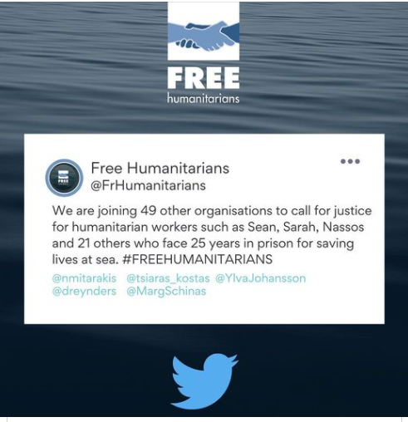

THE WIDER ISSUE and CONTEXT OF THE CRIMINALISATION OF SOLIDARITY
In 2018, 2,300 people drowned attempting to cross the Mediterranean to seek safety. The Irish Navy was an important partner in the team that patrolled the area, saving over 45,000 lives and leading to the arrest of 150 smugglers between 2015 - 2019. Yet in 2019 the EU called off its naval rescue patrols in the Mediterranean, putting thousands of lives at risk. Voluntary sea rescue missions like Pro Activa Open Arms, Sea Watch, SOS Méditerranée, Médecins Sans Frontières (MSF), and others who have worked to save lives have also been prevented from carrying out rescue patrols in the area. They have been blocked from entering ports, barred from allowing people who were rescued at sea to disembark, and had their ships seized. Harsh human trafficking laws have been used against crew members, and many face criminal prosecution for simply attempting to save lives.
www.irishtimes.com/news/ireland/irish-news/eu-ends-migrant-rescue-mission-in-mediterranean-1.3840827
www.amnesty.ie/croatia-eu-complicit-in-violence-and-abuse-by-police-against-refugees-and-migrants/

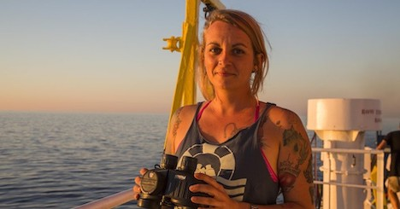
Captain Pia Klemp – image Seawatch (2017)
In one example of this clampdown, in 2019 captain of the rescue ship Iuventa, Pia Klemp, was arrested with nine others. Between 2016 and 2017 the Iuventa was involved in the rescue of over 14,000 lives at sea. “[We now face] up to twenty years in prison [and enormous fines] for having rescued those people and brought them to Europe. We are not alone. The criminalisation of solidarity across Europe, at sea and on land, has demonstrated the lengths to which the European Union will go to make migrants’ lives expendable.”

THE CITY OF PARIS IS AWARDING THE MEDAILLE GRAND VERMEIL TO PIA KLEMP

“You want to award me a medal for my solidarity action in the Mediterranean Sea, because our crews 'work to rescue migrants from difficult conditions on a daily basis'.
At the same time your police are stealing blankets from people that you force to live on the streets, while you raid protests and criminalize people that are standing up for rights of migrants and asylum seekers. You want to give me a medal for actions that you fight in your own ramparts. I am sure you won't be surprised that I decline the Medaille Grand Vermeil.

…I'm not a humanitarian. I am not there to 'aid'. I stand with you in solidarity. We do not need medals. We do not need authorities deciding about who is a 'hero' and who is 'illegal'. In fact, they are in no position to make this call, because we are all equal. What we need are freedom and rights. It is time to call out hypocritical ‘honourings’ and fill the void with social justice.”

See Pia’s full statement here: www.facebook.com/pia.klemp/posts/10156318059491611

In August 2019, the Mayor of Paris awarded Captain Pia Klemp and Captain Carola Rackete with the prestigious Médaille Grand Vermeil. They refused to accept the honour. Pia explained her reason for declining the medal:
“I’m not a humanitarian. I am not there to ‘aid’. I stand with you in solidarity. We do not need medals. We do not need authorities deciding about who is a ‘hero’ and who is ‘illegal.’ In fact, they are in no position to make this call, because we are all equal. What we need are freedom and rights. It is time we call out hypocritical honourings and fill the void with social justice…”

ACTIVITY • Art/English/CSPE/Politics & Society
Create a group definition of ‘solidarity’:
When was the first time you became aware of global poverty? Can you remember how old you were? (Most people will reference fundraising campaigns, shoebox appeals, or aid agency adverts on television.)
Ask for words associated with ‘charity’ and note these on the board. Then ask the group to consider the meaning of ‘solidarity’ and how it might contrast with the idea of ‘charity.’ Seek a selection of words from the group - including phrases and associations with ‘solidarity’ and invite the students to use these to create a poster, or collage of these terms.

ACTIVITY • English/Politics & Society/TY
Many people are moved by the injustices facing refugees. What drives some people to take action and show solidarity? Refer back to your group definition of ‘solidarity’ (see Activity 1 above) and keep this understanding in mind as you watch Pia Klemp’s talk about why she fights for human rights and read her powerful statement about why she refused to accept a medal from the Mayor of Paris in honour of her ‘humanitarian work’. (See below)
www.ted.com/talks/pia_klemp_why_i_fight_for_solidarity
www.facebook.com/pia.klemp/posts/10156318059491611

ACTIVITY • Taking Action
Create an awareness campaign for use on social media, and/or a poster for display at school highlighting the criminalisation of solidarity. Select cases from the list provided by Amnesty of everyday acts of solidarity that have led to people facing charges and prosecution.
Discuss a slogan for the campaign and decide who should be the key target of the campaign. For example, in Ireland refugee issues are primarily handled by the Minister for Justice. The Minister for Foreign Affairs can also address these matters with other countries.

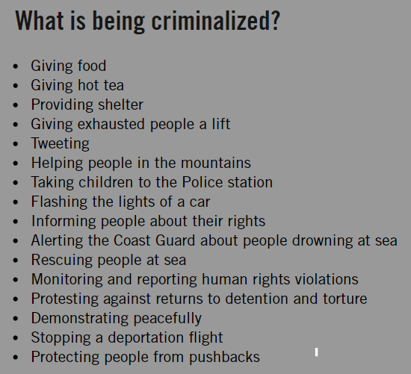

See Pia’s full statement here: www.facebook.com/pia.klemp/posts/10156318059491611

ACTIVITY • English / CSPE / Politics and Society
Discussion: In her Ted Talk (see link above), Pia Klemp says that as an activist she has been inspired by the words of environmentalist Bruno Manser: “Those who have understood and do not act have not understood after all.” What kind of understanding do you think moves people to act in solidarity? Is it a deeper kind of understanding or realisation, which goes beyond gaining information and learning facts? What helps, and what hinders, the development of this kind of deep understanding? Chose a quote that speaks to you about solidarity and illustrate it for display or sharing online.

“By refusing to abide by a wall, map, property line, border, identity document, or legal regime, mobile people upset the state's schemes of exclusion, control, and violence.

They do this simply by moving.”

Reece Jones, Violent Borders: Refugees and the Right to Move

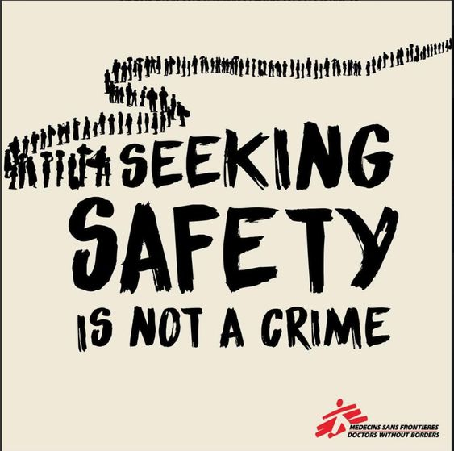

THE CRIMINALISATION OF DESPAIR
The harsh fines and penalties facing volunteers is an extension of the long-running criminalisation of refugees themselves. In a particularly harrowing example, 3 teenagers were arrested and charged with terrorist offences as they landed in Malta. Read this article from the BBC European correspondent about their journey and their arrest.

Malta: The Teenagers Pulled From The Sea And Accused Of Terrorism, By Jean Mackenzie (9 August 2021)
www.bbc.com/news/world-57988934

ACTIVITY • English / Politics and Society
At the end of the article, they mention reading letters of support from around the world. What do you think motivates people to write a letter like this to someone they’ve never met? What else might someone do if they wished to show solidarity with people in this situation?

ACTIVITY • English / Drama
Explain that the class is going to create a courtroom activity loosely based around the details of this case. Create a fictitious island state, which is part of the EU, and a landing site for some refugees attempting to reach Europe. The country also has a high immigration rate (meaning that a lot of people move abroad for work, studies, and other reasons. Membership of the EU makes this a straightforward process.) Ask the group to name their country.
Chose volunteers to play the roles of the teenagers, some other passengers, the captain of the ship, as well as the country’s minister for Foreign Affairs, two members of a refugee solidarity group, and two members of an anti-migration group from the island. Give each volunteer time to prepare, and to reflect on what motivated them and what their hopes and fears are. Ask them to build their character around the details of the case, but not to assume the identity of the actual people. This is to allow the students freedom to use their imaginations to consider the thoughts, feelings, and motivations of their character, whilst maintaining respect for the three young people actually facing criminal charges in Malta.
Teacher can take the role of the ‘judge’ and to call each of the witnesses forward, explaining what they are accused of and inviting them to tell their story.
Explain that usually a court hearing would involve lawyers for the defence and the prosecution, with cross examination of the witnesses, but that in this case the process is an attempt to learn more about the motivations and root causes of the problem, rather than deliver a guilty/not-guilty verdict. The process aims to increase understanding and exploring solutions, rather than pronouncing blame. In this drama the class should listen and reflect on the testimony and circumstances of each of the witnesses, and consider if there are any further questions they wish to put to them. These questions can be broad and can probe into some of the deeper elements and causes of the issue.
Encourage the class to consider if there are any other witnesses who should be called to come forward. For example, should the EU be asked to speak about the failure to help relocate refugees when they arrive in Malta, Greece, or Italy (as mentioned by the Minister in the article)?
The judge should also maintain a focus on human rights, reminding the ‘jury’ that we are all entitled to seek safety in another country if we are not safe in our own, and that it is acknowledged that people sometimes have enter a safe country “illegally” to claim this right. In recent years, the EU struck deals with Turkey and Libya to create additional obstacles for people fleeing persecution and conflict. Refer back to the France 24 interview with Seán Binder, and his description of the catch 22 facing people seeking safety and ask the ‘jury’ to consider if the EU is upholding human rights.

Finally ask the Jury to consider the question of whether the charges of terrorism against the 3 ‘accused’ should be upheld or dropped. This can be done by walking debate, or by secret ballot with each jury member writing ‘drop’ or ‘uphold’ the charges, along with a sentence or two about why they’ve come to this conclusion.
In this way the activity can be open-ended, with the option to return to some of the points, if necessary. This would be important if reasons given to uphold the charges that were based on myths or stereotypes.

