COMMON THREADS: THE CONNECTIONS BETWEEN TEXTILES and MIGRATION
SECTION 2

This section looks at some of the links between migration, climate change, and the textiles industry, a sector reliant on the work of migrants, often under difficult or dangerous conditions.
It also presents a range of textile artists dealing with issues of migration and conflict, as well as refugee solidarity projects and initiatives making meaningful use of discarded materials and textiles.

AIM OF THIS SECTION:
- To develop understanding of the links between the textile industry, environmental issues (including climate change), and forced migration.
- To consider ways of raising awareness of these issues, and actions that could help to halt or reverse some of these harms.
- To learn about initiatives led by migrants and refugees to repurpose or recycle textile waste in meaningful ways.
- To look at the work of number of textile artists and arts projects that address refuge and migration issues, and the benefits they can bring.

SUBJECT AREA: Home Economics / Art / English
Additional Curriculum Links: History / Business (TY Enterprise Projects) / Wellbeing /Technology

ACTIVITY OPTION ONE: HALF THE WORLD

“It really boils down to this: that all life is interrelated. We are all caught in an inescapable network of mutuality, tied into a single garment of destiny. Whatever affects one directly, affects all indirectly. We are made to live together because of the interrelated structure of reality. Did you ever stop to think that…before you finish eating breakfast in the morning, you’ve depended on more than half the world? This is the way our universe is structured; this is its interrelated quality. We aren’t going to have peace on Earth until we recognize this basic fact of the interrelated structure of all reality.”
Dr Martin Luther King Jr.
“A Christmas Sermon on Peace” (1967)

Read the quote with the students. Ask for one example of what Dr King might have meant by this statement, and then break into small groups to consider how they have depended on “more than half the world” today.
Students give feedback with post-its. Some students will have very direct examples – drinking coffee from Kenya, eating a banana from with their cereal. Others may note that the alarm on their phone was made in a Chinese factory, while others may note that the minerals used to make the components in the phone were mined in a variety of countries, including Bolivia, Congo, DRC and Indonesia, under harsh conditions.
Some students may take the web of interconnections further by talking about water, air, and the climate as a whole. There is much more to explore in this activity, above all questions about power relations, and whether these interconnections take place on a level playing field.
Many questions will be raised about the origins of these familiar products. Where did the banana in the cereal come from? Do we know? For the purposes of this section, we are focussing on the clothes on our backs, and the very direct connections we have with ‘more than half the world’ through the clothes on our backs. Where are the raw materials from, and where were the processed, and finally assembled into garments?

ACTIVITY TWO: WARDROBE AUDIT
As a homework activity, take a look at the labels of the clothes in your closet, and list the countries you find named on the labels inside. Also note the fabrics used.
As a class create a shared list and map the places that the clothes produced by the fashion industry are most commonly from, and where fabrics or fabric crops may have been produced. This is best done digitally with an app like Menti or Kahoot to preserve anonymity and avoid any focus on individuals.
Please note that the emphasis in this activity is on systemic issues, and the practices of the textile and fashion industry, rather than on individual shopping choices, which may be influenced by a range of factors beyond the personal control of the students in the room.

VIDEO: The Story of a T-Shirt
This video describes the story of a t-shirt -one of the most commonly purchased and worn garments in the world. It describes where and how many of the 2 billion t-shirts that are made annually, and what their environmental impact. The production process for cotton yarn and garment-making are described in good detail.
The life cycle of a t-shirt - Angel Chang - YouTube
www.youtube.com/watch?v=BiSYoeqb_VY

EXPLORING TEXTILES and MIGRATION
Preparation: Pre-teach, or revisit vocabulary relating to migration and displacement in the ‘Words Count’ section of the Beyond Borders Toolkit. Please note the emphasis on language as fluid and evolving, the importance of recognising the humanity of people, regardless of labels, and questions relating to how those labels are applied, and the impact of them.

ACTIVITY ONE: GROUP DISCUSSION
If someone wished to move to further their studies or to find work, or better job prospects, what kind of constraints might they encounter?
Think/Pair/Share and then take examples:
- Money (can they afford to move)
- Do they need a visa to get into another country?
- Will they be allowed to work or study?
- If they have qualifications and experience, will they be recognised in the new country?
- If they have children or other dependents at home, will they be allowed to come too?

The textile industry employs over 60 million people around the world (World Bank, 2020) many of whom are migrant workers, working under notoriously difficult and sometimes dangerous conditions.
Depending on their place of birth, nationality, the passport or papers they hold, and a range of other issues, people around the world may face restrictions on their movements. These restrictions often leave displaced people with little choice about the kind of work they can access, and therefore vulnerable to exploitation by companies and bosses.

VIDEO: THE REFUGEES WHO MAKE OUR CLOTHES (2016)
This documentary traces garments from familiar retailers such as Zara, Asos, and Marks & Spencer’s to factories using Syrian refugees, including children, as workers.
BBC Panorama documentary: Undercover: The Refugees Who Make Our Clothes (2016) – 30 minutes. The programme is no longer available on the BBC website, but a search will provide options hosted on other sites.
A shorter 5-minute clip is available here: https://www.youtube.com/watch?v=3tf6qc51Kbw
Discussion questions:

FASHION DESIGNERS SPEAKING OUT FOR MIGRANT RIGHTS:
This article features four successful designers in the US fashion scene and how they used their platform to respond to the Trump Administration’s ‘Muslim Ban’, and the limits imposed on migration and travel to the country in 2017. They also spoke out to acknowledge the important role played by migrants in all aspects of the industry (though without any comment about labour conditions or workers’ rights.)
Four Fashion Designers on the Importance of Immigration (elle.com)
www.elle.com/fashion/a43740/immigrant-designers-why-fashion-should-stand-up-for-immigrants/#:~:text=Immigrants%20are%20the%20backbones%20of%20the%20fashion%20industry.,would%20say%2080%20percent%20of%20designers%20are%20immigrants.

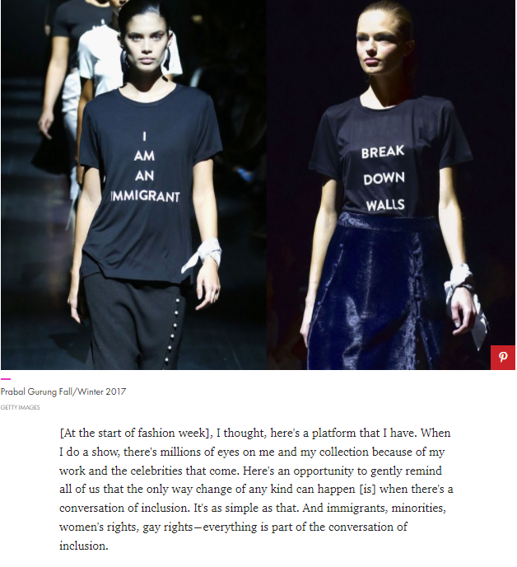

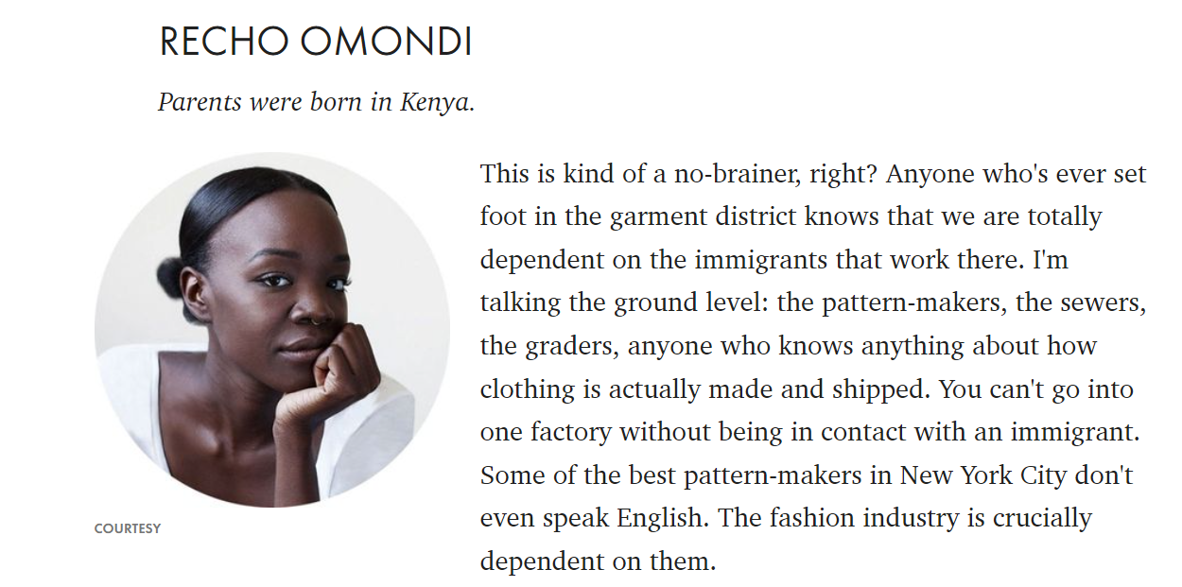

WEAVING THE THREADS – TEXTILES, CLIMATE and MIGRATION
The following activities explore the links between the textile industry, climate change, migration and displacement.

BACKGROUND INFORMATION:
Cotton production is a major source of pollution to soil, water, and air. In addition, it consumes massive quantities of water. One of the starkest examples comes from Uzbekistan, where cotton farming was a major drain on the Aral Sea, once one of the world’s largest lakes, reducing it to a fraction of its size.
- Emissions from textile production account for10% of humanity’s carbon emissions
- It is the second biggest consumer of water, stressing water sources, and a major contributor of pollution.
- 85% of all textiles are discarded each year, at the rate of a truck load every second.
More information here:
Is fashion bad for the environment? | World Economic Forum (weforum.org)
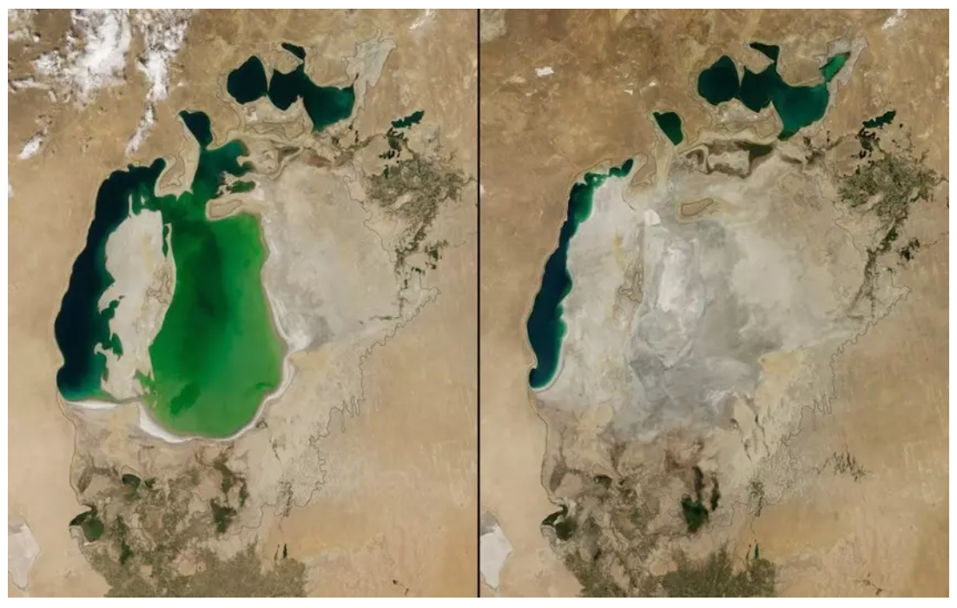
Satellite images from showing the desertification of the Aral Sea. Source: NASA /weforum.org

In 2021 the US government acknowledged that climate change was one of the forces pushing people to migrate from Central America to the United States, where many are then employed under poor conditions, in sweatshops, in agriculture and other sectors.
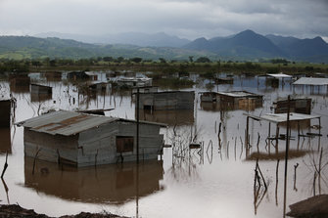
Damage caused by Hurricane Eta in Nicaragua in November 2020.
(Image credit: D. Membreño, European Union, CC BY-ND 2.0)

Climate-related displacement is a worldwide issue. In 2021 weather-related disasters around the world uprooted 30 million people, with catastrophic floods affecting communities in Canada, Germany, The Netherlands, Belgium, and wildfires displacing millions in Australia, Africa, and in South and North America, where more than a million were forced to move, according to the Internal Displacement Monitoring Centre. (Sanford Research, 2021).

MINDMAP ACTIVITY:
Establish a mind map template on the board with 3 elements - climate change, forced migration, and textiles production.
Distribute one of 3 articles/links relating to climate change, forced migration, and textiles production to small groups. Each group reads one of the articles and creates a summary to share, as well as noting or underlining references to climate change, migration or displacement, textiles production, or sweatshops.
The task is for students to look for links between these three issues - climate change, migration, and the textiles industry – and share these connections in their feedback to help build the visual mind map on the board. (Post-its may be a good way to do this, or digitally using a Google doc, Miro, or the teachers preferred collaborative whiteboard.)

Questions to explore:
- What connections can you see between the issues of climate change, migration, and textiles?
- How does the textile industry contribute to the problem of climate change?
- How does climate change force people to migrate to new areas?
- What other environmental and social problems does the textile industry create that might contribute to forced migration? (For example: the vast amounts of water required for crops such as cotton, contamination of rivers and streams from dye and other chemical treatments, and health impacts on workers and people living in affected areas).
- How might the experience of being displaced from home push people into to the textile industry?
- What makes undocumented migrants and refugees particularly vulnerable to jobs with poor working conditions and pay?
- How does the cycle continue? For example, how might the fashion industry’s drive to produce cheaper and cheaper consumer products lead to greater pressure on garment workers, or link to higher consumption of throw-away clothing and textiles, and to pollution or climate change issues?

As feedback is being given the teacher can facilitate the connections being made between the issues. While the link between textiles and climate may not be immediately obvious, or direct, they can be seen in:
- the employment of migrant labour at every stage of garment production and disposal
- the reliance on migrant labour to produce ultra-cheap clothing and textiles
- as the second most polluting industry in the world (second to oil) the textile industry is also one of the underlying causes and contributors to climate change

The articles relate to communities forced to relocate because of the impact of climate change. Examples include communities in Ghana’s northern region which is particularly sensitive to changes in the climate because of its hot, dry conditions. It only has one rainy season a year compared to two seasons in the midlands and south of the country.
Diminished rains are leading to poorer farming conditions. Traditionally seasonal migration from the North to the more fertile midlands helped communities to find work and food during the dry season, but now rain-fed agriculture is suffering there too.
More and more people are being pushed into the cities in the south, where they are vulnerable to exploitation in sweatshops. The southern coastline of Ghana is also under threat from rising sea levels caused by climate change.
While migration has long been one of the ways that communities deal with difficult farming conditions, climate change has exacerbated these problems to the extent that it can no longer be seen as a solution, even a temporary one. The Ghanian government, and civil society groups are exploring a range of climate change mitigation policies and actions.

It is widely acknowledged that those with least responsibility for the causes of climate change are amongst the most severely affected. It should also be noted that only one single country - Gambia - is on track to meet their commitments under the Paris Climate Agreements. The findings of the Climate Action Tracker report in September 2021 also noted that only one ‘developed’ country - the UK - had plans in place that would limit emissions sufficiently to help curb global heating to 1.5C above pre-industrial levels but had failed to put in place the policies needed to implement those plans.
‘Time is running out’: Researchers warn climate progress has stalled as only one country doing enough to meet 1.5C target | The Independent
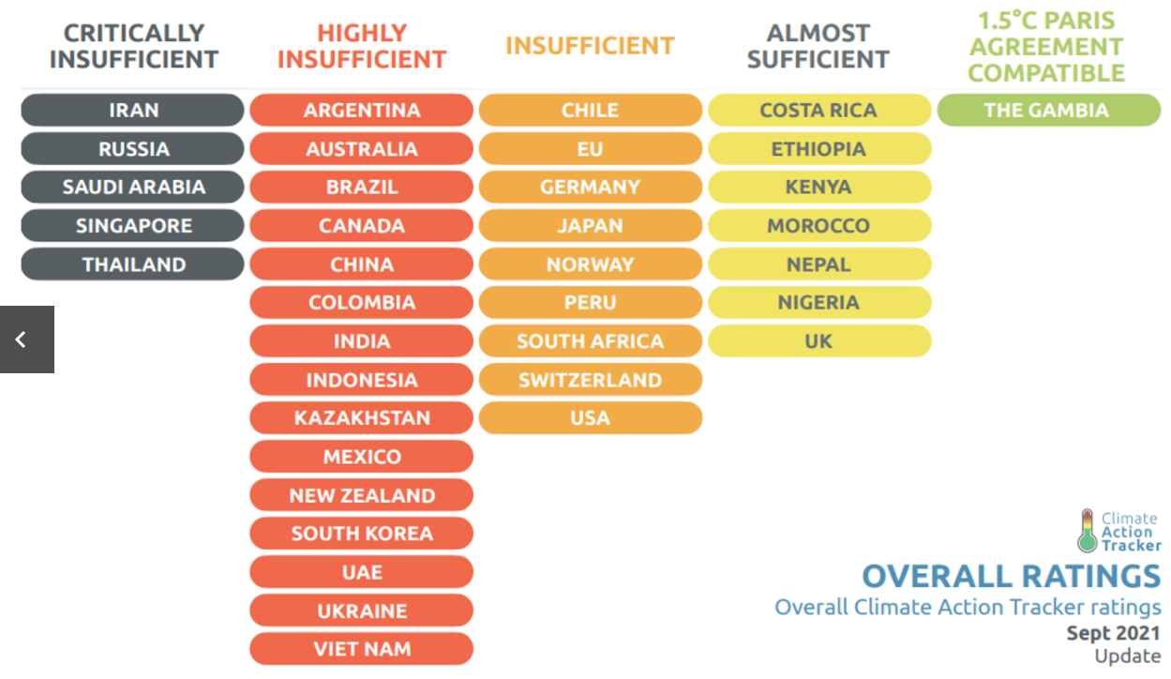

Article 1:
Climate crisis leaving ‘millions at risk of trafficking and slavery’ | Global development | The Guardian
The Guardian 20th September 2021

Article 2:
Are Your Favourite Fashion Brands Using Forced Labour?
www.aljazeera.com/economy/2021/7/14/are-your-favourite-fashion-brands-using-forced-labour
Are your favourite fashion brands using forced labour? | Fashion Industry News | Al Jazeera
www.aljazeera.com/economy/2021/7/14/are-your-favourite-fashion-brands-using-forced-labour

Article 3 + video Garment Worker Diary
Read the article and watch the interview with Shila, a garment worker in Dhaka. Like 90% of people working in the textile factories, Shila migrated to the city, when her home was damaged by rising sea levels. Shila’s 5-minute interview was carried out as part of her involvement with the Garment Workers Diary project with the
https://www.fashionrevolution.org/garment-workers-and-climate-change-the-socioeconomic-link/

MIND MAP FOLLOW-UP ACTIVITY: Another World Is Possible:
When the connections have been established, and issues identified consider ways that this picture could be changed or influenced for the better.
Look at each of the 3 headings Textile Industry / Refugees / Climate Change, and the connections the students made between them.
Ask the students to return to their small groups and think about how problems and issues could, potentially be turned around, using a 3-step questioning process.
Questions:
- What are the problems identified?
- What kind of changes or interventions could help to slow, stop, or reverse this cycle? What kind of alternatives could be put in place?
- What kind of actions would be needed to make this happen?
Illustrate these on your mind map, using symbols or images as well as words.

It can be helpful to model the approach by using an example:
1.What is the issue or problem being addressed changes are needed? Students can begin by thinking in broad terms, like ‘pollution’ caused by the textile industry.
2. If ‘pollution’ is the issue, the broad solution might be ‘sustainable, or non-toxic textile production’. They can follow this with a more specific example, like ‘replace toxic dyes with natural alternatives.
3. They can then consider what kind of actions could help to bring this about. In this case, they might come up with ideas for a ban on toxic dyes and other polluting chemicals currently used in the industry. Or incentives for organic, less polluting and polluting farming practices.

Take feedback from each group, including inclusion of the images and symbols, and inviting them to share examples from their analysis, and ideas for interventions or alternatives to create change.
Ideas for action: consider these change-making ideas, and discuss which, if any could have the most impact, and which, if any, could be supported by the class.

CRITICAL THINKING ABOUT FAST-FASHION
THE BIGGER PICTURE – INDIVIDUAL VS. SYSTEMIC CHANGE
The subject of ‘fast-fashion’ is a popular Global Education topic, with a lot of potential for making local and global connections. However, it is worth considering some of the underlying assumptions and narratives around fast-fashion and asking why they so often end up pointing the finger of blame for one of the world’s most toxic, exploitative industries at teenage girls. Certainly, there is a need to learn and take responsibility for our individual actions but making this is the central focus is problematic as reduces a systemic problem to one of personal responsibility and avoids looking at the bigger picture.
In the first instance, this shifts the focus and responsibility from a massively powerful and profitable industry and redirects it towards school children.
It also frames the students’ engagement with the issue to that of a consumer, rather than a citizen (for example) and therefore limits the possibilities for analysis and action.
Being a ‘better consumer’ will only ever have a limited effect, when the bulk of the pollution and waste occurs much earlier in the production cycle, and even at the garment-manufacturing stage, waste is endemic. Studies estimate that between 15% - 25% of material end up on the factory floor. Production of materials such as cotton, the processing and transport of raw materials and finished garments, and the end-use of discarded textiles are similarly out of an individual’s control.
So, when we approach this issue it’s important to ensure that we centre the systemic issues, and the structural forces at play. We must acknowledge that people are purchasing far more clothes than in previous times, but we should also make sure to ask ‘why?’ How and why has this come about? Beyond looking at individual shopping habits, we could also ask about:
- Massive up-scale in production to meet demand from Fashion companies to deliver constantly changing ranges, along with lowering standards and the production of disposable clothing.
- A media industry built on fostering consumerism (including the emergence of influencers, ‘unboxing’ genres, and huge advertising campaigns and sales models targeting the ‘youth market’.)
- Deeper questions about gender norms, conditioning, expectations for boys and girls are also relevant to this discussion. As has been pointed out, in most societies, girls are taught that the most important thing about them is how they look. Boys are also taught that the most important thing about girls is how they look. The problem is not how girls look, or girls looking at themselves, the question is why everyone is looking at girls? (Author unknown)
Around The World, Girls Are Taught The Same Limiting Lesson | HuffPost Life

- ‘Recycling’ is also frequently put forward as a response to the problem of excess clothing, with donations to charity shops sometimes promoted as a simple and virtuous solution. Global Education should bring a more critical focus to the issue and pay attention to the impacts felt in the Global South. Global Education should also feature the voices of people themselves and ensure that students learn about examples of Southern and community-led initiative to deal with these issues.

Any of the above topics could be the focus of a class discussion, or a student project and presentation. Materials and links for an exploration of charity shop waste is covered below, as well as a podcast which offers an opportunity to learn and critically reflect on some of the issues linking the textile industry, consumerism, and migration
ACTIVITY: PODCAST and REFLECTION
Listen to this 20-minute interview with Hoda Katebi, an Iranian-American designer and activist who campaigns against the harmful effects of fast fashion, but also acted to create an alternative, with the establishment of a small garment producer collective and worker-owned factory.
- Hoda’s collective is called Blue Tin. Where did it get its name?
- Create a mind map or other visual representation to explain Hoda’s $5 t-shirt story.
- What do you think she means by ‘the myth of capitalism’?
- “Fast-fashion is cheap. I don’t agree with it, but I can’t afford more expensive clothes” How does Hoda respond to the question of affordability of clothes? How would you answer this question yourself?

CLASS DISCUSSION or STUDENT PROJECT: TEXTILE DUMPING
Some say that ‘charity begins at home’ but where does it end up?
Here are some links to learn about and discuss the impact of textile dumping on communities in Ghana and Chile.
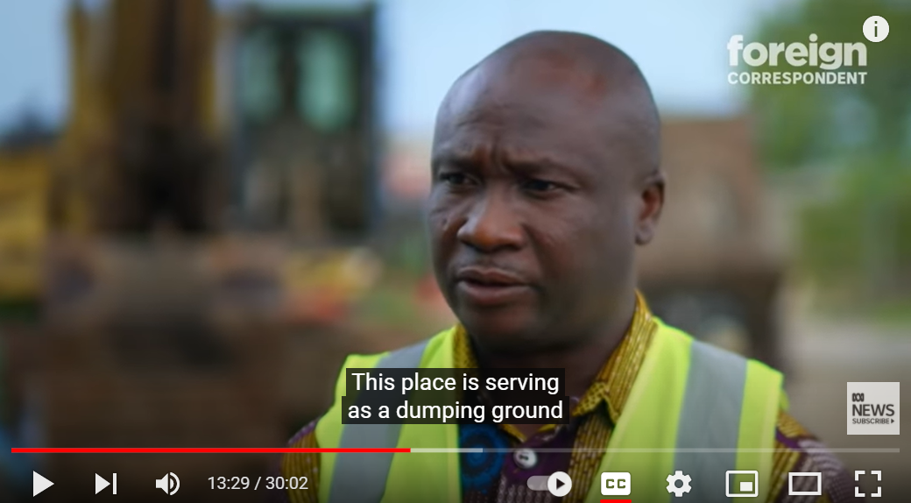
“This place is serving as a dumping ground for textile waste in the name of second-hand clothing.”

5-minute video: Fast fashion: The dumping ground for unwanted clothes - BBC News - YouTube

Chile’s desert dumping ground for fast fashion leftovers (November 2021)
Chile's desert dumping ground for fast fashion leftovers (france24.com)
Chile’s desert dumping ground for fast fashion leftovers | Gallery News | Al Jazeera

STUDENT AWARENESS-RAISING ACTION:
Consider creating a display or social media awareness campaign to highlight the fashion industry’s links to migration and climate change, and that also explores root causes and systemic issues, and critical thinking about flipping the narratives that drive consumerism.
Think about and discuss what kind of imagery would draw attention. Discarded garments (ones that are no longer fit for purpose) could be used to create patchwork and/or embroidery pieces. Or use discarded paper to create cut out garments or origami shirts. See The Fashion Museum, Bath (UK) for instructions: PowerPoint Presentation (fashionmuseum.co.uk)
Alternatively, old t-shirts (that are beyond use) could be repurposed to create a ‘washing line’ exhibition, with facts and information written, sewn, or stuck onto the garments and hung in the school, local library, or community building.
Alternatively try creating a stop-motion video to explain the issues. See this video on textile disposal in Ireland, The State of It (2020)
Textile disposal in Ireland on Vimeo

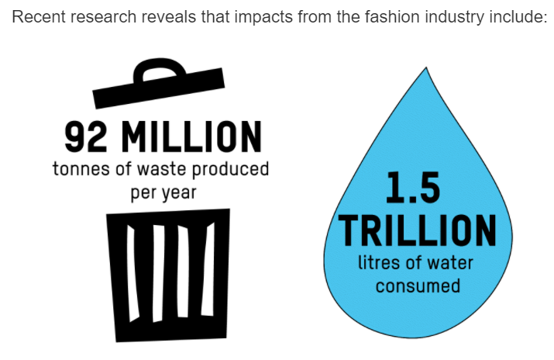
Image Oxfam.org

- Between 1996 and 2012, it’s been estimated that the amount of clothes bought per person in the EU increased by 40 percent
- 26kg of textiles each person in the EU buys a year, of which nearly 1/4 are discarded in mixed household waste.
- According to a 2019 UN report, global clothing production doubled between 2000 and 2014, and the industry is “responsible for 20 percent of total water waste on a global level”.
Find more statistics here: 60+ Shocking Fashion Industry Waste Statistics & Facts 2021 (woollygreen.com)

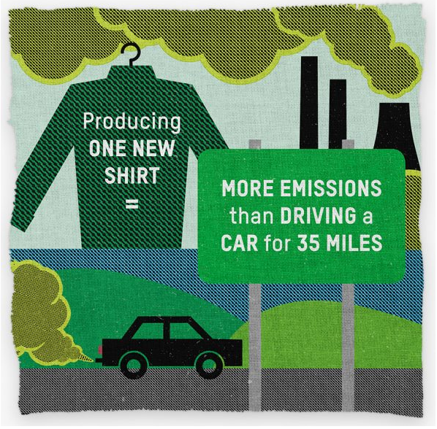
Image: Oxfam.org

STUDENT ACTION: SHARE THE LEARNING
Textile reuse is the largest re-use activity in Ireland. Charity shops are the main drivers of this re-use activity and have been operating in this space for over 30 years.
According to the Irish charity Shops Association 10 million garments were sold through ICSA members shops in 2019.

Using discarded textiles, create a display to create awareness of the positive ways that people can help to address textile waste through textile reuse. Textile reuse is when you buy an item of clothing from a charity shop, second hand/vintage shop, or swap clothes with your friends instead of buying a new item.
Share - Swop – Repair - Transform - Donate - Rethink [is there a need to buy a new item?]

TY SOCIAL ENTERPRISE ACTIVITY: DEVELOPMENT DEN
The challenge is to come up with useful and meaningful ways to reuse or transform waste textiles from local charity shops, which could form the basis of a TY Social Enterprise project.
A social enterprise should address a social or environmental problem (in this case, textile waste) and may also create additional benefits to the community such as:
- Building or teaching new skills.
- Raise awareness of the underlying problem, and thereby help to reduce textile waste in the future.
- Create volunteering options for community members.
- May generate income for local community projects, or for solidarity projects elsewhere.

Each group has a number of weeks to research the issue and generate ideas for an enterprise project, and then select their best one. Each group should then prepare a ‘pitch’ for the rest of the class.
Amongst other elements, the pitch should clearly identify:
- What problem is being addressed
- How the Social Enterprise project addresses the problem
- How it will help to raise awareness of the underlying issues
- Other benefits to the community.
- Explain how the project will be resourced and funded and suggest how the income generated will be used (will profits go back to the charity shops providing the waste textiles, for example, or will it create funding for a local recycling initiative, or a refugee solidarity project?)

Students will then select a project, or number of projects (depending on the approach taken by the teachers). They will need to develop their ideas further with more specific research and design. Including:
- Researching the needs of shoppers – what kind of size and strength is required.
- Should a variety of sizes be available? Liaising with local businesses and other potential outlets for their products.
- Developing designs, and then create and evaluate their prototypes
- Modifying their designs to incorporate any issues that emerge in the trials.
- Considering how the bags will be marketed – can recycled materials also be used for displays, labels, and awareness raising materials.

ADDITIONAL CROSS CURRICULAR CONNECTIONS: SCIENCE/ENGINEERING/CONSTRUCTION STUDIES
RECYCLED AND RECLAIMED MATERIALS CASE STUDY:
Professor Veena Sahajwalla is a founding director of the Centre for Sustainable Materials Research and Technology at the University of New South Wales, with many awards to her name for recycling innovations in the steel and e-waste industries. After years of experimenting, Professor Sahajwalla came up with a way to combine waste glass and textiles to produce tiles for construction and housing in Australia.
Veena grew up in Mumbai, India. "There is no such thing as waste; everything had a value, and everything had potential," she says. As a girl she could see widespread recycling in action, as she walked through her city:
"I'd see people working, repairing shoes, guys carting stuff around like television sets, all kinds of…things...Even today there is a big part of the economy that operates off repairing things. It was fascinating for me. It is really what inspired me to take on engineering as a field of study."
3 minute video: How Veena Sahajwalla's 'green ceramics' made from glass and clothes are revolutionising manufacturing - ABC News
30 minute profile: Recycling revolutionary Veena Sahajwalla turns old clothes into kitchen tiles | Australian Story - YouTube The use of textiles is covered from 16 minutes onwards.

The video is also suitable to prompt discussion about gender equality in STEAM subjects, and the importance of role models to tackle gender and race inequalities in science and engineering, in particular.
- Where did Veena find inspiration to study and practice engineering?
- What was the attitude towards waste in India that influenced Veena when she was growing up? How does it contrast to Western attitudes towards consumption and waste?
- Describe the innovation Veena has pioneered using discarded textiles.
- Migration benefit’s host countries in a number of ways. Do you see examples in this story? What about the costs to Veena’s home country? (For example, ‘brain drain’, and the costs associated with education that are then lost due to emigration.)

