Let’s Talk SDGs activities

Click on The Global Indicator Framework and open the document. Hit Ctrl and F to open the word search
box. Type the words and phrases associated with global injustice into the search box.
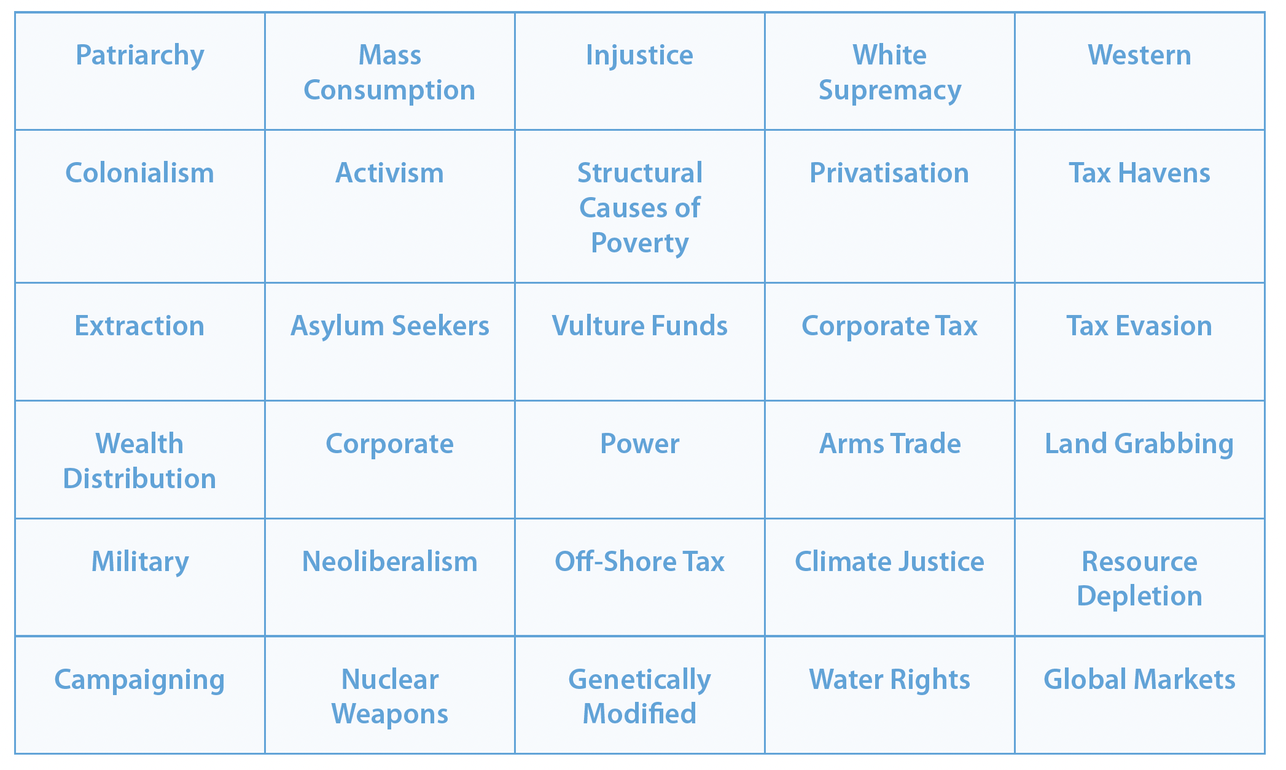

• Do your typed words or phrases appear in the Framework?
• If so, what goals, targets and indicators are they connected to?
• If not, why do you think this might be the case?

