IMAGE 1:
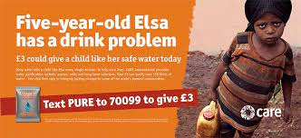

Stretch and Challenge - What messages or ideas have you heard about this issue before? (from media, from school, from friends, from family, your own experience, just ‘around’)
Which ideas seem mainstream? Which are different from mainstream?

Power - Who has the power/control/makes decisions on this issue?

Perspectives - Whose perspectives do we usually hear from on this issue? Who decides which opinions are heard or valued?

Background and root causes
What systems and structures allow this to continue to be an issue (local or international laws, policies, agreements, societal response?)

Response
-is there solutions that have stronger potential for positive change?
-what should our response be?

