ARTIVIST RESOURCE PACK

WEBSITES
Creative activism and the coronavirus
https://c4aa.org/2020/03/dont-cancel-creative-activism-and-coronavirus
Digital activism
https://en.reset.org/knowledge/digital-and-online-activism
https://wagingnonviolence.org/2019/03/how-technology-is-shaping-creative-activism-in-the-21st-century/
http://theconversation.com/going-viral-what-social-media-activists-need-to-know-96043
Waging Non Violence Activism website
https://wagingnonviolence.org/
Centre for Artistic Activism
https://c4aa.org
AdbustersThe original culture jammers
https://www.adbusters.org
Open Culture Database of online courses and educational media:
http://www.openculture.com
Actipedia Online bank of actions
https://actipedia.org/
Google Street Art Amazing database of street art around the world and the stories behind it, with virtual tours and audio commentary:
https://streetart.withgoogle.com/en/
Cultre Strike US Arts for change organisation
https://www.culturestrike.org/
Crimethinc Rebel alliance
https://crimethinc.com/
Artworks for Change Creating contemporary art exhibitions around the world to address critical social and environmental issues
https://www.artworksforchange.org/
Commons Library
https://commonslibrary.org/

ACTIONS

Hostile Terrain 94 Participatory art/research project highlighting deaths on the US/Mexico border, currently exhibited at the Glucksman gallery, UCC and other locations around the world:
https://www.undocumentedmigrationproject.org/hostileterrain94
Creative actions in Hong Kong protests
https://www.ft.com/content/526e2d46-ee97-11e9-bfa4-b25f11f42901
Creative actions in Chile protests
https://wagingnonviolence.org/2020/01/how-new-creative-actions-are-fueling-chile-uprising/
Previous actions by C&C participants
https://www.creativityandchange.ie/online-actions/
https://www.creativityandchange.ie/climate-street-action/
https://www.creativityandchange.ie/street-action-think-about-tea/
https://www.creativityandchange.ie/in-her-shoes/
https://www.creativityandchange.ie/street-art-for-climate-action/

Historical Protest Art
https://magenta.as/historys-most-powerful-protest-art-29150c02931
1970’s feminist posters
https://www.wmagazine.com/gallery/70s-feminist-posters-international-womens-day-protest-signs-inspiration/
Liberate Tate Activists who campaigned for years to stop the Tate gallery's sponsorship by the BP oil company:
https://www.theguardian.com/environment/gallery/2016/mar/19/liberate-tates-six-year-campaign-to-end-bps-art-gallery-sponsorship-in-pictures

VIDEOS
The Yes Men
https://theyesmen.org/movies
Films for Action
https://www.filmsforaction.org/
TED Talks
https://www.ted.com/playlists/476/powerful_art_activism
Naomi Klein Curated playlist of NFB films that look at the impact of corporate decisions on the environment:
https://www.nfb.ca/playlist/naomi-kleins-playlist/
on How to Beat Coronavirus Capitalism:
https://theintercept.com/2020/03/16/coronavirus-capitalism/
Offset Festival Five inspirational talks on public art:
https://www.iloveoffset.com/news/5-talks-to-inspire-art-in-public-spaces/
Activism in Music Videos
https://i-d.vice.com/en_uk/article/59byak/the-i-d-guide-to-activism-in-music-videos

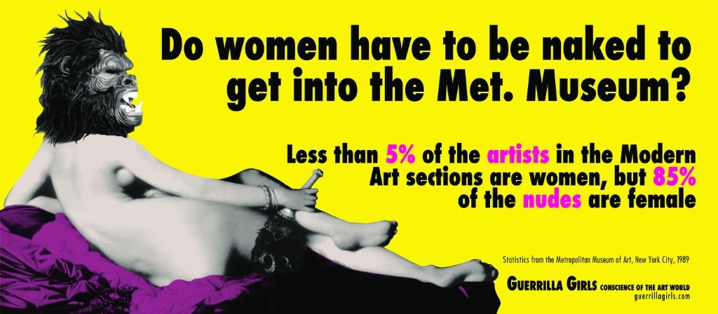
Guerilla Girls

ARTISTS

Climate Youth Artivists Young creative activists facilitated by C&C
https://www.hotpress.com/culture/black-lives-matter-a-war-of-words-breaks-out-in-cork-22820947
https://cetsl-my.sharepoint.com/:p:/g/personal/mhenchi18_cetsl_ie/ES-5Hb7DHIdLuMIZAPjAkXkBI3vDOasFnFZBC6T3yOTyMA?rtime=ZAkTJiQo2Eg&PreviousSessionID=3e3ac4c7-65f9-4c03-a482-6a43d3090a2e
Eve Olney and Kate O' Shea Irish artivists running a number of current socially engaged projects:
https://www.spareroomproject.ie/people
Joe Caslin Irish street artist and art teacher using street art to support social change:
https://www.rte.ie/brainstorm/2018/0424/956787-the-street-theatre-of-joe-caslins-art/
https://www.youtube.com/watch?v=bh7BvJtDTfw
Rob Hopkins UK climate activist and author who promotes the use of imagination in creating a different world:
https://www.robhopkins.net
JR French photographer using art to empower communities:
Can art change the world? (Essential viewing!):
https://www.ted.com/talks/jr_my_wish_use_art_to_turn_the_world_inside_out?language=en
https://www.jr-art.net/
http://www.canartchangetheworld.net
Emory Douglas Black Panther’s Minister for Culture:
https://www.culturetype.com/2019/04/23/emory-douglas-i-was-the-revolutionary-artist-of-the-black-panther-party/
Clowns Without Borders Irish circus performers entertaining children in war torn countries:
http://cwbireland.com/
Citadel Cork-based band featuring musicians living in direct provision:
https://twitter.com/citadeleire?lang=en
Tania Brugruera Cuban artist who has created socially engaged projects around the world:
https://www.theguardian.com/artanddesign/2018/sep/26/tania-bruguera-interview-cuba-tate-modern-turbine-hall
Swoon American street artist using art to empower communities:
https://www.nytimes.com/2014/08/10/arts/design/swoon-blurs-the-line-between-art-and-activism.html
Ai Wei Wei Chinese artist who uses art to speak out against oppression by the Chinese government:
https://www.theartstory.org/artist/ai-weiwei/
https://theplaidzebra.com/that-time-ai-weiwei-flipped-off-the-worlds-most-important-monuments-to-prove-a-point-photos/
Shepard Fairey American street artist and printmaker who uses subvertising and strong graphics to promote justice:
https://thecreativeindependent.com/people/shepard-fairey-on-political-art/
https://www.youtube.com/watch?v=rcSBr4ZKmrQ
His 'We the People' campaign for the women's march at the Trump inauguration:
https://amplifier.org/campaigns/we-the-people/
https://theconversation.com/shepard-faireys-inauguration-posters-may-define-political-art-in-trump-era-71583
Guerilla Girls Anonymous art collective using culture jamming to promote gender equality in the art world:
https://www.theartstory.org/artist/guerrilla-girls/artworks/
https://www.guerrillagirls.com
Brandalsim Culture jammers
http://brandalism.ch/
Darren Cullen UK subvertiser
https://www.spellingmistakescostlives.com/
Chris Jordan Data visualisation as art
http://www.chrisjordan.com/gallery/rtn2/#carbon
Vik Muniz Brazilian photographer who created the documentary Wasteland, in which he created art with workers in Brazil's largest dump:
https://time.com/3775724/portraits-with-purpose-vik-muniz-in-waste-land/
Alfredo Jaar Chilean/American artist who uses installations to critique war and injustice:
https://www.theguardian.com/artanddesign/2019/aug/01/alfredo-jaar-artist-interview-change-the-world-pinochet-chile-edinburgh
Naomi Klein Journalist, author, filmmaker concerned with addressing capitalism and globalisation:
https://naomiklein.org/about-naomi/
Gregory Sholette Author, artist, activist. His website contains essays, resources and links to other great sites:
http://www.gregorysholette.com/
Joey Skaggs Original Culture Jammer:
https://joeyskaggs.com/
The Yes Men Brazen activists using culture jamming as a tool for raising awareness:
https://theyesmen.org/
Pussy Riot Feminist punk rock collective:
https://www.nme.com/blogs/nme-blogs/who-are-pussy-riot-russia-activist-group-world-cup-final-pitch-invasion-2354987

TOOLKITS
Creativity & Change Resources A collection of resources developed by Creativity & Change
https://www.creativityandchange.ie/toolkit/
Beautiful Trouble
https://www.creativityandchange.ie/wp-content/uploads/2017/06/beautiful-trouble.pdf
Beautiful Rising
https://beautifulrising.org/
Interventionists
http://www.gregorysholette.com/wp-content/uploads/2011/04/Interventionists_03_14_041.pdf
Youth Activist Toolkit
https://advocatesforyouth.org/wp-content/uploads/2019/04/Youth-Activist-Toolkit.pdf
Create with Artists
https://issuu.com/bis_publishers/docs/create_with_artists_e0e60056bc9ced
Activist toolkit https://howto.informationactivism.org/

Culture Declares Emergency A toolkit of resources for Arts & Culture climate crisis advocates:
https://www.culturedeclares.org/
Amplifier Digital poster database:
https://amplifier.org/
Bank of Actions for Global Citizens Action design kit
https://issuu.com/creativitychange/docs/bank_of_actions
Art, Activism & Beyond Inspiring Initiatives of Civic Power
https://thespindle.org/wp-content/uploads/2017/06/Activism-Artivism-and-Beyond-PDF-2017.pdf
The Commons Social Change Library
https://commonslibrary.org/creative-activism-start-here/
Subvertising Manual Bus stop jamming by Brandalism
http://brandalism.ch/wp-content/uploads/2016/12/Brandalism_Subvertising_Manual_web.pdf
Design in activism
https://eyeondesign.aiga.org/designs-role-in-activism-can-go-deeper-than-posters-and-t-shirts/

METHODS
Photography
https://witness.worldpressphoto.org/is-there-such-a-thing-as-an-activist-photographer-18f3798f4ad6
Culture Jamming
http://brandalism.ch/
https://en.wikipedia.org/wiki/List_of_culture_jamming_organizations_and_people
https://www.graffitistreet.com/bill-posters-takes-aim-at-blackfriday-with-subvertising-installations-across-the-uk-2018/
https://depts.washington.edu/ccce/polcommcampaigns/CultureJamming.htm
https://www.thoughtco.com/culture-jamming-3026194
Street art as activism
https://www.globalcitizen.org/en/content/street-art-and-graffiti-unlikely-methods-to-spread/
https://theconversation.com/street-artists-are-joining-the-fight-to-save-the-environment-110400
Land art
https://www.boredpanda.com/land-art-andy-goldsworthy/?utm_source=google&utm_medium=organic&utm_campaign=organic

Protest signs
https://www.rollingstone.com/culture/culture-features/george-floyd-protest-signs-photos-1012

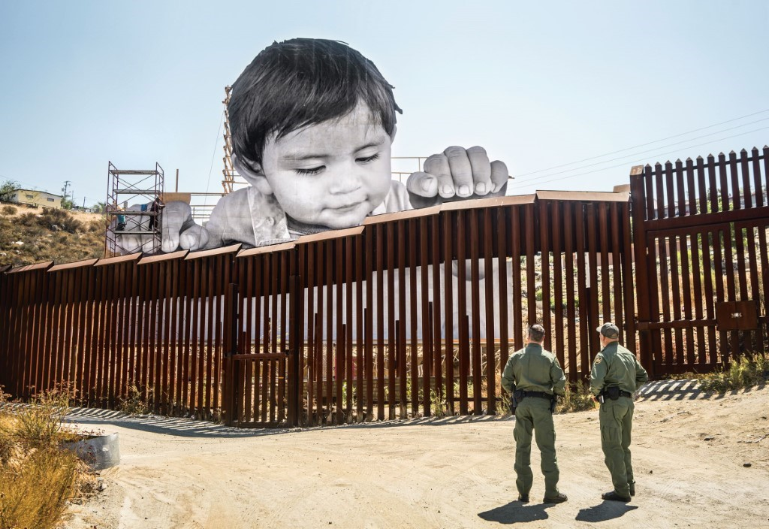
JR
TOOLS
Fonts
www.dafont.com
Photo Editing
www.fotor.com
Photo Enlarging
https://rasterbator.net/
Zines
https://www.youtube.com/watch?v=9INUang4oMA
http://zineopolis.blogspot.com/p/h.html
Digital zine example: https://issuu.com/creativitychange/docs/cloughjordan_-_c_czine_-_06.2019_-_
Paste-ups
https://crimethinc.com/2017/07/18/a-field-guide-to-wheatpasting-everything-you-need-to-know-to-blanket-the-world-in-posters
Common Cause Handbook
https://valuesandframes.org
UNCRC
https://www.oco.ie/childrens-rights/education-materials/
Word Art
https://wordart.com/create
Colour Palette
http://colormind.io/image/#
ISSUU Digital magazines
https://issuu.com/
Shepard Fairey-style posters
http://obamapostermaker.com/

PODCASTS

Hozier Cry Power Musician Hozier interviews artists and activists on creating global change:
https://www.globalcitizen.org/en/connect/crypower/
Have You Heard George's Podcast? Social issues affecting young people in England addressed by George the Poet through spoken word and music:
https://www.georgethepoet.com/podcast-library
Rob Hopkins Podcast about creativity, the environment and positive change in communities:
https://player.fm/series/rob-hopkins
Rebel Matters Cork based activism-themed podcast:
https://rebel.libsyn.com
United Ireland Issues you care about in Ireland, and around the world:
http://www.unitedirelandpodcast.com/

MOVIES
Cultures of Resistance Films
https://culturesofresistancefilms.com/
Films for Action
https://www.filmsforaction.org/
Ai Wei Wei, Never Sorry
http://www.aiweiweineversorry.com/
The Art of The Prank Documentary about original culture jammer, Joey Skaggs:
https://www.youtube.com/watch?v=RIygY-BHXyM
Wasteland Vik Muniz and workers from Brazil’s largest dump create participatory art:
http://www.wastelandmovie.com/
For Sama Multi-award winning documentary created by activists in Syria:
https://www.channel4.com/programmes/for-sama
Camera Person Powerful collage-style documentary telling stories from around the world:
https://www.vox.com/culture/2017/2/7/14525500/cameraperson-kirsten-johnson-augustine-confession
Subvertisrs for London
https://vimeo.com/329129255
John Jordan on Creative Activism
https://www.youtube.com/watch?v=WPQ2MyLwiJI

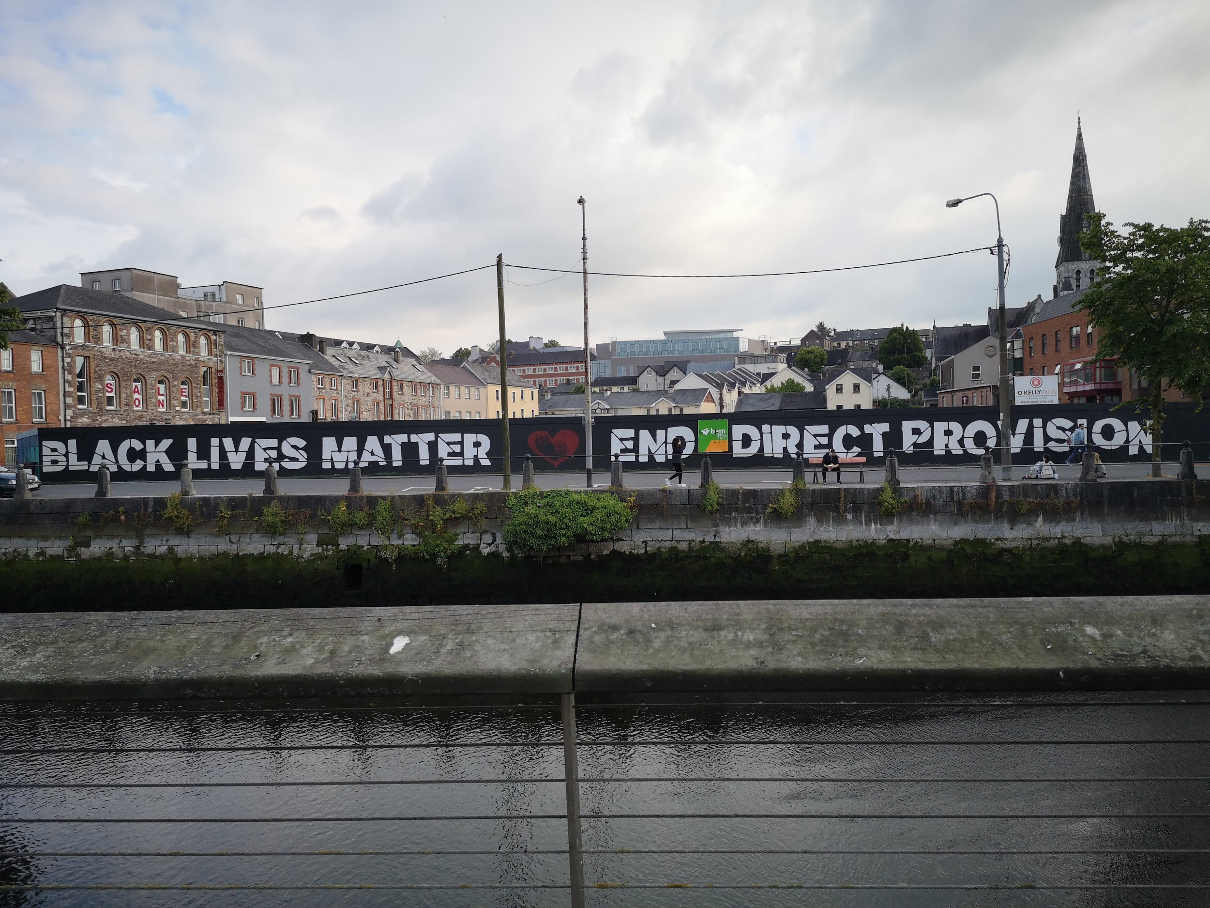
Climate Youth Artivists’ mural in Cork City

