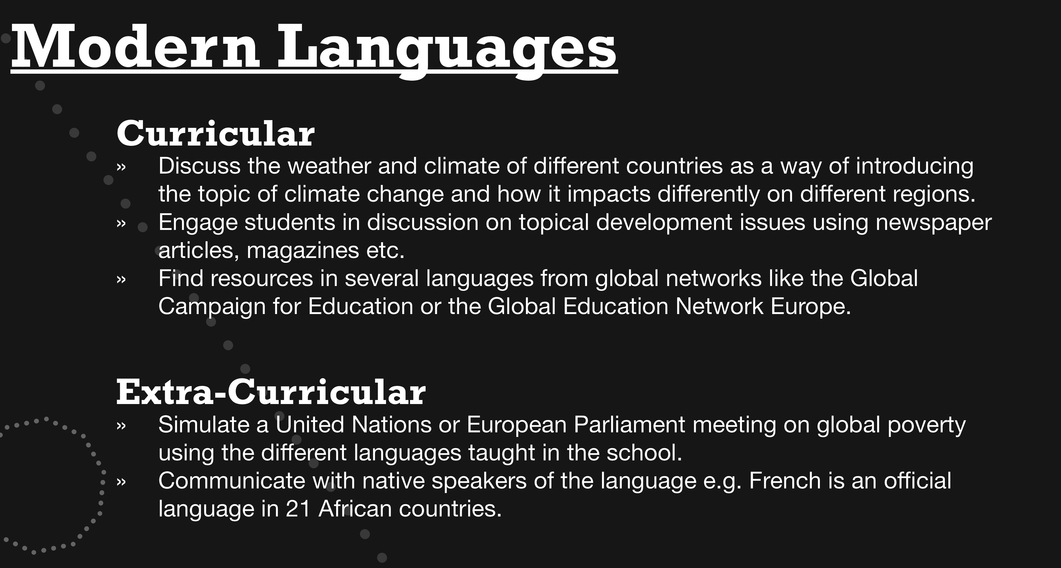

Websites that give you language options:

www.campaignforeducation.org

http://www.globalgoals.org

