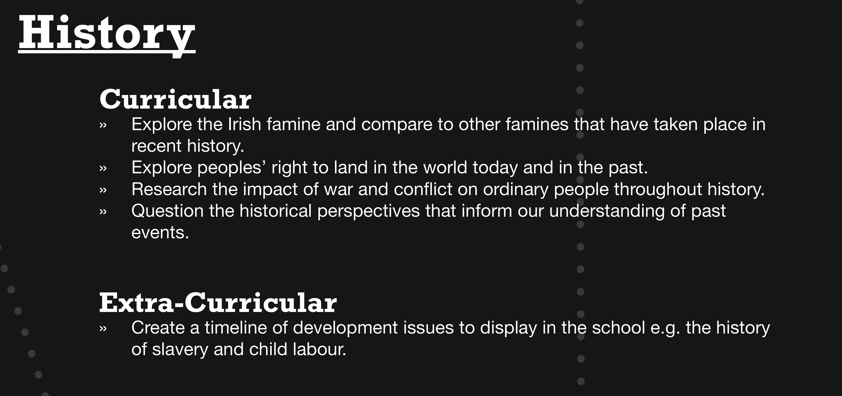

History and DE
'time and change may be described as the essence of history. While other disciplines investigate aspects of human life, human institutions and cultural traditions, only history is primarily engaged with measuring and explaining the manner in which all of these have undergone the experience of change.'
Understanding how change comes about is integral to the study of History and is also a central theme of development education.
- In many cases the topic being studied may not be directly related to development education but the skills acquired in History are transferable when dealing with issues in development education. (For example, skills of critical thinking, ability to distinguish between fact and opinion, ability to recognise bias and identify propaganda, ability to look at issues from more than one point of view, etc.) Under Later Modern Europe and the Wider World, two topics are particularly relevant to development education; Topic 5 - European retreat from Empire and the aftermath, 1945- 1990 and Topic 6 - The United States and the World, 1945-1989. Both offer many opportunities to examine issues from a justice perspective and to understand historical factors that have influenced current development issues. However, it remains to be seen if these topics will be chosen by many students or whether they will continue to study the topics that are more similar to sections of the old history syllabus. The availability of teaching resources is an influence here.
Each student must submit a research study as part of the final examination. This may be on any subject of historical significance. This allows the student to choose any issue or subject of interest to him/her. This presents a great opportunity to study issues directly relevant to development education. For example, a student could choose to research the history of the debt crisis in Africa, the history of the World Bank or the history of a specific developing country, etc.

