[cover – page 1]

[insert WorldWise logo]

[insert image]

Doing Development Education in junior cycle GEOGRAPHY

Climate change
Climate justice
Development assistance
Economic development
Energy resources
Fracking
Gender
Heatwaves
Human Development
Migration
Mudflows
Natural resources
Sustainability

www.worldwiseschools.ie

[inside cover – page 2]

CHANGING ATTITUDES
DEVELOPING SKILLS
GROWING KNOWLEDGE

What is Development Education?
Development Education (DE) is an educational process aimed at increasing awareness and understanding of the rapidly changing, interdependent and unequal world in which we live. DE seeks to engage people in analysis, reflection and action for local and global citizenship and participation. DE is about supporting people in understanding and acting to transform the social, cultural, political and economic structures which affect their lives at personal, community, national and international levels.

Key components of Development Education:
• Methodologies which are learner-centered and participatory
• Knowledge about how the world works
• Skills of critical thinking, reflection, problem solving, analysis, teamwork
• Values and attitudes of solidarity, respect and empowerment
• Action to effect change for a more just and equal world

[INSERT QUOTE FROM JC GEOGRAPHY TEACHER]
CHANGING
ATTITUDES
DEVELOPING SKILLS
GROWING
KNOWLEDGE

[page 3]
The aim of this resource
This resource aims to support teachers of Geography to teach through a global justice lens, a lens with great educational benefits, which meets the requirements as laid out in the junior cycle Geography specification, and in the (2015) Framework for Junior Cycle. It is one of a series of WorldWise Global Schools resources that support teachers in different subject areas to address Development Education-related themes and concepts. The Doing DE resource series enables teachers to challenge their students to look at our world, and our place in making it more just, equitable and sustainable.

Development Education (DE) and junior cycle Geography
The rationale for junior cycle Geography states that the ‘scientific study of the Earth’s landscapes, peoples, places, and environments’ ‘promotes a deep understanding of people and place’ and develops skills that help students to ‘read their environment’, ‘observe climatic events with an informed eye’ and ‘discuss world events in a knowledgeable manner’. Studying Geography encourages students to ‘appreciate the processes that shape their world and view global issues as ethical citizens’ so that they can ‘make valuable contributions to the economic, social, and cultural life of their communities, localities and countries’ on issues such as sustainable development and climate change. Students who study Geography are ‘well placed to be part of a generation which can deal effectively with and mitigate global challenges, and can rise to related opportunities’ (NCCA, 2017: 4).

Both Development Education and junior cycle Geography share the central aim of developing ‘knowledge, skills, values and behaviours that allow students to explore the physical world, human activities, how we interact with our world and to recognise the interconnections between systems’ (NCCA, 2017: 5).

Doing DE in junior cycle Geography does not mean doing something extra.

Statements of Learning
DE contributes to the achievement of all seven Statements of Learning mentioned in the junior cycle Geography specification, but is most explicitly evident in:

Statement of Learning 6:
The student appreciates and respects how diverse values, beliefs and traditions have contributed to the communities and culture in which she/he lives.
Statement of Learning 7:
The student values what it means to be an active citizen, with rights and responsibilities to local and wider contexts.
Statement of Learning 8:
The student values local, national and international heritage, understands the importance of the relationship between past and current events and the forces that drive change.
Statement of Learning 9:
The student understands the origins and impact of social, economic and environmental aspects of the world around him/her.
Statement of Learning 10:
The student has the awareness, knowledge, skills, values and motivation to live sustainably.

Key Skills
The 8 Key Skills outlined in the Framework for junior cycle (2015) have much in common with those engendered when a DE approach is employed. DE therefore contributes to the key skill elements articulated in the junior cycle Geography specification.

[page 4]

[INSERT NCCA KEY SKILLS IMAGE – as per page 4 MFL guidance note
Caption should read: Figure 1: Eight junior cycle key skills with associated key skill elements]
[page 5]
Structure of junior cycle Geography
Junior cycle Geography is organized into three interconnected strands:
- Strand One: Exploring the physical world
- Strand Two: Exploring how we interact with the physical world
- Strand Three: Exploring people, place and change
The three strands share three cross-cutting strand elements, which inform how students experience the learning outcomes:
- Processes, patterns, systems and scale
- Geographical skills
- Sustainability

The three strands and three cross-cutting strand elements are informed by the concept of Geoliteracy. This refers to students’ ability to develop far-reaching decisions through geographical thinking and reasoning. The core components of Geoliteracy are: interactions, interconnections and implications. Interactions refers to how systems, both human and natural, interact. Interconnections refers to the tangible and non-tangible linkage between people, places, environments, and spatial patterns. Implications refers to the individual’s ability to reason the consequences of their decision making and that of others. The aims of Geoliteracy - to develop cognitive, interpersonal, and intrapersonal competencies through the curriculum that are sustainable throughout students’ lives - are complimentary to the key components of DE, outlined on page X.

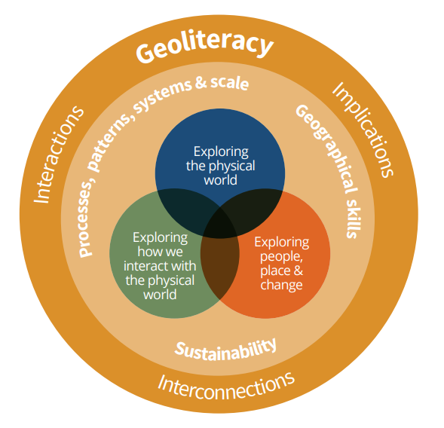
Caption should read: Figure 2: Geography strands and strand elements]

[page 6]
Learning outcomes and assessment
DE themes are integral to learning outcomes from across the three strands of the junior cycle Geography specification. This resource supports teachers to take advantage of the opportunities to create rich and layered learning experiences and outcomes for students, supporting ongoing and summative assessment tasks, with opportunities for self- and peer-assessment, as well as opportunities for teachers to give feedback to individual learners.

To show how DE is embedded across junior cycle Geography, and in keeping with the non-linear, integrated approach across strands outlined in the specification, this resource exemplifies a cross-section of nine learning outcomes from across the three strands and the three cross-cutting strand elements. In line with the encouragement outlined in the specification to combine learning outcomes across strands, additional learning outcomes are identified in all the activities suggested in this resource.
Processes, patterns, systems and scale

Geographical skills

Sustainability

 | Strand One  Exploring the physical world | Strand Two  Exploring how we interact with the physical world | Strand Three  Exploring people, place and change
 | LO 1.3  LO 1.7  LO 1.9 | LO 2.2  LO 2.4  LO 2.6 | LO 3.2  LO 3.7  LO 3.8

Caption should read: Figure 3: Learning outcomes supported in this resource]
Doing DE in junior cycle Geography lends itself to the completion of Classroom-Based Assessments (CBAs). For example, for completion of an individual, pair or group Geography in the news classroom-based assessment (CBA1) in second year, you could support your students to engage with key geographical questions, including analysis of geographical significance and sustainability, and demonstrate their awareness of the processes, patterns and systems by:
- Apply key geographical questions (who, what, when, where, how, why) to reporting of natural disasters and climate change events in the Global South
- Compare the level and quality of coverage of geographically significant issues or events by the media in the Global South and Global North
- Analyse media coverage about energy production and consumption, natural resource use and/or climate change
- Revise media content to reflect a sustainability perspective (i.e. making links and connections between social, economic and environmental causes and implications)
- Generate their own media content, based on research, about Ireland’s progress in relation to the Global Goals for Sustainable Development

A deliberate DE focus in junior cycle Geography can help students to achieve in their individual My geography classroom-based assessment (CBA2) in third year. A DE focus is an especially useful way for you to facilitate your students as they identify how their chosen local geographical aspect(s) relates to their own lives and environment, both in the present and for the future.

[page 8]

Resource structure
In the following pages, the learning outcomes identified in Figure 3 (page X) are presented with relevant background information, and ideas for activities in the classroom and beyond.

Entry point learning outcome | Page no
LO 1.3 | X
LO 1.7 | X
LO 1.9 | X
LO 2.2 | X
LO 2.4 | X
LO 2.6 | X
LO 3.2 | X
LO 3.7 | X
LO 3.8 | X

There is a Thinking about the Global Goals heading in each section, referencing one or more of the United Nations (UN) Global Goals for Sustainable Development. These are a universal set of goals, targets and indicators that UN member states, including Ireland, will be expected to use to frame their agendas and policies until 2030. The Global Goals follow, and expand on, the Millennium Development Goals (MDGs), which concluded at the end of 2015. As Geography teachers, you will find the Global Goals very useful in terms of ensuring that your students experience teaching and learning which ‘encourages participation, generates engagement and enthusiasm, and connects with life outside the school’ (DES, 2015. Framework for junior cycle, page 11).

[NEW SECTION/NEW PAGE]
STRAND ONE: EXPLORING THE PHYSICAL WORLD

Entry point learning outcome = LO 1.3
Students should be able to: ‘analyse the processes and effects of weathering and mass movement on our landscape’

FOCUS: Mudflows
Mudflows or mudslides are a common type of landslide that usually happens after very heavy rainfall when soil gets saturated and mixes with water to form mud, then moves down slopes very quickly. Mudflows are the fastest type of mass movement (movement of loose material downslope under the influence of gravity). When recorded, mudslides can look like flash floods, appearing almost instantly. Unlike flood waters, however, mud can be more densely packed with debris and more difficult to swim through.
Sierra Leone, a small country in West Africa, and one of Irish Aid’s (Department of Foreign Affairs and Trade) key partner countries, experiences intense rainfall every year. On 14 August 2017, after days of heavy rainfall, the side of the Sugar Loaf Mountain in Freetown, the capital city of Sierra Leone, collapsed. The resultant mudflow decimated a 5km stretch in the Regent area of the city, killed 1,141 people and destroyed 300 homes. For a country so historically accustomed to periods of heavy rainfall, the level of destruction prompted questions about what could have triggered the slide and what factors made it worse.
Freetown is one of the world's largest natural harbours with one million people living in and around the city. The population increased dramatically as people moved from rural areas in search of employment at the end of the civil war, which lasted from 1991 to 2002. This rapid population growth has put pressure on basic needs for housing, electricity, sewage and water.
Homes were built in areas identified as at risk, with many slums and informal settlements appearing on the hill slopes behind the city. Despite the creation of an EU-funded Freetown Development Plan in 2014, city planning has been given little priority. The laws to prevent illegal construction are often flouted or permits obtained through bribery. Builders cut down the protected forest areas on the hills, causing soil erosion - a phenomenon that contributed to the August landslide.
According to Global Forest Watch, Sierra Leone lost nearly 800,000 hectares of forest cover in decade before the Freetown mudslide, with loss accelerating in 2015. Sugar Loaf Mountain sits at the edge of the Western Area Forest, a protected swath of land that runs along the spine of the Freetown peninsula and provides a home for a wide array of plant and animal species, some of them endangered. The park has existed for over a hundred years, yet many of its hillsides, once thickly forested, have been stripped bare. Loss of forest cover affects the capacity of the hills to absorb rainwater and control its flow, leading to water shortages at various points in the year. During heavy rains, water runoff and siltation of the city's drainage system, coupled with poor waste management, led to flooding in urban slums.
The Sierra Leonean government was and continues to be under-resourced and unable to carry out basic disaster risk management. Deforestation presents a significant threat to regions prone to mudslides. Tree roots are often effective in anchoring soil in place, and as roots are removed, it's more likely rain will trigger deadly slides. The Environmental Protection Agency were aware of the threat to the Sugar Loaf Mountain and tried to plant trees on the slopes just two weeks prior to the mudslide. In July/August 2017, Freetown saw more rainfall than usual for that time of year, meaning the ground was oversaturated and more susceptible to movement. Many believe that the changing pattern of rainfall is caused by climate change.
In the immediate aftermath of the disaster, survivors of the mudslide, approximately 3,000 people, were moved into temporary camps. Local and international non-governmental agencies and United Nations agencies, such as UN Women, the World Food Programme (WFP), UN Population Fund (UNFPA) and UNICEF, worked to support the people affected. UN Women, an organization dedicated to gender equality and the empowerment of women, distributed dignity kits, containing basic health and hygiene products, such as soap, underwear and sanitary napkins. They set up empowerment hubs in the camps, one-stop centres to meet, seek psychosocial support and access information and critical services, such as cash-for-work programmes.
The Sierra Leonean government promised cash payments and free permanent resettlement of survivors. However, some survivors couldn’t prove that they had lived on the slopes and so were unable to access the money and the planned resettlement area, Mile Six, is far from the city, has no transport links, no running water and no electricity. In addition, the Sierra Leonian government has backtracked on it’s promise of free houses and potential residents are now expected to afford a mortgage.

Thinking about the Global Goals
By 2030…
- End poverty in all its forms everywhere (Goal 1)
- Ensure availability and sustainable management of water and sanitation for all (Goal 6)
- Reduce inequality within and among countries (Goal 10)
- Make cities and human settlements inclusive, safe, resilient and sustainable (Goal 11)
- Ensure sustainable consumption and production patterns (Goal 12)
- Take urgent action to combat climate change and its impacts (Goal 13)
- Protect, restore and promote sustainable use of terrestrial ecosystems, sustainably manage forests, combat desertification, and halt and reverse land degradation and halt biodiversity loss (Goal 14)
- Promote peaceful and inclusive societies for sustainable development, provide access to justice for all and build effective, accountable and inclusive institutions at all levels (Goal 16)

Teaching and learning activities
DIY
Watch the ‘Understanding disasters: Do it yourself experiments’ film (see Links below). Work in groups to recreate and video this experiment.

Anatomy of a mudflow
Copy the sequence chart below into your copy.
Watch the film ‘The mountain will fall’ (see Links below).
As you watch, take notes, then work together in small groups to identify the causes of the Sierra Leonian mudflow using the sequence chart below.

Bibliography
Create a bibliography including three or more online news articles from reputable sources on the mudflow in Freetown, Sierra Leone on 14 August 2017. At least one of these articles should contain information about status of survivors after the closure of the temporary camps in November/December 2017.
Amalgamate your bibliographies into a class bibliography and give this to your teacher as a teaching/learning resource for this topic.

Reforesting Regent
On 5 June 2018, World Environment Day and in Sierra Leone, National Tree Planting Day, the United Nations, with environmental actors and government, held a symbolic tree planting ceremony on the site of the Regent mudslide in Freetown Sierra Leone.
Create a poster with images and text to raise awareness about the importance of trees in the prevention of mudflows.

Linking to the SDGs
Produce a newspaper article linking the 2017 Sierra Leone mudflow response by United Nations organizations to the 17 Global Goals for Sustainable Development (see Links below). Your article should include: a headline, four or more images (including at least one Global Goals logo and one image from Sierra Leone), and three or more paragraphs of text. Remember to respect copyright by acknowledging the sources of images in your completed work.
Share your first draft with a classmate and take their (constructive) feedback on board as you produce your finished work.

Press release
Imagine that you are a public servant working in the Department of Communications, Climate Action and Environment. You have been asked to write a short press release on behalf of the Department in the aftermath of a mudflow event.
Your press release must be based on research focusing on one of the following mudflows: Urris, Co Donegal – 2017; Doon, Co Limerick – 2014; Lyreacrompane, Co Kerry – 2008; north-west Mayo – 2003. Your finished press release should contain three or more paragraphs with detail about the causes and effects of the mudflow and the support that the Department will provide for people affected by the disaster.
Vote on the best 3 press releases produced in class and send these to the Minister for Communications, Climate Action and Environment, with a covering email explaining what you have learned in this topic.

Links
DIY
Saferworldcomm (2013), ‘Understanding disasters: Do it yourself experiments: Landslides’ (1.37mins): www.youtube.com

Anatomy of a mudflow
Paul Glynn & Banyak Films (2017), ‘The mountain will fall’ (25.00mins): www.aljazeera.com

Reforesting Regent
United Nations Sierra Leone, ‘Reforesting Regent’ photo story: https://unsierraleone.exposure.co/reforesting-regent?more=true
Linking to the SDGs
United Nations Sierra Leone mudslide response: https://unsierraleone.exposure.co/sierra-leone-landslide
17 Global Goals for Sustainable Development: www.globalgoals.org
Press release
Contact details for the Department of Communications, Climate Action and Environment: https://www.dccae.gov.ie

[NEW SECTION/NEW PAGE]
STRAND ONE: EXPLORING THE PHYSICAL WORLD

Entry point learning outcome = LO 1.7
Students should be able to: ‘investigate the formation and behaviour of a significant
weather event’

FOCUS: Heatwaves
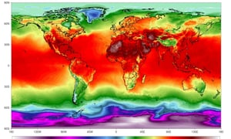
Caption should read: Figure 4: A simulation of maximum temperatures on 21 July 2018. Photograph: Climate Reanalyzer/Climate Change Institute/University of Maine
In Ireland, a heatwave is defined as five consecutive days with temperatures (the degree of hotness or coldness of an environment) of over 25 degrees occurring around the country. The heatwave in Ireland in the summer of 2018 was caused by an anti-cyclone (a weather system with high barometric pressure at its centre, around which air slowly circulates in a clockwise (northern hemisphere) or anticlockwise (southern hemisphere) direction), coming up from the mid-Atlantic Portuguese islands of the Azores. This anticyclone allowed the sun to heat the earth and in turn the earth heats the air causing the temperature to rise.
The highest ever temperature recorded in Ireland dates from a measurement taken in Kilkenny in June 1887, when it was 33.3 Celsius. On 28th June 2018 the weather station in Shannon Airport measured a temperature of 32 Celsius. Met Eireann issued a series of status yellow heat warnings, the criteria for which is a maximum expected temperature in excess of 27C, in June and July 2018. A status yellow weather warning is issued to ‘notify those who are at risk because of their location and/or activity, and to allow them to take preventative action’.
On 30th June 2018 Met Eireann issued a drought warning. An absolute drought is defined as 15 or more consecutive days of less than 0.2mm of rainfall. Met Eireann have no drought category, this warning was issued under the rainfall category, highlighting the unusual nature of the weather at the time. On 6 July 2018 Irish Water announced a national ban on the use of hosepipes, as a way of saving the remaining water in depleted reservoirs. Heatwaves and droughts often go hand in hand as compound weather events. The summer of 2018 highlighted how sensitive our water systems are to a relatively short, though intense drought event and highlighted the need for additional investment in our water infrastructure.
The heatwave in Ireland was part of a wider trend of temperature records in the summer of 2018. The highest temperature recorded was 51.3 Celsius on 5 July 2018 at a weather station in Ouargla, Algeria. These global extreme heat conditions raised fears about crop yields in China, fuelled forest fires in Portugal, Spain, Sweden, Norway and Russia's Far East, forced flight cancellations in the United States, melted tarmac on roads in the United Kingdom and led to higher than usual death rates in Canada and Japan. The heatwaves around the world also:
- led to a surge in solar power generation in countries like Germany
- forced the closure of nuclear power plants in France and Sweden, which use water to cool reactors
- caused power shortages in California because of overuse of air-conditioning units
- created perfect conditions toxic algae to bloom in the Baltic Sea, facilitating scientists to collect bacteria used in medical research
- affected the growth of vegetation, allowing drone and satellites to capture imagery of archaeological discoveries in Ireland and the United Kingdom
Taken collectively, these heat records are consistent with the kind of extremes that scientific researchers expect to see arising from human-induced climate change (see pages x-x). Depending on how effective we are at reducing greenhouse gases, we expect more, hotter and longer heatwaves.

Thinking about Global Goals
By 2030…
- Ensure healthy lives and promote well-being for all at all ages (Goal 3)
- Ensure availability and sustainable management of water and sanitation for all (Goal 6)
- Take urgent action to combat climate change and its impacts (Goal 13)

Teaching and learning activities
Measuring temperature Links also to LO 1.8
At the same time every day for a month, use a mercury thermometer to measure the temperature in a shaded outside environment. Keep a record of your data.
After a month, draw a line graph to represent the data, with the dates along the horizontal axis and the temperatures along the vertical axis.
Calculate the average (mean) temperature for the month by adding up the temperature recorded on each day and dividing by the total number of days in the month.
Compare your average shaded air temperature with the highest/lowest shaded air records in the same month for Ireland (see Links below).

In the past? Links also to LO 1.3
Work together in small groups to research how one of the following archaeological discoveries connected to the 2018 summer heatwave:
- A Neolithic henge in Newgrange, Co Louth
- Birr Castle’s original ‘Black Castle’ in Co Offaly
- The lost home of St Oliver Plunkett in Co Meath
Use ICT (PowerPoint, Prezi or similar) to present your findings to another junior cycle Geography or History class.

Hot off the press Links also to LO 1.8
Investigate news reports of the impact of the 2018 summer heatwave in Ireland and elsewhere.
Categorise these impacts under the relevant Global Goal(s) for Sustainable Development.

Severe weather event Links also to LO 1.8
Met Eireann is a member organization of the Network of European Meteorological Services (EUMETNET). EUMETNET hosts a website called www.meteoalarm.eu which provides a picture of all current severe weather events across a range of European countries, including Ireland.
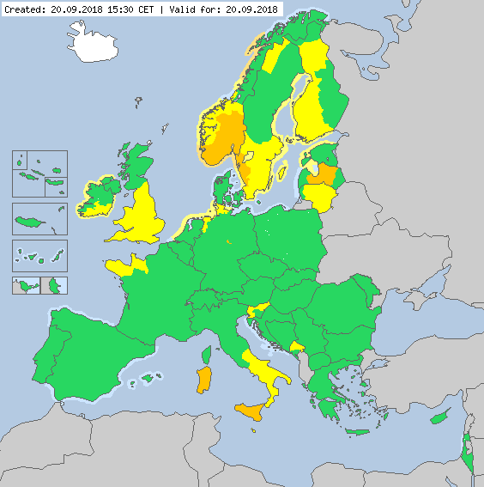
Caption should read: Figure 5: Meteoalarm extreme weather alert, 20 September 2018]

Log onto www.meteoalarm.eu and use the interactive map and table to research a country experiencing a severe weather event today (status yellow, orange or red).
Imagine you work for the national public weather service (equivalent to Met Eireann) in that country.
Work in small groups to script a severe weather event warning for people in that country.
Act out your severe weather event warning using appropriate terminology and props to get your message across to the public. For inspiration, watch ‘Storm surge like you’ve never experienced it before’ (see Links below).

Our extreme weather Links also to LOs 2.6 & 3.7
Source photographs taken during an extreme weather event in Ireland (e.g. heatwave – summer 2018; Beast from the East – March 2018). These can be photos taken by you, family members or friends, or images sourced online.
Caption your images and create a large class collage entitled ‘Our extreme weather’. Compare your experiences those of young people from countries in the Global South during extreme weather events.

In conclusion… Links also to LOs 1.8 & 2.6
Study NASA’s global temperature time machine graph, showing the earth’s changing temperature between 1884 and 2017 (see Links below).
Reflect on the information presented, then work in pairs to complete the following stem sentence: ‘In conclusion, I think … and because of this, I intend to …’

Links
Measuring temperature
Met Eireann, extreme weather records: https://www.met.ie/climate/weather-extreme-records/
Hot off the press
Global Goals for Sustainable Development: www.globalgoals.org

Severe weather events
Met Eireann - major weather events: https://www.met.ie/climate/major-weather-events
Network of European Meteorological Services (EUMETNET) – current severe weather warnings around Europe: http://www.meteoalarm.eu/
Weather channel (USA), ‘Storm surge like you’ve never experienced it before,’ forecast footage using wraparound greenscreen technology to show the potential danger of Hurricane Florence as it approached the South Carolina coast in September 2018: www.youtube.com
In conclusion…
NASA’s global temperature time machine graph: https://climate.nasa.gov/interactives/climate-time-machine

[NEW SECTION/NEW PAGE]
STRAND ONE: EXPLORING THE PHYSICAL WORLD

Entry point learning outcome = LO 1.9
Students should be able to: ‘differentiate between the types of energy resources produced by the physical world’

FOCUS: renewable versus non-renewable energy sources
Energy resources are needed to generate electricity and heat homes, power industrial machines, cars and other transport vehicles.
Renewable energy sources can never be used up. Examples include: wind, solar (generated by the sun), hydro (generated by falling or fast running water), geothermal (generated by the earth’s internal heat), biomass (generated by burning organic matter, renewable only if crops are replanted) and tidal (generated by waves). As of 2015, the world obtained 17.5% of its total final energy consumption from renewable sources, of which 9.6% was geothermal, hydropower, solar and wind. The remainder was traditional uses of biomass (such as fuelwood and charcoal).
Non-renewable energy sources will not be regenerated in our lifetime. These energy sources are formed over millions of years. Plants and animals die, but their remains still have chemic energy. They are buried and preserved, and over a very long period, the remains are turned into gas, oil, peat and oil. Because these types of fuel are made up of remains of plants and animals they are called ‘fossil fuels.
There is debate about whether nuclear energy is renewable or non-renewable. Those that say it is renewable argue that nuclear power plants have very low carbon emissions, and the small amount of uranium used in nuclear fission means that it can be classified as renewable. The opposing view is that uranium deposits on earth are finite, and to be counted as renewable there would need to be enough uranium available to last forever.
In a world where everyone lived sustainably, we would rely mainly on renewable energy sources, and energy usage would be clean and efficient. There would be little or no environmental damage (i.e. carbon emissions leading to climate change, air quality issues and acid rain). Sustainable energy also implies affordable energy, for all households, schools and businesses and institutions everywhere.
In 2018, the Irish Government launched Project Ireland 2040, a long-term planning policy, which includes a Climate Action Fund. The objective of this fund is to improve energy efficiency and to reduce overall greenhouse gas emissions. This is badly needed. 2018 data from Sustainable Energy Authority Ireland, demonstrates that the residential sector in Ireland, which accounts for 25% of our energy related greenhouse gas emissions, is nearly 60 per cent higher than the EU average. This is attributed to intense use of coal, peat and oil in homes. In stark contrast, one billion people – or 13% of the global population of 7.6 billion – live without electricity. Most of these people live in rural areas in Sub-Saharan Africa, and Central and South Asia. The Climate Action Fund will support projects including heating homes and businesses using farm and food waste and electrifying our public transport system.
Ireland is set to become the first country to divest public money from fossil fuel assets, with the cross-party support for the Fossil Fuel Divestment bill leading to a landmark vote in the Dáil in July 2018. Fossil fuel divestment means the removal of money or investment capital from stocks, bonds or funds with links to oil, coal and gas companies. Initial opposition to the Fossil Fuel Divestment bill during the first Dáil debate (January 2017) centred around the argument that its passage would lead to unintended consequences for Ireland’s energy security and for semi-state energy companies like Bord na Móna.
Since establishment in 1946, Bord na Móna has commercially extracted peat mainly from raised bogs (which have a greater depth of peat than blanket bogs). However, peat used as a fuel, and in power generation, represents ‘a triple negative’, as it produces a poor fuel, releases CO2, and diminishes Ireland’s best way to store carbon in the landscape. Using the tagline ‘naturally driven’, Bord na Móna has committed to stop production of energy peat by 2030 and promises to ‘leave behind a landscape which is rich in terms of biodiversity and amenity as well as making a valuable contribution to Ireland’s renewable energy targets through wind and solar projects’.
The realisation of sustainable energy initiatives like those envisaged under the Climate Action Fund, by Ireland’s commitment to fossil fuel divestment and Bord na Móna’s sustainability agenda will help Ireland meet its commitments to Global Goal 7 targets and under the 2015 Paris Climate Change Agreement and will go some way towards countering our national reputation as a ‘climate-laggard’.

Thinking about the Global Goals
By 2030…
- Ensure access to affordable, reliable, sustainable and modern energy for all (Goal 7)
- Ensure sustainable consumption and production patterns (Goal 12)
- Take urgent action to combat climate change and its impacts (Goal 13)

Teaching and learning activities
Pros and cons table
Using Word, Excel or similar create a table outlining the pros (advantages), cons (disadvantages) of, and interesting facts relating to different energy sources. Your table must include two or more renewable and two or more non-renewable energy sources.
 | Pros | Cons | Interesting fact
Renewable example
Renewable example
Non-renewable example
Non-renewable example

Country fact files
Work together in pairs to produce a one-page fact file for:
- an oil producing country (e.g. Saudi Arabia)
- a country that is heavily reliant on fossil fuels (e.g. Ireland)
- a country that determined in its’ efforts to switch to renewable energy sources (e.g. Iceland or Costa Rica)
As a class, agree the success criteria for your completed country fact files.
Create a book of your finished country fact files with Global Goal 7 (Affordable and clean energy) on the front cover. Give this book to the school or local library.

Naturally driven? Links also to LO 2.3
Bord na Móna use the tagline ‘naturally driven’ to underline their sustainability agenda. Investigate Bord na Móna’s past, current and planned activities and consider whether this tagline is a PR exercise or a true reflection of the organization’s move towards a more sustainable future.
Organize a class debate on the following motion: Bord na Móna has earned the tagline ‘naturally driven’.
Do the maths! Links also to LO 3.3
There are currently is 7.6 billion people in our world. One billion people – or 13% of the world’s population – still live without electricity. The United Nations estimates that the world population will reach 9.8 billion by 2050.
Work out how many people will be without electricity in 2050 if current trends continue.
Logo match Links also to LO 2.2
Log on to www.globalgoals.org. Click on Global Goal 7 (Affordable and clean energy) and scroll down to the targets. Find the text to match these Global Goal 7 target logos:

When you have matched each target logo to the correct text, use your own words to simplify the target text.

Energy consumption tips Links also to LO 2.2
Work in small groups to create a tip sheet for young people about how to move towards sustainable energy use at home and in school.
Work to persuade school management to include the best tips as an energy consumption page in next year’s school diary.

Peer presentation
Summarise what you have learned about different types of energy sources into a presentation.
Give this presentation to a junior cycle Science class and ask them to compare what you present to what they have learned about energy sources in their Science class.

Links
Naturally driven?
Bord na Móna: https://www.bordnamona.ie/
Logo match
17 Global Goals for Sustainable Development (and targets for each Goal): www.globalgoals.org

[NEW SECTION/NEW PAGE]
STRAND TWO: STRAND TWO: Exploring how we interact with the physical world

Entry point learning outcome = LO 2.2
Students should be able to: ‘evaluate the environmental, economic, and social consequences of rock exploitation and energy resources’

FOCUS: Hydraulic fracturing (Fracking)
Fracking or hydraulic fracturing is a technique designed to recover gas and oil from shale rock. Fracking is the process of drilling down into the earth, then injecting a high-pressure mixture of water, sand and chemicals at the rock. This forces the gas or oil inside the rock out. The term fracking comes from the idea that the rock is fractured or broken apart during the process. Common concerns about the fracking as a fossil fuel extraction method include worries about the impact on human health, water and air quality and biodiversity.

In 2017, after many years of extensive grassroots activism and advocacy, Ireland joined France and Bulgaria in banning onshore fracking. The Petroleum and Other Minerals Development (Prohibition of Onshore Hydraulic Fracturing) Act 2017 legislates for the protection of large shale and other tight sandstone deposits which can be found across counties Sligo, Leitrim, Roscommon, Donegal and Clare. Elsewhere around the world the economic benefits of fracking as a method of extraction are considered too valuable to consider undermining.
The Alberta oil sands, located in Western Canada, are large deposits of bitumen or extremely heavy crude oil. Alberta's oil sands represent the third largest oil reserve in the world, after Venezuela and Saudi Arabia. In 2017, approximately 140,300 people were employed in this sector. The area currently being mined for oil is the size of Ireland.
Downstream from the open-pit mining and fracking operation on the shores of Lake Athabasca lies the tiny native community of Fort Chipewyan. A beautiful place, ‘Fort Chip’ is on the far north-eastern tip of the province of Alberta. In winter it is accessible by the ‘ice road’ – a road that is constructed from the harsh northern climate. In summer access is by way of a small plane. Most of the people that live here are either Méti or First Nation - that is, native Canadians who have lived on the land through traditional methods of trapping, hunting, fishing and gathering berries.
In 2000, Dr John O’Connor – or Dr O as locals call him - became family physician to the tiny community of 1,200 people. Originally from Limerick, Dr O’Connor started hearing concerns among the community about high rates of cancer in the community. He did something that no outsider had done before: he listened to them. Then he spoke out about it. As a result, professional complaints were made against him by the Canadian health authorities. And he would live with one of these – ‘causing undue alarm' among the community – for five years. Dr. O’Connor went from being a simple GP to a tireless campaigner and activist on behalf of native communities in Canada.
Opposition to the Alberta oil sands continues today. In August 2018 news broken that the Federal Court of Appeal quashed the approval of the contentious, $7.4-billion Trans Mountain pipeline that would nearly triple the flow of oil from Alberta's oil sands to an oil tanker port near Vancouver, British Columbia. The court ruled that that the government’s National Energy Board had not adequately consulted with Indigenous people along the pipeline’s route or assessed the project’s potential effects on the waters off British Columbia. Industry leaders in Canada expressed dismay at the court’s decision, citing the negative impact on the country’s international reputation and its’ ability to attract overseas investment. Environmentalists and Indigenous activists immediately called the ruling a major victory.

Thinking about the Global Goals
By 2030…
- Ensure healthy lives and promote well-being for all at all ages (Goal 3)
- Ensure access to affordable, reliable, sustainable and modern energy for all (Goal 7)
- Build resilient infrastructure, promote inclusive and sustainable industrialization and foster innovation (Goal 9)
- Ensure sustainable consumption and production patterns (Goal 12)
- Take urgent action to combat climate change and its impacts (Goal 13)
- Protect, restore and promote sustainable use of terrestrial ecosystems, sustainably manage forests, combat desertification, and halt and reverse land degradation and halt biodiversity loss (Goal 15)

Teaching and learning activities
What the Frack?
Search for and watch the following two short videos: ‘What is fracking?’ and ‘Fracking: opportunity or danger’ (see Links below).
Working on your own complete the following sentence: Fracking is controversial because…
Join with one other person and compare sentences. Agree a joint sentence and share this in small groups. Agree a group sentence, then share your group sentence with the rest of the class.

Sustainable Development spheres
Sustainable development is long lasting changes or development that benefits humans (society) and the economy and does not negatively impact on the environment.
Draw two Venn Diagrams, each with 3 overlapping spheres or circles, as below:

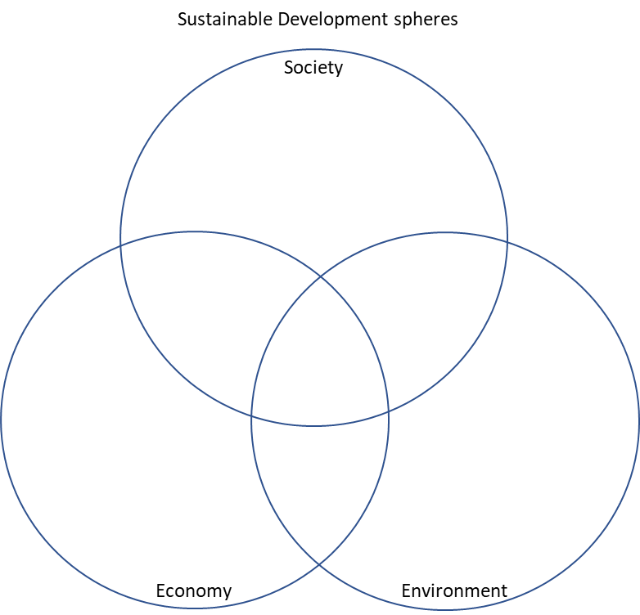

Use one Venn Diagram to record negative consequences of fracking and the other for positive consequences. In each Venn Diagram complete at least one consequence for each of the three spheres. If consequences apply to two or three spheres write these into the overlapping space between the relevant spheres.

Doc documentary
Use google maps and satellite view to locate and explore Fort Chipewyan on the shores of Lake Athabasca in Alberta, Canada. Examine the photographs of both Fort Chip and Lake Athabasca available on Google maps.
Listen to the ‘Undue alarm’ radio documentary, taking notes as you listen.
Participate in a class discussion about whether Dr John O’Connor caused ‘undue alarm’ when he raised concerns about human health as a result the Alberta Oil Sands extraction operation.

In the pipeline
Carry out a Google search for news footage (video) relating to Canada’s Trans Mountain pipeline (your search might include words such as: Canada, Trans Mountain pipeline, environmental, economic, First Nation, Kinder Morgan, Justin Trudeau).
Watch three or more videos generated by different news outlets and identify the one that best represents the range of perspectives in the debate about the pipeline.
Share this news video in class, explaining your reason(s) for picking it.

Exercise your judgement
Imagine you were one of the three Federal Court judges in the Trans Mountain pipeline case. Write a short summary outlining your judgement of the case.
Your summary must include: at least one sentence with your final judgement; and, an explanatory paragraph referencing the economic, social and environmental consequences of the pipeline that have led to your judgement.

Links
What the Frack?
How stuff works (2015) ‘What is fracking?’ (3.00mins): www.youtube.com
‘Fracking: opportunity or danger’ (5.03mins): www.youtube.com

Doc documentary
Google maps: https://www.google.ie/maps/
Nicola Greer (2013), ‘Undue alarm: How an Irish doctor came face to face with the biggest industrial project on the planet’ (37.29 mins): www.rte.ie/radio1/doconone/

[NEW SECTION/NEW PAGE]
STRAND TWO: Exploring how we interact with the physical world

Entry point learning outcome = LO 2.4
Students should be able to: ‘assess the exploitation of water, fish stocks, forestry, and soil
as natural resources’

FOCUS: Soil
Soil is the thin layer of loose material that covers the surface of the earth. It is made up of five main ingredients:
- Mineral matter, like stones, sand, clay and silt, the result of weathering and erosion of rocks.
- Water, which dissolves the minerals and nutrients in the soil which are then absorbed by plants through root systems and help them grow.
- Air, found in the spaces between soil particles, which supplies plants and insects with oxygen and nitrogen.
- Living organisms such as earthworms and other insects, microrganisms like bacteria and fungi. These mix the soil by burrowing and breaking down plants and creatures to form humus.
- Humus, a dark, jelly-like substance, rich in nutrients because it is made up of decayed remains of plants and creatures. Humus helps bind the soil and increases soil fertility.

In 1937, the 32nd American President, Franklin D. Roosevelt, sent a letter to all state governors, wherein he pushed for a national soil conservation law. In his letter Roosevelt referred to soil as a ‘basic asset’ and claimed that ‘The nation that destroys its soil destroys itself’. ‘This letter was written after severe dust storms caused by recurrent droughts and unsustainable farming practices affected large swathes of plains land across Texas, Oklahoma, New Mexico, Colorado and Kansas. Known as the Dust Bowl, this environmental disaster meant that poverty-stricken families, unable to pay mortgages or grow crops, were forced to abandon their farms. The Dust Bowl exodus was the largest migration in American history within a short period of time. Between 1930 and 1940, approximately 3.5 million people moved out of the Plains states.

Soil degradation is not a problem from the past. Around the world, an estimated 33 percent of soil is moderately to highly degraded due to urbanization, deforestation, erosion, loss of soil organic matter, nutrient depletion, acidification, salinization, compaction and chemical pollution (pesticides). Threats to soil also pose risks to the food security and livelihoods of over one billion people who live on degraded lands globally. Worst affected is sub-Saharan Africa, but poor land management in Europe contributes to soil loss from erosion. High levels of food consumption in wealthy countries are also a major driver of soil degradation overseas. However, sustainable management and careful farming techniques can reverse the trend of soil degradation and ensure current and future global food security.

Soils do amazing things that we often take for granted. They sustain food production, filter our water, are the source for many medicines and help us to combat and adapt to climate change. The following information represents just some of the reasons why we should care for and appreciate soil.

1. Food production and security
95% of food is produced in our soils. The nutrient content of soils directly influences that of the plants grown in them. Soils exchange nutrients and water with the plant’s roots. The healthier the soil is, the better the crop will be. We can’t hope to feed the growing global population and produce the 50% more food we need by 2050 without considering and preserving the quality of our soils.
2. Biodiversity
Soils host a quarter of our planet’s biodiversity. There are more living organisms in a tablespoon of soil than there are people on Earth. Nowhere in nature are species so densely packed as in soils. Biodiversity is important to the well-being of our planet. It helps species survive and adapt to the changes in nature. Preserving biodiversity means that we are helping keep our planet resilient, adaptive and healthy. Organic farming, rotation grazing, crop rotations and conservation agriculture can preserve the biodiversity found in soils. These methods sustainably increase farm productivity without degrading soil and water resources.
3. Greenhouse gases
Soils help to combat and adapt to climate change. When managed sustainably, soils can play an important role in mitigating climate change by storing carbon (sequestering carbon) and decreasing greenhouse gas emissions into the atmosphere. Healthy soils with a high organic matter content can also store large amounts of water which help crops cope with drought and adapt to extreme precipitation (water falling from clouds in the form of rain, hail, sleet or snow).
4. Livelihoods and homes
Healthy soils can ensure food security, provide better livelihoods and reduce forced migration. Degraded soils mean loss of food sources and livelihoods. More than 10 million people have abandoned their homes due to environmental issues including soil erosion, desertification, deforestation and drought. Implementing sustainable soil management strategies that help farmers cope with long-term droughts and soil degradation can help to give people a choice of whether to migrate or stay home.
5. Water
Soils are key to a supply of clean water. Soils capture, store and filter water, making it safe to drink. Forests in highland areas not only prevent soil erosion but also ensure good quality drinking water for downstream users. Soils also store water, making it available for crops.
6. Medicines
Soils are important to human health. Most well-known antibiotics, including penicillin, originated from soil microorganisms. Did you know that over 500 antibiotics come from soil microbes!

Few people know that soils are a non-renewable resource. It takes over 1,000 years to
make 1 cm of soil. This means that in our lifetime, all the soil we see is all there is, so we had better appreciate and take care of this ‘basic asset’.

Thinking about the Global Goals
By 2030…
- End hunger, achieve food security and improved nutrition and promote sustainable agriculture (Goal 2)
- Ensure sustainable consumption and production patterns (Goal 12)
- Protect, restore and promote sustainable use of terrestrial ecosystems, sustainably manage forests, combat desertification, and halt and reverse land degradation and halt biodiversity loss (Goal 15)

Teaching and learning activities
Grow it, cook it, eat it Links also to LO 1.4
Grow a plant or herb in some locally sourced soil. Use what you have grown in a recipe. Eat it. Record the experience in a series of photos with captions. Reflect on the importance of soil composition in this process.

The ground beneath her feet
Watch Karen Wynne’s ‘Stop treating our soil like dirt!’ TEDx Talk (see Links below).
Rewrite the lyrics to U2s ‘the ground beneath her feet’ so that the song becomes a message about the importance of soil as a natural resource.

Highlighting passages Links also to LO 3.2
John Steinbeck’s 1939 novel, The grapes of wrath, traces the migration of an Oklahoma Dust Bowl family to California.
Read the opening chapter of The grapes of wrath, highlighting the passages (text) you think are most effective in describing the physical environment during the Dust Bowl era.
Read chapter 21, which includes the quote below, highlighting the passages you think echo the experiences and what you hear about migration and migrants in our world today.

'The movement changed them; the highways, the camps along the road, the fear of hunger and the hunger itself, changed them. The children without dinner changed them, the endless moving changed them. They were migrants. '

Irish soil info system Links also to LO 1.4
Find out about the soil type and properties in your local area by accessing the Irish soil information system interactive map (see Links below).
Design a logo
Global Goal 15 (Life on Land) contains a target to ‘End desertification and restore degraded land’. This target means that by 2030 all 193 countries, including Ireland, who have committed to the Global Goals for Sustainable Development must work to ‘combat desertification, restore degraded land and soil, including land affected by desertification, drought and floods, and strive to achieve a land degradation-neutral world’.
Work together in small groups to design a logo for this Global Goal 15 target. Your logo should be visually attractive and relevant to the text of the target.

#Allweseeisallthereis
Design a label for a commonly grown plant or crop, targeting gardeners or farmers and encouraging them view soil as a non-renewable resource and to stop using pesticides.
Share your finished label on appropriate social media platforms, using the hashtag #Allweseeisallthereis.

Links
The ground beneath her feet
Karen Wynne (2014) ‘Stop treating our soil like dirt!’ TEDxHuntsville (8.32mins): www.youtube.com

Irish soil info system
Irish Soil Information System interactive map: http://gis.teagasc.ie/soils/map.php

[NEW SECTION/NEW PAGE]
STRAND TWO: Exploring how we interact with the physical world

Entry point learning outcome = LO 2.6
Students should be able to: ‘examine the causes and implications of climate change’

FOCUS: Human-induced climate change and climate justice
The earth's climate has changed throughout history. Just in the last 650,000 years there have been seven cycles of glacial advance and retreat, with the abrupt end of the last ice age about 7,000 years ago marking the beginning of the modern climate era — and of human civilization. Most of these climate changes are attributed to very small variations in earth’s orbit that change the amount of solar energy our planet receives.
The current warming trend is significant because scientific evidence points to it being the result of human activity since the mid-20th century. Human-made climate change comes from activities that lead to the release of greenhouse gases, such as carbon dioxide, methane and nitrous oxide. Once released into the atmosphere, these gases stop energy and heat from leaving and they cause the climate to warm. Even if/when greenhouse gas emissions are cut, emissions already released into earth’s environment will continue to have a warming effect for centuries after.
The most harmful human activities involve the extraction and burning of fossil fuels (like coal, oil, gas or peat), for example in electricity and heat production, for transport and in agriculture. Agriculture accounts for almost 25% of global emissions, with meat and dairy farming contributing the most. In Ireland, agriculture is the single largest contributor, accounting for over 30% of our total emissions.
Cows and sheep release methane. Methane is a natural by-product of their digestion. Over the years, livestock breeding programmes have breed bigger cows that eat more, and therefore release more methane. Globally, livestock numbers have grown massively in response to consumer demand. People in middle to high income countries consume far more meat and diary on a more regular basis than previously.
Average global temperatures have been on the rise since the industrial revolution, but 2015 was the first year on record that temperatures reached 1oC higher than before the industrial revolution (first half of the eighteenth century). 1oC might seem like a small amount, but it led to extreme weather events, the like of which had not been seen before. For each 1 degree of temperature increase, grain (like wheat, maize, corn) yields or harvests drop by about 5%.
Without immediate action climate change will impact significantly on our planet and people. For example, around our world people will experience:
- Greater water stress and scarcity
- Lower crop yields and less food security
- Health risks, from heat exposure, to sicknesses caused by unsafe water (e.g. diarrhoea) and by increased numbers of insects (e.g. malaria), to childhood under-nutrition due to lower crop yields
- Greater gender inequality because climate change affects girls and women more than boys and men. Women make up half of the world’s agriculture workers but they only own 10%-20% of the land. Girls are particularly vulnerable in situations where water is scarce because it is usually their job to find and carry water, a responsibility which can prevent them from attending school.
- Damaged economies because extreme weather often destroys infrastructure (e.g. roads and buildings) and businesses and protecting against extreme weather events (e.g. flood defences) costs money.
- Increased migration and displacement with movement from places:
(a) experiencing extreme weather events, like hurricanes, cyclones or storms
(b) at risk of rising sea levels, caused by the melting of snow and ice
(c) where there is a lack of water and food
(c) where there is conflict caused or worsened by the scarcity of resources

A global agreement on climate change was agreed in Paris on 12 December 2015. Ireland is one of the 194 states who under the Paris Agreement has committed to taking ambitious action against climate change. This Agreement is a legally binding commitment to limit global warming to well below 2 degrees centigrade above pre-industrial levels and to pursue efforts to limit the temperature increase to 1.5 degrees.

The ‘developed’ world is responsible for the bulk of human-made emissions, but vulnerable people living in the least developed countries are more exposed to the worst effects of climate change. In 2015, Oxfam estimated that the richest 10% of the world’s population were responsible for 50% of the total carbon emissions. The poorest 50% were responsible for around 10% of human-made emissions.
People living in poverty have fewer resources and supports and all it takes is one shock, a drought or flood to wreck one harvest, for them to lose everything. In contrast, countries in the developed world have, until recently, been able to afford to spend money on adaptation strategies to limit the effects of climate change. For this reason, climate change is not just an environmental issue, it is also an ethical issue. This reality has given rise to the term climate justice.

Thinking about the Global Goals
By 2030…
- Take urgent action to combat climate change and its impacts (Goal 13)
- Strengthen the means of implementation and revitalize the global partnership for sustainable development (Goal 17)

Teaching and learning activities
Ask an expert
As a class come up with a set of key geographical questions about climate change – who, what, when, where, how, why.
Find the answers to these questions using reputable online sources. Consider emailing your questions to the Climate Change Advisory Council or another person or organization with climate change expertise.
Create a series of ‘Who, What, When, Where and How’ flash cards using Quizlet or similar.

Climate Action profiles Links also to LO 2.5
In 2018 the Government of Ireland launched ‘Project Ireland 2040’, a long-term planning policy. Watch the ‘Project Ireland 2040’ video (see Links below). Take notes about aspects relating to climate action.
As part of Project Ireland 2040, €500 million has been allocated to a Climate Action Fund. The objective of this funding is to improve energy efficiency and to reduce overall emissions. Profile a local or regional initiative that seeks to improve energy efficiency and reduce overall emissions (in keeping with the objective of the Climate Action Fund).
Your profile must include: the name of the initiative; contact details for the person or organization responsible (including online details); the inputs, processes and outputs involved in this initiative; a brief description of the initiative (where the idea came from, how it relates to climate action, how the idea has evolved) and future plans. If possible, you could also include relevant images with captions. Remember to respect copyright by acknowledging the sources of images in your completed work.
Display your finished climate action profiles in a prominent place in the school, e.g. on the walls outside your classroom, in the library or in the reception area.
Climate change audit
Climate change is the focus of SDG 13 (Climate Action), but it is also a theme that cuts across other Global Goals for Sustainable Development.
Log onto www.globalgoals.org. Work in pairs to identify climate change related targets from across the 17 Global Goals for Sustainable Development.

Mapping emissions Links also to LO 3.7
Carbon Dioxide (CO2) is one of the greenhouse gasses contributing to climate change. Access the ‘Carbon dioxide emissions on the rise’ web map on Scoilnet (see Links below).
Click on Ireland and make a note of kilotons of CO2 emissions in the most recent year where data is available. Choose two or more countries from the Global South countries and note also the kilotons of CO2 emissions for the same or most recent year where data is available.
In small groups discuss the implication of CO2 emissions from (1) Ireland and (2) your chosen Global South countries on society, the economy and the environment.

Quoting Mary
Watch Mary Robinson’s Ted Talk called ‘Why climate change is a threat to human rights’ (see Links below). As you watch, record one or more Mary Robinson quotes that you find especially striking, either because they are interesting or because they make you feel angry or hopeful, happy or sad.
After watching, check the transcript of Mary Robinson’s talk to make sure that you’ve recorded her words verbatim (accurately - word for word).
Share your chosen Mary Robinson quote on an appropriate online platform using the hashtag #climatejustice.
‘Climate Change is a women’s issue’ Links also to LO 3.7
Engage with UN Women’s photo essay entitled ‘Climate Change is a women’s issue’ (see Links below).
Use what you learn to help you make a list of climate change implications that are specific to women and girls.
Participate in a whole class discussion about whether these implications affect all women/girls everywhere (i.e. are they affecting women and girls locally, nationally and/or globally).

Climate changed Links also to LO 3.7
Access the ‘Climate in 2050’ interactive map (see Links below).
Click on Ireland and make a note of the expected temperature rise by 2050 if current trends continue. Choose one or more countries from each continent and note the expected temperature rise there.
In small groups discuss the implications of these temperature rises for the health, education and employment of young people in Ireland and your chosen countries in the future.

Links
Ask the expert
Climate Change Advisory Council: www.climatecouncil.ie
Irish Environmental Network (see members section): www.ien.ie

Climate change audit
17 Global Goals for Sustainable Development (and targets for each Goal): www.globalgoals.org

Mapping emissions
‘Carbon emissions on the rise’ web map: http://maps.scoilnet.ie/

Quoting Mary
Mary Robinson (2015) ‘Why climate change is a threat to human rights’ TED Talk (21.40mins): www.ted.com

Climate change is a women’s issue
UN Women (2017) ‘Climate Change is a women’s issue’ photo essay: www.unwomen.org

2050
The Revelator ‘Climate in 2050’ interactive map: https://therevelator.org/interactive-map-climate-2050/
[NEW SECTION/NEW PAGE]
STRAND THREE: EXPLORING PEOPLE, PLACE AND CHANGE

Main learning outcome = LO 3.2
Students should be able to: ‘investigate the causes and consequences of migration’

FOCUS: Refugees and climate migrants
People migrate for many different reasons or causes. These causes can be classified under the headings of economic, social, political and/or environmental migration:
- economic migration - moving to find work or follow a career path
- social migration - moving somewhere for a better quality of life or to be closer to family or friends
- political migration - moving to escape political persecution or war
- environmental migration – moving because natural disasters such as flooding
Some people choose to migrate, e.g. someone who moves to another country to enhance their career opportunities. Others are forced to migrate, e.g. someone who is forced to flee to escape conflict or famine.
Push factors are the reasons why people leave an area, for example unemployment or drought. Pull factors are the reasons why people move to a specific area, for example employment opportunities or less risk of natural disasters.
The 1951 Geneva Convention Relating to the Status of Refugees, which is a legally binding instrument, defines a refugee is someone who 'owning to a well-founded fear of being persecuted for reasons of race, religion, nationality, membership of a particular social group or political opinion, is outside their country of nationality and is unable, or owing to such fear, is unwilling to avail him/herself of the protection of that country'. When people who have fled their country of origin because of fear of persecution arrive in countries who have signed up to the Geneva Convention they have a legal right to formally apply to live there. While this application is pending the person is known as an asylum seeker. If/when the application for asylum is approved, s/he gains refugee status in the new country.

A 2018 World Bank report, Groundswell: Preparing for Internal Climate Migration, estimates that by 2050 Sub-Saharan Africa, South Asia and Latin America could be dealing with a combined total of over 140 million migrants. These people will be pushed out by droughts, failing crops, rising sea levels, and storm surges. However, ‘environmental’ or ‘climate change’ migrants are not included or protected under the Geneva Convention. The United Nations High Commission for Refugees (UNHCR) already struggles to provide adequate support for the world’s 25.4m refugees (driven from their homes by and persecution). The UNHCR admits that the Syrian war and resultant refugee crisis has stretched the limits of their resources. If the definition of ‘refugee’ was broadened to support an entirely new category, it is unclear if the political appetite exists to provide the necessary funding.
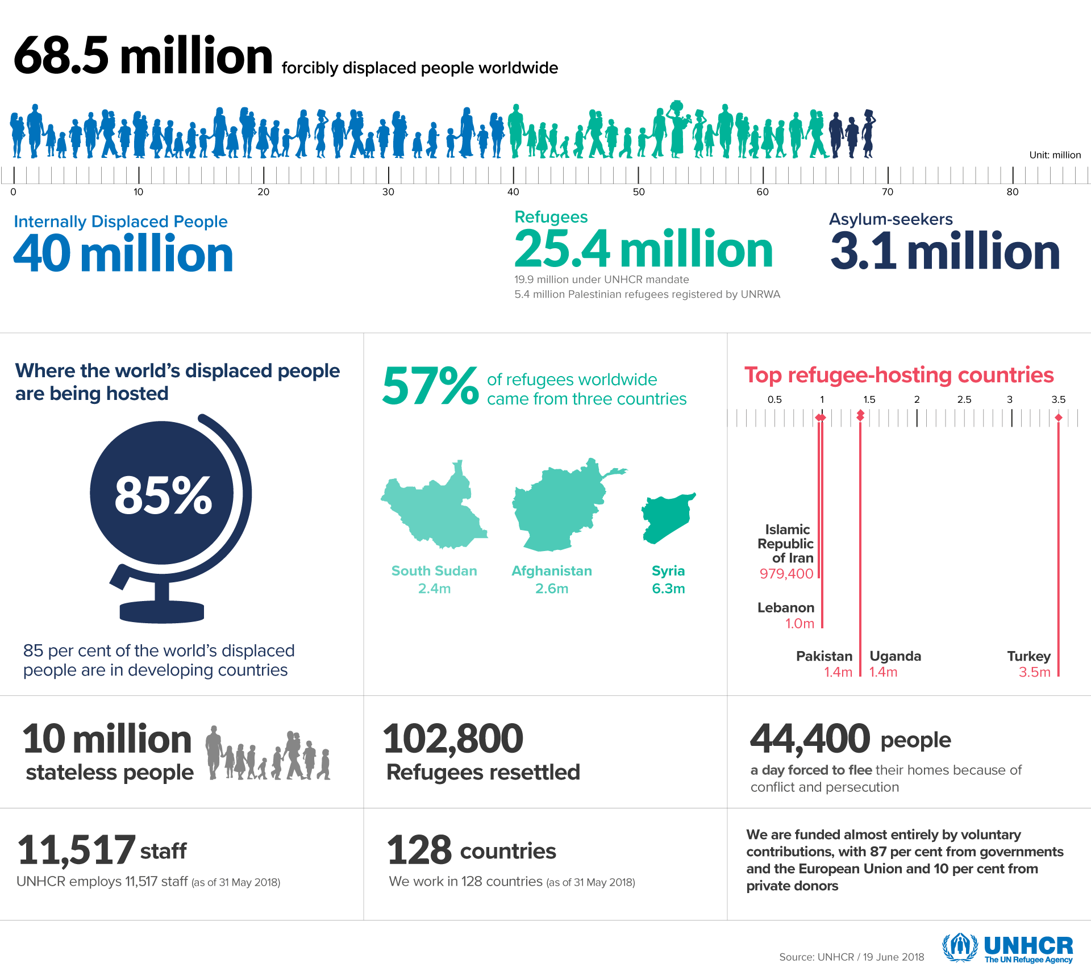
Caption should read: Figure 6: UNHCR forced displacement data]

Thinking about the Global Goals
By 2030…
- Promote sustained, inclusive and sustainable economic growth, full and productive employment and decent work for all (Goal 8)
- Reduce inequality within and among countries (Goal 10)

Teaching and learning activities
Push and pull
Work in pairs to decide which of the following is a push factor and which is a pull factor for migrants:
- A better quality of life
- A lack of services or amenities
- A more attractive climate
- A perception of low crime rates
- Adequate or good public services
- Concerns about high crime rates
- Crop failure
- Fertile land
- Good defences against natural disasters
- Good food supplies
- Greater wealth or affluence
- Political security
- Political stability/security
- Poor safety and security
- Poverty
- Unemployment
- War or conflict
- Water scarcity

Migration interview
Interview a family member or friend with experience of migration. Plan your questions in advance. You must include questions about the reasons why they migrated (push and pull factors), their experiences as a migrant and the consequences of migrating for their own life and the lives of other family members.
Record the interview (e.g. using your mobile phone), with the permission of your interviewee.
Share your recordings in class.

CSO infographic Links also to LO 3.3
Study the Central Statistics Office (CSO) infographic based on information gathered in the last Irish census in 2016.
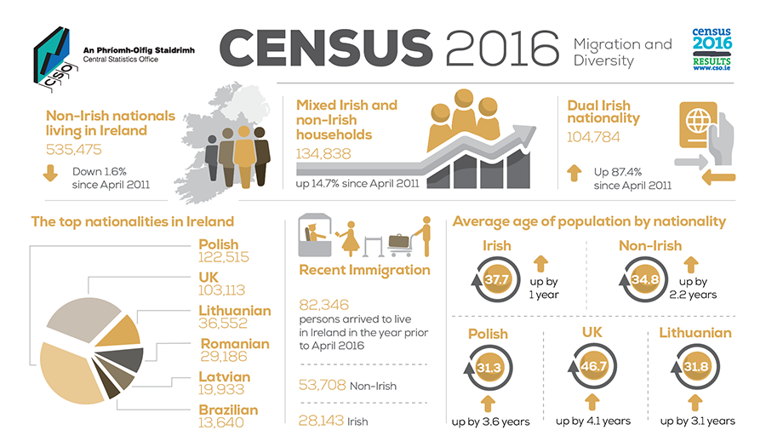
Caption should read: Figure 7: Census 2016, migration and diversity data]

Participate in a class discussion about how global migration trends relate to your own life and environment, both now and in the future. In your inputs, use at least one piece of information presented in the CSO infographic as evidence to support what you are saying.

Which Global Goals?
Migration is a focus of targets in two of the Global Goals for Sustainable Development.
In pairs, discuss which two Global Goals these might be. Then log on to www.globalgoals.org and identify the two Goals and the targets in question.
Watch ‘Global Trends: Forced displacement in 2017’ (see Links below).
Participate in a whole class discussion about the scope and limitations of the Global Goals for addressing the current global migration challenge.

Links
Which Global Goals?
17 Global Goals for Sustainable Development (and targets for each Goal): www.globalgoals.org
United Nations High Commissioner for Refugees (UNCRC), ‘Global Trends: Forced displacement in 2017’ (5.13 mins): http://www.unhcr.org/globaltrends2017/

[NEW SECTION/NEW PAGE]
STRAND THREE: EXPLORING PEOPLE, PLACE AND CHANGE

Main learning outcome = LO 3.7
Students should be able to: ‘compare life chances for a young person in relation to gender equality, health care, employment and education opportunities in a developed and a developing country’

FOCUS: Human Development Index
Sustainable development is development that meets the needs of the present without compromising the ability of future generations to meet their own needs. Brundtland Commission, 1987

This widely accepted definition encompasses several key concepts:
• The interdependent relationship between people and planet – meaning that sustainable economic and social development and progress is only possible if we also consider our environment.
• The universal nature of development – which demands participation and action by rich and poor countries so that everyone everywhere benefits.
• Intergenerational equity – which means that we have a responsibility to make sure that future generations inherit a healthy planet.

There is lots of debate about how to measure development. The United Nations has a measurement tool called the Human Development Index (HDI). The HDI tracks average achievements in three basic aspects of human development – leading a long and healthy life (life expectancy), being knowledgeable (education) and enjoying a decent standard of living (income). *

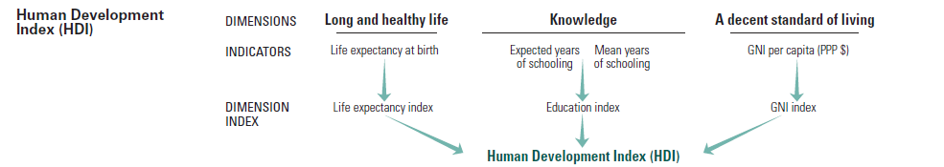
Caption should read: Figure 8: United Nations Human Development Index (HDI)

The HDI takes data about life expectancy, being knowledgeable, and standards of living from around the world into consideration and ranks countries into one of four tiers of development: very high, high, medium and low.

Every year the United Nations produce a Human Development Index report, based on the available data from the 193-member countries. In 2016, The Human Development Report 'Human Development for Everyone', examined the gains made in recent decades in terms of human development and asked, ‘who has been left behind and why?’ The report also looked at what can be done to advance human development for everyone. It sets out policy recommendations at the national level and looks at ways to achieve the Global Goals for Sustainable Development.

*To measure human development more comprehensively, the Human Development Report also presents other composite indices such as the Gender Inequality Index (GII). This index measures women’s empowerment by considering data like maternal mortality and adolescent birth rates, proportion of parliamentary seats occupied by female, proportion of adult females with at least some secondary education, and labour force participation rates by females older than 15 years. The higher the GII rank the more disparities between females and males and the more loss to human development.

Country | HDI Rank | HDI status | Gender inequality index rank (see *note above) | Life expectancy at birth (health) | Youth unemployment (% of labour force aged 15-24 years) | Expected years of schooling (Education)
Ethiopia | 174 | Low | 116 | 64.6 | 7.6 | 8.4
Ireland | 8 | Very high | 26 | 81.1 | 20.9 | 18.6
Mozambique | 181 | Low | 139 | 55.5 | 37.8 | 9.1
Malawi | 170 | Low | 145 | 63.9 | 8.9 | 10.8
Sierra Leone | 179 | Low | 151 | 51.3 | 5.3 | 9.5
Tanzania | 151 | Low | 129 | 65.5 | 6.3 | 8.9
Uganda | 163 | Low | 121 | 59.2 | 6.0 | 10.0
Viet Nam | 115 | Medium | 71 | 75.9 | 5.3 | 12.6
Zambia | 169 | Medium | 124 | 60.8 | 19.7 | 12.5

NB: This table includes data from Ireland and from Irish Aid’s eight key partner countries.

Thinking about the Global Goals
By 2030…
- Ensure inclusive and quality education for all and promote lifelong learning (Goal 4)
- Ensure healthy lives and promote well-being for all at all ages (Goal 5)
- Promote inclusive and sustainable economic growth, employment and decent work for all (Goal 8)
- Reduce inequality within and among countries (Goal 10)
- Promote just, peaceful and inclusive societies (Goal 16)

Teaching and learning activities
3-2-1 development
Watch the animation based on the 2016 HDI report (see Links below). As or after you watch, write down 3 things that you learned, 2 things that surprised you and 1 question that you still have.

Read the data Links also to LO 3.8
Discuss the things that you find interesting or surprising about the data on the board. What, if any, questions do you have about information presented in this table?
The Human Development Index (HDI) data is displayed in alphabetical order (by country name). Ask your teacher to send/give you a copy of this table.
Reorder the table so that the data is displayed in numerical order according to HDI rank (column 2), i.e. showing the countries with a HDI ranking closest to 1 (high human development) to the country ranked furthest from 1 (low human development). What, if anything, do you notice about the data now (for example, geographical location of countries)?
Reorder the data again, this time in numerical order according to Youth unemployment (% of labour force aged 15-24 years) (column 6). What does your revised table tell you about the importance of employment for human development?
Reorder the table so that the data is displayed in numerical order according to Gender Inequality Index rank (column 3), i.e. showing the countries with the GDI ranking closest to 1 (less inequality between females and males) to the country ranked furthest from 1 (highest inequality between females and males). What, if anything, do you notice about the data now (for example, what does the table now tell you about the life chances of females in the different countries)?

Add to the stats
Copy the table below into your copy.
Country | HDI Rank | HDI status | Expected years of schooling (Education)
Ireland | 8 | Very high | 18.6
Working in small groups, choose three countries from the Global South that are not already in the table below. At least one of these should be in Latin America. Add the names of these countries into the first column of your three blank rows at the bottom of the table.
Access the United Nations Human Development Index – Country Profiles website (link below). Click on each of your four chosen Global South countries in turn and find the data for expected years of schooling (education).
Reorder your table in numerical order according expected years of schooling (column 7). Participate in a class discussion about the importance of education for human development in your twelve countries?

Comparing case studies Links also to LO 3.8
Research Irish-based non-government organisations, sometimes called NGOs or overseas aid organisations (see Links below), identifying those working in countries in the Global South.
Contact these NGO(s) requesting case studies (images and text and/or video footage) of young people living in these countries. Ask for case studies for both males and females, which include details about the daily lives of young people, including school, health and family life and employment or jobs.
Create a similar case study for yourself. Compare your experiences, activities and life chances with those of one of the young people from the Global South.

Links
3-2-1 development
Human Development Report Office (2017) ‘Animated video – Human Development Report 2016’ (4.05mins): www.youtube.com

Add to the stats
United Nations Development Programme, Human Development Report – country profiles: http://hdr.undp.org/en/countries

Comparing case studies
Dόchas, the Irish Association of Non-Governmental Development Organisations (see membership): www.dochas.ie/membership/our-members
Dόchas Code of Conduct on Images and Messages: www.dochas.ie/images-and-messages

[NEW SECTION/NEW PAGE]
STRAND THREE: EXPLORING PEOPLE, PLACE AND CHANGE

Main learning outcome = LO 3.8
Students should be able to: ‘evaluate the role of development assistance in human development’

FOCUS: Irish Aid - Ireland’s official programme for overseas development
Human development grew out of global discussions on the links between economic growth and development during the second half of the 20th Century. In the 1970s and 80s development debate considered using alternative focuses to go beyond GDP (economic growth), including putting greater emphasis on employment, followed by redistribution with growth, and then whether people had their basic needs met. These ideas helped pave the way for the human development approach, which is about expanding the richness of human life, rather than simply the richness of the economy in which human beings live. It is an approach that is focused on creating fair opportunities and choices for all people.
Ireland established an official (government) overseas development programme in 1974. Today this programme is called Irish Aid. Irish Aid works in close collaboration with the governments and non-governmental organizations in 8 key partner countries: Ethiopia, Malawi, Mozambique, Sierra Leone, Tanzania, Uganda and Zambia in Africa, and Vietnam in Asia. Over the years, Ireland has developed a good reputation when it comes to making sure our aid budget goes to least developed countries.
Overseas aid comes in two different formats. Development aid is when an international organization, government or non-governmental organization works in a least developed country over a long period of time to fight poverty, improve the environment, grow more food, create jobs, build schools and hospitals etc.
When disasters strike, emergency help, like food, tents, medical supplies and personnel, are sent to help people suffering from war, floods, earthquakes etc. This sort of help is known as humanitarian or emergency aid.
Overseas aid can reach vulnerable people through different channels:
- Bilateral aid: from a government in a developed country (known as the donor country) to a government in a least developed country (known as the recipient country)
- Multilateral aid: from a government to an international organization, for example from the Irish government to the European Union, United Nations agencies or World Bank, and then from the international organization to fund programmes and initiatives in least developed countries.
- Through the work of non-governmental organization (NGOs) or charities which get money for their work by fundraising from ordinary people, and sometimes they get funding by applying for money from governments.

In 2000, Ireland agreed to a United Nations target of spending 0.7% of Gross National Income (GNI*) on overseas aid by the end of 2007. Spending peaked at 0.59% in 2008, but since then we have seen a downward trend – with Ireland spending just 0.33% on ODA in 2016. The Irish public supports increasing the aid budget. In a survey conducted by Dóchas and IPSOS MRBI in May 2018, 80% of people agreed that it was important that Ireland keep its promise on overseas aid. In 2018, the government renewed the 0.7% of GNI promise with a target date of 2030. If this target is achieved, it would mean that 70 cent out of every €100 spent would be going to help the poorest and most vulnerable people in the world.

Thinking about the Global Goals
By 2030…
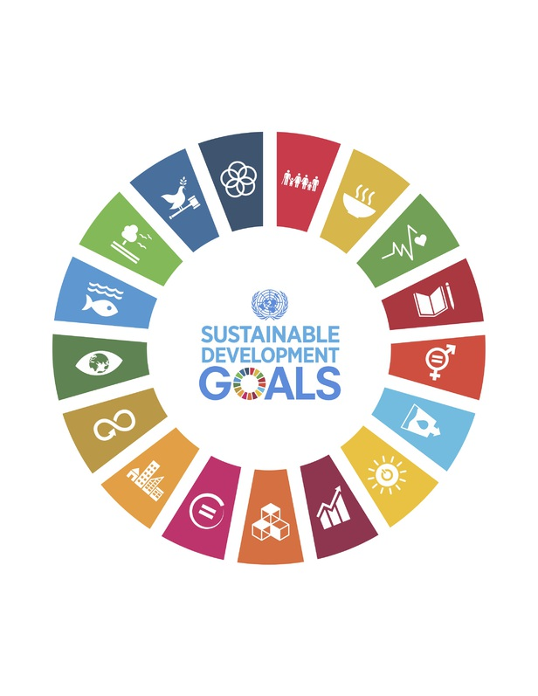

Teaching and learning activities
Global Ireland Links also to LO 3.9
In June 2018, the Irish government launched ‘Global Ireland: Ireland’s Global Footprint to 2025,’ a plan for the renewal and expansion of Ireland’s international presence.
Watch the ‘Global Ireland: Ireland’s Global Footprint’ video (see Links below).
As you watch, take note of the main points made about development aid. Compare what you saw/hear with a partner and add to your notes if necessary.
Analyse media reaction to the launch of the Global Ireland plan (hint: search google news using the following key words: Global, footprint, Ireland, plan, double).
Create an attention-grabbing news headline highlighting the link between the Irish government’s Global Ireland plan and Ireland’s globalized economy and society.

True or False?
Read the statements below and use the columns on the left-hand-side to tick whether they think each statement is true or false.
Watch Irish Aid’s ‘You are making a difference’ video (see Links below), and while/after you listen, tick true or false for each statement again, this time using the columns on the right.

Before watching |  | Statements | During/after watching
True | False | Statements | True | False
 |  | Irish Aid is the Irish Government’s programme for overseas development
 |  | Irish Aid has 8 key partner countries
 |  | Reduced hunger and stronger resilience is one of Irish Aid’s three goals
 |  | Climate change and development is one of Irish Aid’s priority areas for action
 |  | Irish Aid is part of the Department of Foreign Affairs and Trade

Annual report Links also to LO 3.7
Access Irish Aid’s latest annual report.
Working in small groups, find a case study (if possible, one that profiles a young person) that demonstrates the contribution that Irish Aid is making to one or more of the Global Goal targets.
Present a summary of your case study and the Global Goal target links to the rest of the class.

Walking debate
Take time on your own to reflect on your opinions about each of the following statements about overseas aid:
- People who get aid have no incentive to help themselves
- Giving aid is pointless because the money never gets to the people who need it the most
- Governments in countries that receive aid are mostly corrupt
- Ireland gives enough aid to poorer countries
- Giving aid is always positive
- When times are bad in Ireland we should lessen the amount of aid we give to other countries
- Giving aid is ‘the right thing to do’
- Aid will never work while unfair trade systems exists between countries
- Aid is about charity, giving to those less well off
- Ireland should keep its’ promise to give 0.7% of GNI to overseas aid
Participate in a walking or moving debate about overseas aid. Move towards an ‘Agree,’ ‘Disagree,’ or ‘Unsure’ poster or corner in response to the 4-5 statements read aloud by your teacher.

Links
Global Ireland
Government of Ireland (2018) ‘Global Ireland: Ireland’s Global Footprint’ video (5.08 mins): www.ireland.ie

True or False?
Irish Aid (2018) ‘You are making a difference’ video (2.02mins): www.youtube.com

Annual report
The most recent Irish Aid annual report will be available in the news and publications section of Irish Aid’s website: www.irishaid.ie

[new section/new page]

Get Active/Get Engaged
Resources to support the teaching and learning of development themes using development education approaches are available from specific non-governmental websites or from platforms such as www.developmenteducation.ie

There are several award programmes open to post-primary students engaged in DE action through junior cycle Geography, the most relevant of which are:

- WWGS Global Passport Award - worldwiseschools.ie/wwgs-global-passport/
- BT Young Scientist and Technology exhibition - https://btyoungscientist.com/
- Clean Coasts: amateur photography competition – www.cleancoasts.org
- Environmental Protection Agency: The story of stuff competition - http://www.thestoryofyourstuff.ie/
- ECO-UNESCO Young Environmentalist Award: http://www.ecounesco.ie
- Geography Society of Ireland: Geoweek competitions: http://www.geographicalsocietyireland.ie/
- Geological Survey Ireland: www.gsi.ie
- International Geography Bee: European championships: http://www.internationalgeographybee.com/europe/
- Sustainable Energy Authority of Ireland (SEAI) One Good Idea competition - https://www.seai.ie/

[INSERT WWGS LOGO]
WorldWise Global Schools (WWGS)
WorldWise Global Schools (WWGS) is the national programme of support for Development Education (DE) at post primary level. It is a one-stop shop of funding, resources and guidance for post primary schools to engage in DE. WWGS is an initiative of Irish Aid (the Irish Government’s programme for overseas development). The current WWGS programme is implemented through a consortium comprised of Gorta-Self Help Africa, Concern Worldwide and the City of Dublin’s Education and Training Board Curriculum Development Unit.
[Global Passport page]

[back page]

