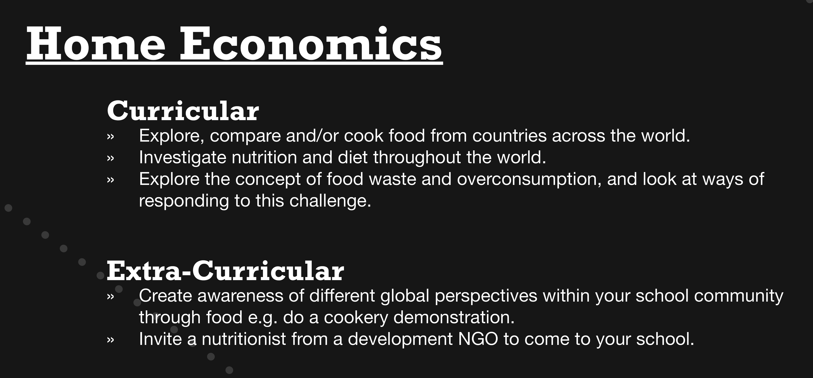

http://www.developmenteducation.ie/resources/climate-change-and-sustainable-development/whats-the-problem-with-wasting-food.html

