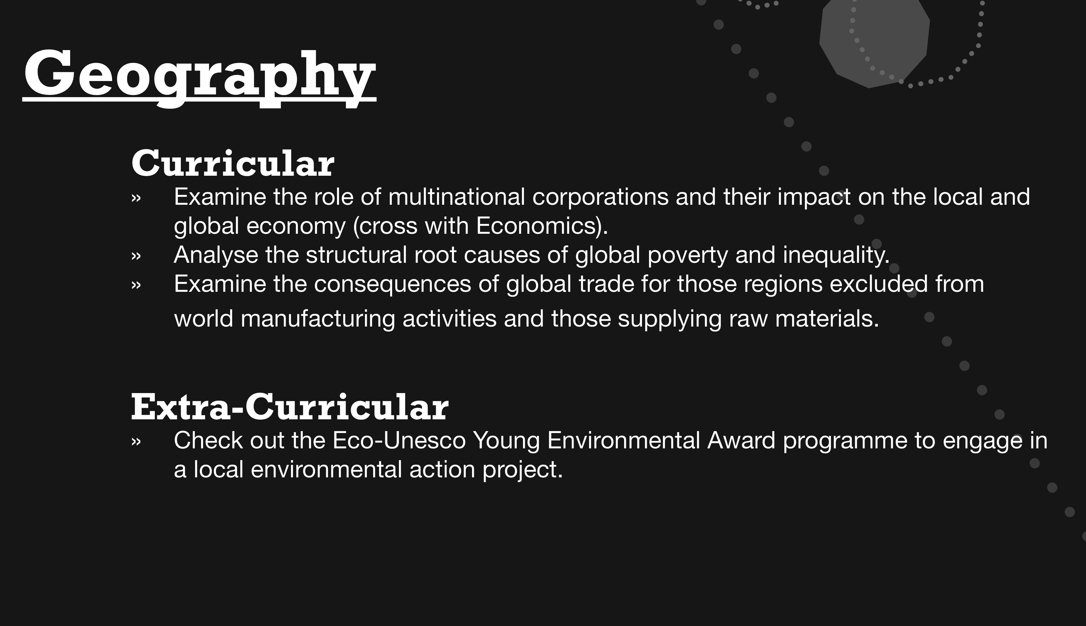

https://www.gapminder.org

https://www.theguardian.com/global-development/interactive/2012/dec/20/geography-game-how-well-know-world

http://www.oxfam.org.uk/education/resources/mapping-our-world

http://www.oxfam.org.uk/education/resources/more-or-less-equal-geography

