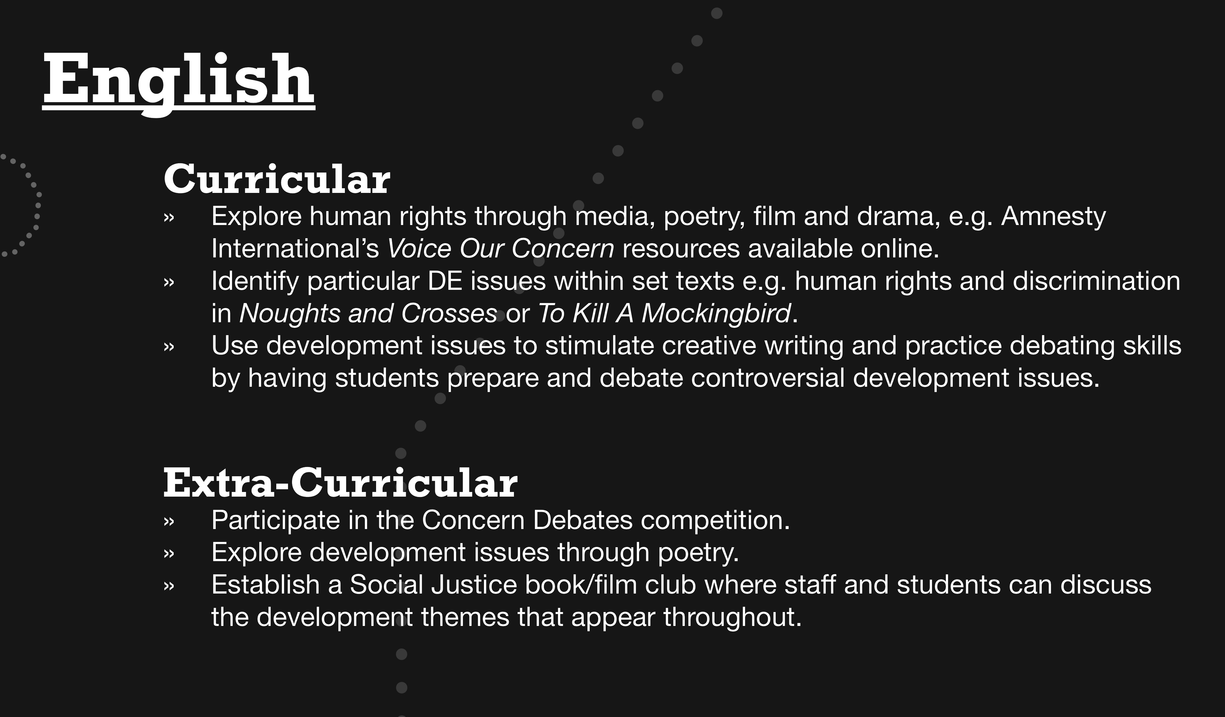

Themes of local and global justice can be integrated in oral language, writing and reading work
Writing Skills
Writing in Impossible Circumstances. Two downloadable lessons produced by Amnesty International and the Anne Frank Trust http://www.amnesty.org.uk/resources/lessons-writing-impossible-circumstances
Oral Presentation: Speaking and listening – make it a Global Social Issue
For the new English syllabus, Second Year students will have to give an oral presentation. Is this an opportunity to link learning with social justice? Perhaps students could select a global issue that is of interest to them, research it, and present to their class.

Reading: There are lots of global issues in the suggested texts. The WWGS Doing DE in English explores some of these texts.
http://www.worldwiseschools.ie/wp-content/uploads/2015/11/WWGS-English-Guidelines.pdf

Find a good reading list on www.developmenteducation.ie

Poetry
See examples of poems you might use p 28-29 which relate to global justice themes: http://www.debtireland.org/education/teachersstudents/how-the-world-works-2.html.
Contact Poetry Ireland education@poetryireland.ie for free DE through Poetry & Creative Writing workshops.
Other Suggested poetry includes : Maya Angelou, The Human Family, Phenomenal Woman, Still I Rise

