ACTIVIST ART
SECTION 4

“People don’t understand how valuable art is because we don’t teach people the value of art.”
Kate DeCiccio
This section explores art as a tool of social change and explore the work of some ‘political artists’, or ‘activist artists’, whose work helps to raise awareness and challenge injustices relating to conflict, migration, and citizenship, amongst other themes.

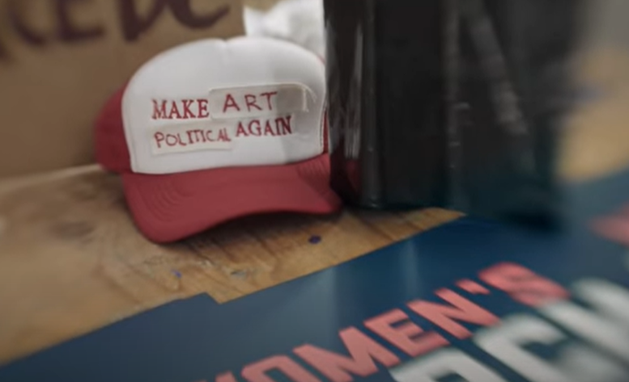

AIMS:
In this section students will:
- Consider the role of art and creativity, in the wider contexts of conflict, forced migration, and the ‘refugee crisis’.
- Explore and respond to examples of contemporary artists, and their approaches to the themes of refuge, migration, borders, and conflict.
- Discuss the impact of art as a tool for action on global justice and human rights issues.
- Consider some criteria for effective and ethical activist art.
- Be supported to develop and express their creativity in work that is “relevant for themselves and the society they live in.” (NCCA, LC Art)

SUBJECT LINKS: Art, English, Home Economics, Geography, History.
This section supports the learning outcomes for Leaving Certificate Art curriculum, offering examples of primary sources for Visual Studies, and reflections by artists about their own socially engaged work.
Students can explore their responses to the works, and the concepts and issues addressed by the featured artists through discussion. Throughout this section they should also be encouraged to record and document their responses, thoughts, ideas and observations in their sketchpads. They should also be encouraged to develop and create work of their own that is, “cognisant of the evolving world around them through these contextual enquiries.” (NCCA)

CONTENTS
- What is Activist Art? We begin this section by introducing and exploring the concept of ‘political art’ or ‘activist art’, with discussion and some short videos with reflections questions. (See below.)

- Virtual Gallery Tour: Links and notes to the virtual gallery tour of the Tulca 2020 Arts Festival: The Law Is a White Dog. This supports preparation for the Leaving Certificate Art Appreciation Gallery visit question.

- Exploring Activist Artists: The Activist Art powerpoint provides a selection of work, mostly from contemporary artists, whose work addresses refuge and migration issues. There are reflection questions and links for further learning throughout. These slides can be used to lead a discussion on the topic, either online or in the classroom, or may be shared with the students as an online notebook for a-synchronous learning and self-study.

- Artist Interview: Slides and a recorded interview with young Palestinian artist Malak Mattar. In this powerful and uplifting conversation, the artist describes her childhood in Gaza, and how painting provided an essential emotional outlet for dealing with the terror of life under bombardment. Malak also provides insights into a selection of her work, which is full of colour, courage and symbolism.

- A critical comparative analysis of two large-scale works by artist JR. The students can read, analyse and contrast the rationale and impact of each piece as a means to tease out elements that make for effective activist art.

- Activist Art Profiles: Ideas for student presentations, with brief profiles and links provided for 7 engaging activist artists working in Ireland and internationally.

Activist art is a term used to describe art that addresses political or social issues and is grounded in the act of ‘doing’.
Tate Gallery

“Art is one way to get to peoples’ hearts and minds. It’s not enough to tell people ‘‘this is what’s happening’. You have to get to their feelings for them to decide to do something.”
Doug Roupp, volunteer with Humane Borders

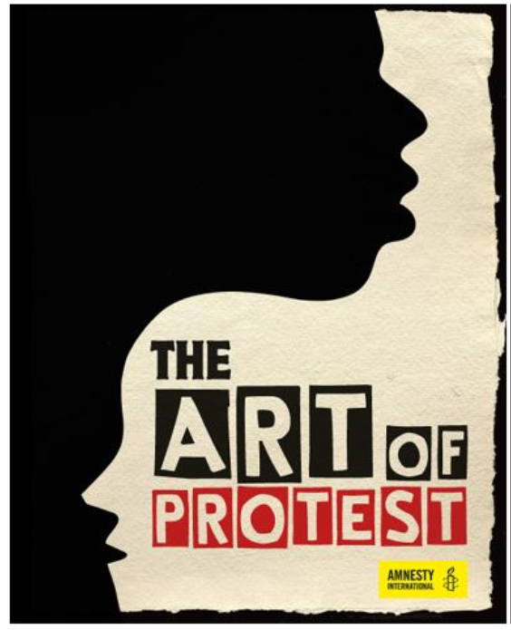

1.WHAT IS ACTIVIST ART?

OPENING DISCUSSION QUESTIONS:
- How do you feel about artists using their work to explore or spread a political message?
- Is there a difference between Activist art/Political art and Propaganda? If so, what is it?
- Can you think of an example of Activist art/Political art?

CIRCLES OF BELIEF – SMALL GROUP ACTIVITY
- What do you think ‘political art’, or ‘activist art’ means?
- What role, if any, can art play in creating social change?
Introduce the topic above in small groups of 3 or 4.
Each person has one minute to speak about the issue, without interruption or response. This is an opportunity to share thoughts, feelings, and questions about the issue, and to practice active listening. (Ask each group to assign a timekeeper to ensure that everyone gets a chance to speak.)

CLASS DISCUSSION:
Return to the large group and invite the students to share their thought and questions.
Additional questions could include:
- What do you think ‘political art’, or ‘activist art’ means?
- What role, if any, can art play in creating social change?
Throughout history, for as long as human beings have been making art, artists, poets, and writers, musicians, and other ‘creatives’ have stood up and spoken out about injustice and inequalities, challenged the status quo, and shone a light on issues that some would rather remain buried. At least, some have. Others have produced their work with little regard for the ethics or the events, social issues, or political upheavals in the world around them.
- What can art achieve in the face of injustice?
Art can produce works of comfort, works that affirm and reproduce existing ideas of beauty, or power, for example. But art also has the power to help us to look at things differently, present new or marginalised perspectives, and open the possibilities of alternatives and new ways imagining the world. When injustices become normalised in the news and media, an artist’s focus on the issue can be an act of defiance. Art can influence the perspective and thinking of the general public, as well as leaders and politicians. Often images speak louder than words and can make a message accessible and universal.
- In your opinion, is it preferable for art to be ‘political’ or ‘non-political’?
- Is it possible for art to be ‘not political’?

VIDEO: THE CASE FOR POLITICAL ART (PBS, 2016) / 12.30 MINUTES
This video provides useful introduction to Political Art (also known as Activist art, Socially Engaged, and Politically motivated art), discussing how artists made use of a range of materials, approaches, and platforms to respond to the social and political events of their times.
The film includes some powerful examples of political art of the 20th Century, including Pablo Picasso's iconic Guernica; Kathe Kollwitz's prints; Kazimir Malevich's Black Square; Iris and Toshi Maruki's Hiroshima Panels; and Martha Rosler's House Beautiful: Bringing the War Home photomontages.
https://www.youtube.com/watch?time_continue=452&v=RfXad3HVox4&feature=emb_title

VIDEO: HOW POLITICAL SHOULD ART BE? (DM, 2021) / 5.30 MINUTES
A short film with examples of contemporary political/activist art from the 7th Berlin Biennale where curators Artur Żmijewski and Joanna Warsza presented a selection of work that eschewed entertainment, and instead highlighted explicitly political art to challenge audiences and break taboos.
PRE-VIEWING DISCUSSION:
"We want our viewers to be angry and furious,” the curators explained.
- Why do you think an artist, or curator of an exhibition might want the viewers to feel anger in response to the work? Do you think they are aiming to evoke other feelings as well? Is anger enough?
Watch the video and make short notes about your response to each of the artists’ work. What kind of feelings do they evoke in you?

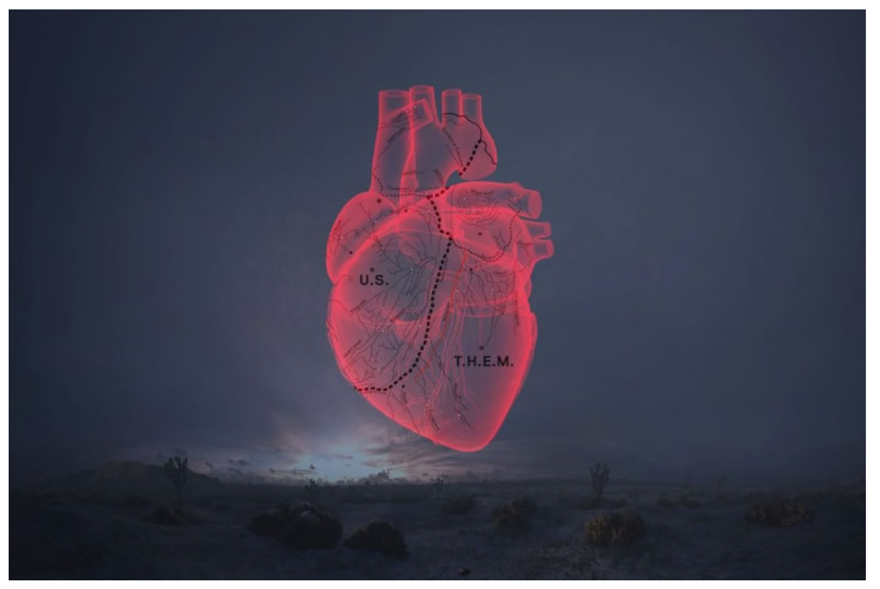
"CARNE y ARENA" (2017) by Alejandro G. Iñárritu. Image: LACMA

2. VIRTUAL GALLERY TOUR
TULCA Arts Festival, Galway (2020): The Law Is a White Dog
Curriculum Links: Art, Politics and Society.
‘The Law Is a White Dog’
The Title of the Festival is borrowed from a book by Colin Dayan, which explores how laws can be used to ‘make and unmake’ persons.
“Conceived in the legal imagination in this way, these different classes of person are allocated unequal capacities for reason and for pain and are distributed different rights to property — whether rights to own one’s own body, or to acquire land.”
Where Dayan explores personhood and dispossession within the USA (especially looking at the inventions of ‘race’ as a category, and justifications for slavery) similar approaches can be found in Ireland, from Cromwell, and the Penal Laws, to the mass evictions of Plantation era in Ireland. Today it is used against people seeking asylum and detained in Direct Provision Centres while awaiting a decision on their applications, and against those who survived (or tragically died) inside state-approved religious institutions, such as the Mother and Baby Homes and Industrial Schools
“While these historical and painful losses may not be confronted directly by all the artists in the festival programme, they have been witnessed by the buildings and landscapes that form its backdrop.”
This video was created for Leaving Certificate art students, in preparation for the gallery question of the Leaving Certificate Art History and Appreciation Exam (2019). A resource pack and worksheet are also available to download to accompany the video.
The video provides information about the role of a Curator, and how artists are selected, along with information about Galway’s annual TULCA Festival. The film guides the students through the 2020 festival theme, along with an exhibition guide, and a focus on four of the exhibiting artists, including Border Tours by Rajinder Singh
Rajinder’s artwork addressing Direct Provision
is covered from 25 minutes into the video.
Watch and respond to the questions after the video tour.
vimeo.com/525858688

3.ACTIVIST ARTISTS
The Activist Art powerpoint provides a selection of work, mostly from contemporary artists, whose work addresses refuge and migration issues.
4. INTRODUCTION TO THE WORK OF ARTIST MALAK MATTAR.
The powerpoint of Malak’s work can be used as an introduction to the work of this young Palestinian artist.
In the recorded interview Malak addresses a Transition Year audience, explaining her own journey as a developing artist, as well as the story behind some of her paintings. The interview was recorded from Malak’s family home in Gaza, shortly after the bombing in 2021.

5. ACTIVIST ART COMPARATIVE EXERCISE
ARTIST: JR
PROJECTS: Face2Face (2007) Jerusalem, and Not A Bug Splat, Pakistan (2014)

#NotABugSplat
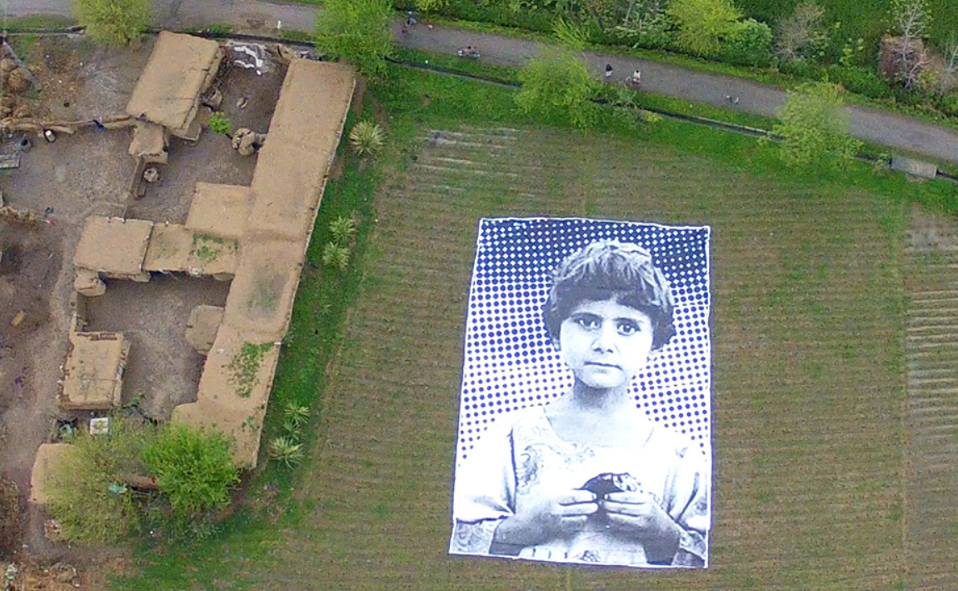
Image: JR | International Museum for Activist Art

FACE 2 FACE:
Face 2 Face (jr-art.net)
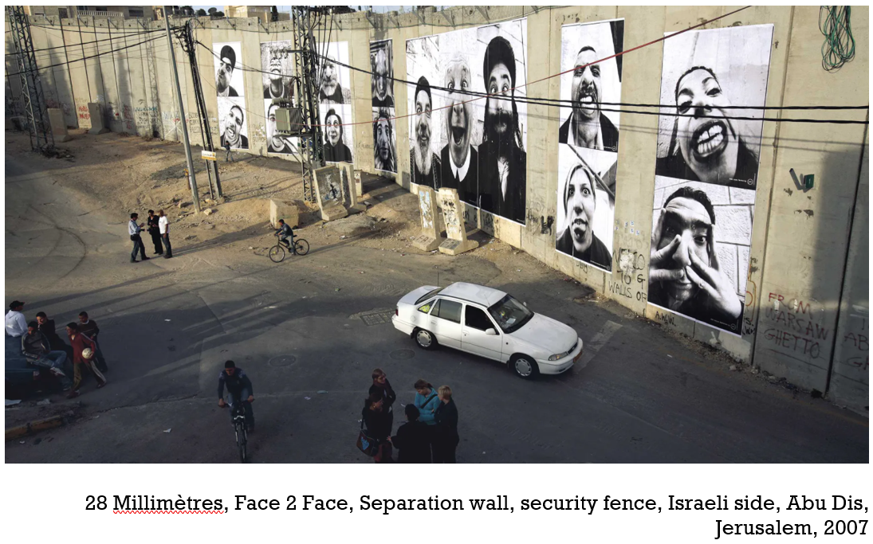
FACE2FACE:
“In 2007, during the Face 2 Face project, JR and Marco organize the largest illegal photography exhibition ever. For this project, portraits of Israelis and Palestinians are pasted face to face, in monumental formats on both sides of the wall and in several Palestinian and Israeli cities.”

JR: “When we met in 2005, we decided to go together to the Middle‐East to figure out why Palestinians and Israelis couldn't find a way to get along together. We then travelled through the Israeli and Palestinian cities without speaking much. Just looking to this world with amazement. This holy place for Judaism, Christianity and Islam. This tiny area where you can see mountains, sea, deserts and lakes, love and hate, hope and despair embedded together.

After a week, we had the exact same conclusion: these people look the same; they speak almost the same language, like twin brothers raised in different families. A religious covered woman has her twin sister on the other side. A farmer, a taxi driver, a teacher, has his twin brother in front of him. And he is endlessly fighting with him.
It's obvious, but they don't see that. We must put them face to face. They will realize.”

___________________________________________

NOT A BUG SPLAT:

“In a creative action, an art collective with the help of enthusiastic locals unfurled an enormous poster in Pakistan’s Khyber Pakhtunkhwa province of a young girl who lost her parents and two younger siblings to a drone strike in August 2009.
The portrait is entitled #NotABugSplat, which is a reference to the term “bugsplat,” used by [US military] drone operators to dehumanize victims of their missile strikes. Rather than seeing small, grainy figures comparable to insects on their computer screens, drone operators who happen to fly over this heavily bombed, rural area near the border of Afghanistan will now be confronted with the image of this innocent girl looking back at them.
Launched by a collective that includes Pakistanis, Americans and others involved with French artist JR’s Inside Out Project — in collaboration with Reprieve UK and the Foundation for Fundamental Rights — the artists involved hope to create a dozen more of these installations around Pakistan.”
This art project, which has garnered significant media attention around the world, is just the latest development in the burgeoning anti-drone movement.”
Artists target drone operators with a giant portrait of one of their victims - Waging Nonviolence | Waging Nonviolence

CRITICAL COMPARATIVE ANALYISIS
What makes for effective art activism?

Read the description for each project.

- What was the rationale for the art piece? How does the artist see the problem (causes)? What is the problem or issue to be addressed – according to the artist?

- What’s the artist’s ‘solution’? How will the art piece address that problem? Is the artwork seen as part of a larger campaign, or a one-off act?

- What is the key, or underlying, message of the work?
Who is it aimed at? Do the titles suggest anything about the intended audiences? What’s the significance of including a hashtag in the title of the piece?

- Do you agree with the artist’s assessment of the issue/problem, solution and the message? What kind of action does it lead to?

- Is the artist working in collaboration and in solidarity with the people most affected by the issue, or working in isolation? Which is most effective?

- What ethics or moral considerations do you think an artist should need to consider when working on projects addressing complex, sensitive, and dangerous issues?

- Do you think the work is effective? Why?

- Do you see any risk that the work could be counter-productive for the people most affected by the issue? (For example, could it reinforce stereotypes? Undermine other approaches or groups working from a different analysis?) If so, how could this be mitigated? Are there any changes you would suggest?

- Compare your assessment of each piece and describe how they differ (if at all).

- Chose the piece you find most engaging and effective, explaining why.

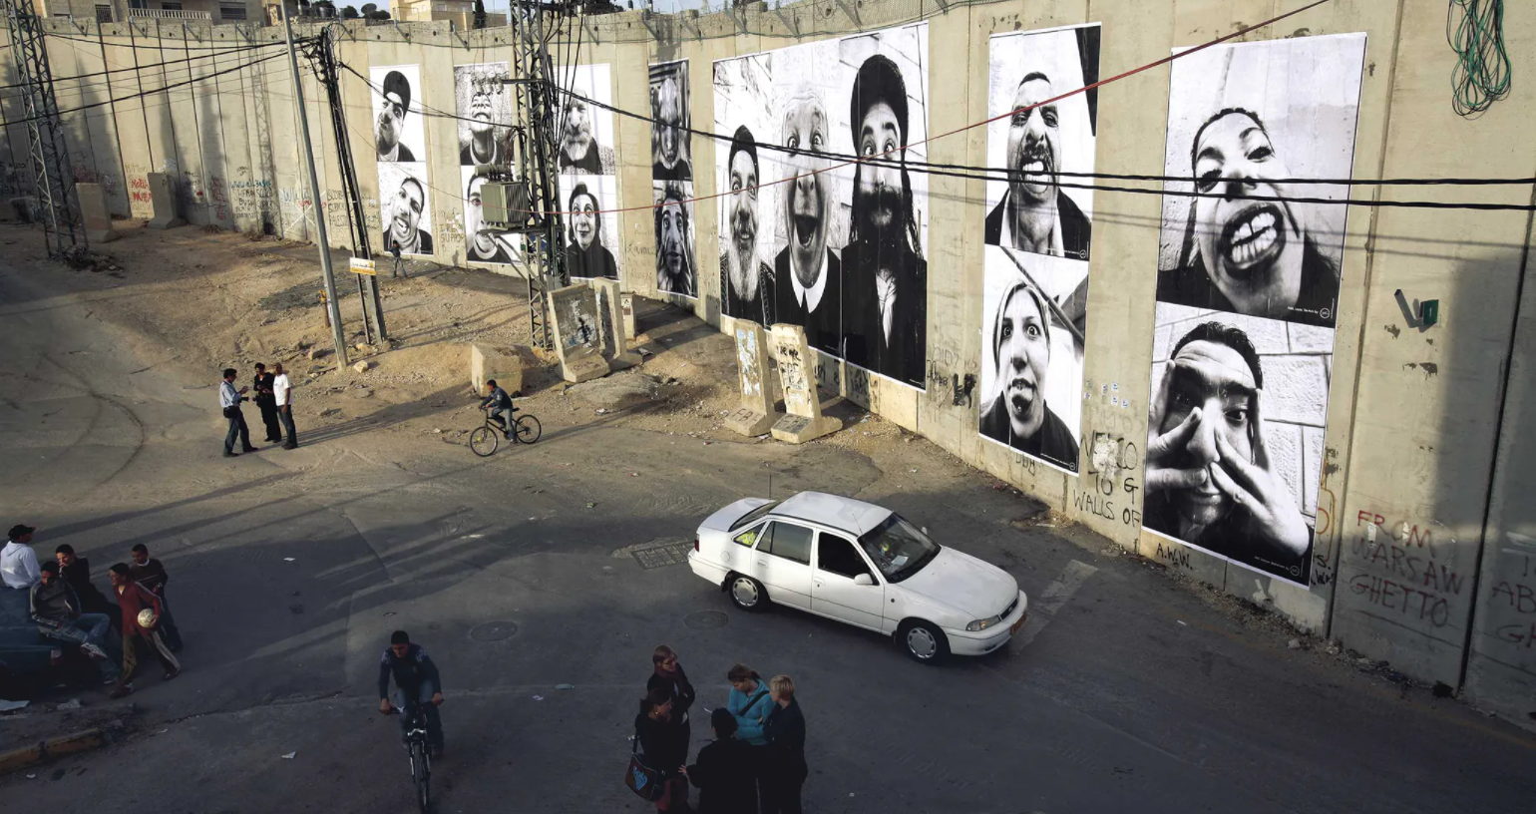
28 Millimètres, Face 2 Face, Separation wall, security fence, Israeli side, Abu Dis, Jerusalem, 2007

6.STUDENT PRESENTATIONS
Small Group Work.
Read or watch the pieces about your chosen artist(s) and see if you can find some more examples of their work.

Create a presentation about their work to share with the group.
If there’s an example a political/activist artist the group wishes to work on, that’s great. Otherwise, there is a list below to select from. Allocate one per group.
Instructions for Students:
Be as creative as you like with your presentation, but if you’re looking for a way to start, or a structure take a Who/What/Where/When/How? approach. You don’t have to follow this in order, or in full, but use it to remind you of the kind of information to include. For example:
- Who? Introduce us to the artist(s)
- What? Explain the issues they work on, and the change they are seeking? What motivates them? What kind of approach and art forms do they use?
- Where? Where are they based? Where do they work? Is context important to their work (e.g., displaying their work in the street.)
- When? When was the particular work you’re showing us created – was it in response to a particular event or issue? (For example, the murder of George Floyd in 2021 sparked a huge response from the Black Lives Matter movement, including street art, postering, poetry and more.)
- How? What kind of approach, materials, working practices do they use? Is collaboration with community groups important to them?
- Quote: Select a key quote from your chosen artist, about the power of art to help create change.
Finish with your assessment of the impact of their work – the process and the product. How, if at all, do you think it contributes to social justice?

ACTIVIST ARTISTS / STUDENT PROJECTS:

Kate DeCiccio
Kate DeCiccio uses large scale portraiture on murals, banners, and parachutes to challenge stereotypes and support local migrant-rights and anti-racism activists. She thinks of her art as “a tool for the community.”
Art as Activism: Kate DeCiccio, Community Artist | Adobe Creative Cloud - YouTube
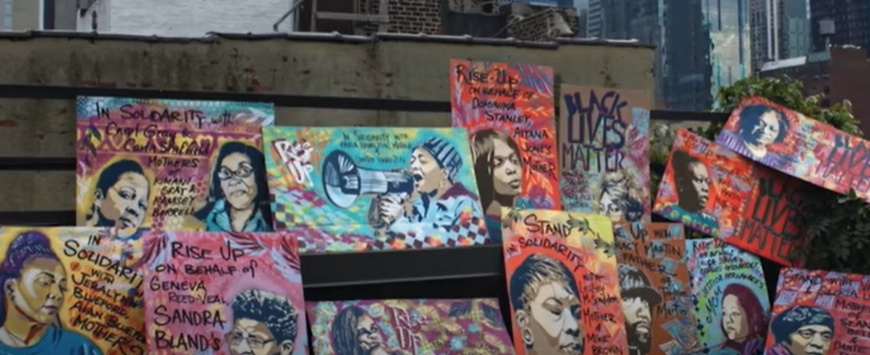

Kate O’Shea
Kate O’Shea is an artist with a broad social practice that includes printmaking, sculpture, curating, the production of ‘social spaces’, collective food making and sharing, and publishing. Her work stems from a concern for contemporary social structures and the fractures within them.
Blog: Cork Migrant Centre Youth Initiative #BLM Artwork – NanoNagle (nanonagleplace.ie)
www.yaycork.ie/a-new-black-lives-matter-artwork-has-been-unveiled-on-douglas-street/
Photography by Clare Keogh www.clarekeogh.ie/cork-migrant-centre-art-work/
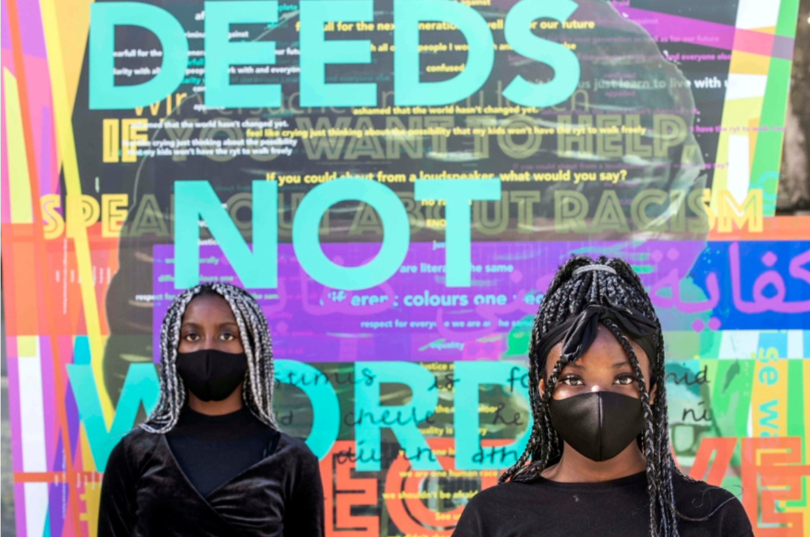

A Black Child Dilemma / ABCD
Confronting Racism Through Arts: Meet ABCD A Black Child’s Dilemma (leargas.ie)
BlackIrish (@a_black_child_dilemma) • Instagram photos and videos

ABCD A Black Child’s Dilemma’ is the initiative of a group of young Cork-based creatives aiming to address racism, social exclusion, bullying and mental health.
They use their creative talents in music, film and the arts as a platform to share stories and build solidarity about the issues facing young people from minority backgrounds in Ireland today.
Examples of work include a series of paintings using a toothpick – “exploring the cataloguing of human beings into categories of colour/differences to justify exclusion, racism, discrimination and othering.”
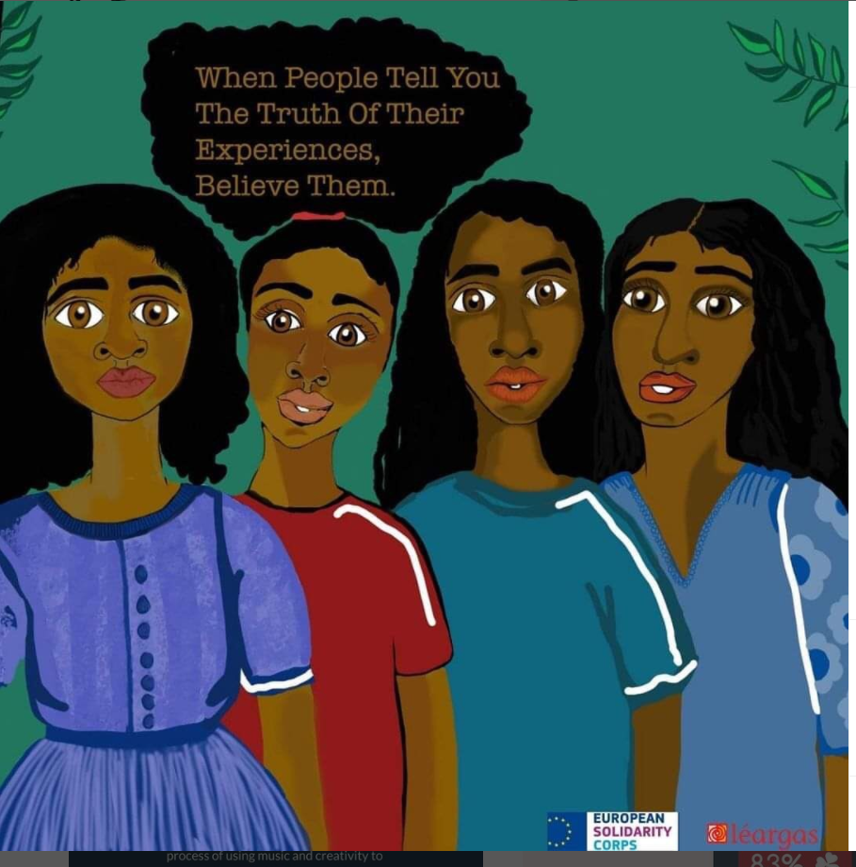

Creativity & Change - Helen Murphy and Claire Coughlan
Black Lives Matter: A War of Words Breaks Out In Cork | Hotpress
Claire and Helen work with the Creativity & Change programme in Cork. They engage with young people on issues like racism, Direct Provision, climate justice and more, supporting groups to make pieces that amplify these issues in public spaces.
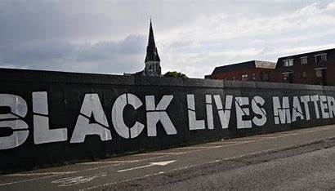

Tatyana Fazlalizadeh
Brooklyn-based street artist, illustrator and activist Tatyana Fazlalizadeh
speaks about her work addressing street harassment, and anti-racism messages.
Video 1 (6 minutes)
Tatyana Fazlalizadeh, Visual Artist: “Stop Telling Women to Smile” - YouTube

Video 2 (1.40 seconds)
'Stop Telling Women To Smile' Artist Tatyana Fazlalizadeh On Her Movement | American Voices | TIME - YouTube
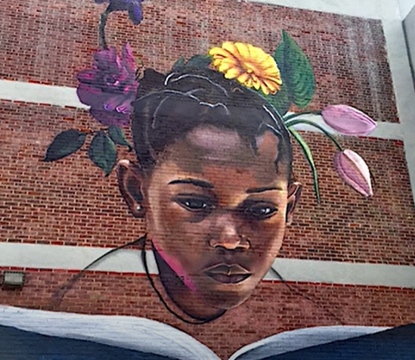

Peter Drew
Life in limbo: street art tells stories of refugees and asylum seekers | Australia news | The Guardian
Artist Peter Drew and works he has placed around Adelaide – in pictures | World news | The Guardian
Peter Drew: artist and activist – Inside the Collection (maas.museum)


