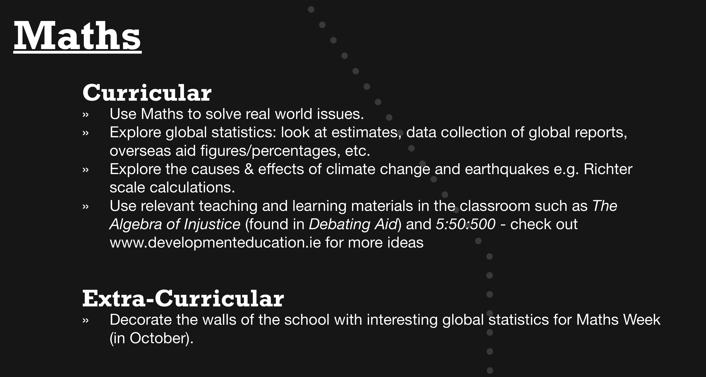

Resources:

Oxfam’s Maths & Global Citizenship Guide:
http://www.oxfam.org.uk/education/global-citizenship/global-citizenship-guides

