Lesson Plan Template

Student Name:
Date:
Class: | JC Science/Geography
Subject: | Science and Geography
Topic of the lesson: | What is climate change?  Learners will first explore their existing ideas about climate change. They will then use the information provided to develop their knowledge and understanding of climate change. Finally, they will carry out a practical activity to reinforce their understanding of what the greenhouse effect is.
Where does this lesson fit in the topic/unit being taught?
JC Geography
JC Science

Geography Human and physical geography links
- Pupils should be taught to understand how human and physical processes interact to influence, and change landscapes, environments and the climate; and how human activity relies on effective functioning of natural systems.
Science links
- Pupils should be taught to make predictions using scientific knowledge and understanding.
- Pupils should be taught to interpret observations and data, including identifying patterns and using observations, measurements and data to draw conclusions.
Biology:
- Pupils should be taught about how organisms affect, and are affected by, their environment, including the accumulation of toxic materials.
Chemistry:
Pupils should be taught about the production of carbon dioxide by human activity and the impact on the climate.

What prior knowledge do student have about this topic?
Materials used during lesson:
By teacher: |  |  | By students:
Oxfam Resources
Climate challenge A slideshow: slides 2 – 8. Activity sheet: The greenhouse effect in a jar.
http://www.oxfam.org.uk/education/resources/climate-challenge-11-14
1. Aims |  | In this lesson I will…
- To recognise the difference between climate and weather.
- To recognise that the Earth’s climate is changing and understand that human activities are contributing towards this change.
- To understand how the greenhouse effect works and the role of carbon dioxide as a greenhouse gas

2. Learning Outcomes |  | At the end of this lesson, students will be able to….
(outline key ideas/concepts/content/vocabulary, use specific active verbs)

- Learners will develop their knowledge and understanding about climate change.
- Learners will be able to explain the results of an experiment that helps them to understand what the greenhouse effect is.
- Learners will share their knowledge and understanding about climate change with others.

3. Assessment How will students’ learning progress be assessed?
Key questions
- What do I know about climate change?
- What is the difference between climate and weather?
- What is climate change?
- What is the greenhouse effect?
- What is the role of carbon dioxide in the greenhouse effect

4. Opening | How will lesson be introduced? What’s the ‘hook’?
(Try to link to real-world application/ or prior knowledge)  Activity: Climate change board race  Show slide 3 and explain briefly what a board race is. A board race is run like a relay with the person at the front of each team running up to the board or piece of paper and writing something related to the question or topic. As soon as they have written something they run back to their team and hand the pen to the next person in line and then head to the back of the queue. The next person then has a go but they must not repeat anything that is already written on their group’s board or piece of paper. The process is repeated until the time is up.  Tell learners that the topic for this race is ‘Climate change’ and that you will give them five minutes to get as many ideas on their paper or board as possible. Organise learners into equal groups of four to six and line them up in front of a piece of paper (or a section of whiteboard) for each group with the topic ‘Climate change’ written at the top. Give the first person in each group a pen or pencil.  If there is insufficient space to run a board race you could carry out a similar activity with groups staying at their tables and learners passing around a pen or pencil to take turns to write on a piece of paper.  At the end of the race, ask learners to sit down. Count the number of answers for each team. Feedback the range of ideas focusing on any themes which emerge.  Congratulate learners on how much they already know and emphasise that they will be building on their knowledge and understanding about climate change during the session.  Differentiation  Make it harder: Make the groups smaller. Make it easier: Buddy up learners, with one person writing and the other giving ideas. |  |  | Timing:  5min
5. Body of lesson (include teaching approaches, when materials are used etc…)
Teacher Activities |  | Student Activities |  | Timing:
Activity: The greenhouse effect in a jar  Source: This activity is based on one in ‘Climate Chaos’ (WWF 2005), which can be downloaded from http://assets.wwf.org.uk/downloads/climate_chaos_info_pack.pdf Use slides 4 to 6 to explain the difference between climate and weather, what the greenhouse effect is and why the climate is getting warmer.  Explain that we can use a glass jar to show the principle of the greenhouse effect. Display slide 7 which shows two thermometers, one in a glass jar and one in the open air. Explain to learners that glass acts like carbon dioxide in the atmosphere by trapping infra-red radiation emitted by the sun. Please note that this is a simplified explanation of the process for a younger audience.  Ask learners to use their existing knowledge, understanding and experiences to predict what will happen to the temperature on each thermometer shown in slide 7 over time.  - Do you think the temperature will always be the same on both thermometers at any given time?  - What do you predict will happen to the temperature over time on each thermometer?  - Why do you think this?  Explain that learners are going to try this experiment (alternatively you could do this as a whole class demonstration). Ask learners to set up (or set up at the front) two thermometers close to a filament bulb. Do not use a fluorescent bulb as they give off less heat. One thermometer should be placed inside a glass jar and the other thermometer should be in the open air. A diagram of the experimental set-up is provided on slide 8.  Safety note: Ensure learners take care when handling glass jars to minimise the risks of breakage and possible injury.  Discuss with learners how they should set up the experiment:  - What should be kept the same for both thermometers?  - How will you measure the results?  - What do you predict will happen to the temperatures of the thermometers?  Check that learners position the bulb so that it is equidistant from each thermometer and that they time each thermometer for the same length of time.  Turn on the bulb and measure the change in temperature at intervals, such as 30 seconds or one minute, for 10-15 minutes. Ask learners to record their results using a table and line graph.  At the end of the time period, ask learners to compare the temperature change for each thermometer.  - What did you find?  - Why do you think this happened?  - Were your predictions correct?  Recap on what the learners learned about climate change in slides 4 to 6. Gases such as carbon dioxide have a similar effect on the Earth’s temperature as the glass jar had on the thermometer. This is why the global warming caused by the emissions of gases such as carbon dioxide is called the ‘greenhouse effect’. The greenhouse effect is important for us as it has made the Earth warm enough to support life. However, human activity is making the layer of ‘greenhouse gases’ thicker and the Earth is getting hotter. Scientists are predicting many negative effects as a result of these changes in temperature and people are already being affected.  Differentiation  Make it easier: Learners could use the templates provided on the activity sheet, The greenhouse effect in a jar, to record their results. |  | Students answering questions  Students answering questions

6. Closing | How will lesson be closed?
Activity`: What do you understand about climate change?
Draw an outline of the Earth on a large piece of paper and write ‘Climate change’ in the middle. (sample below) Learners could write anything they have found out about climate change or words related to climate change inside the Earth. Display the earth in a prominent place in the classroom and encourage learners to add to it as they go through their climate change learning journey.
Any questions that learners have about climate change could be written outside the Earth. Discuss how learners might find out the answers to these questions.
- What information sources could you use?
- What support might you need?
Homework: Ask learners to use secondary sources of information to find out more about what climate change is. Explain that the learners should focus on the science around climate change. Tell them that they will be finding out more about the causes and impacts of climate change, as well as potential solutions, in subsequent sessions. (the human side of climate change)
The following web links might be useful:
- http://www.metoffice.gov.uk/climate-guide
- http://www.sciencemuseum.org.uk/climatechanging/climatescienceinfozone.aspx
- http://climatekids.nasa.gov/time-machine/ Learners could add the findings from their research inside the Earth.
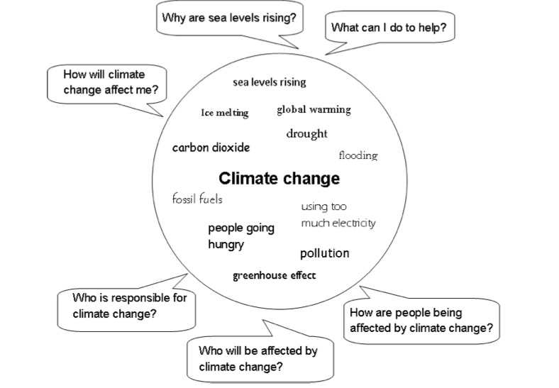

7. Self Evaluation
How did the lesson go?
Were learning outcomes achieved? To what extent?

What would you do differently next time?

What can you learn from this lesson?

You might consider areas such as student understanding, motivation, clarity of instruction, student involvement, learners’ ability to transfer new knowledge to different situations, teaching methods, discipline, resources, surprises and/or unexpected student behaviour

